**eHearing Study Data Dictionary**

Defining Universal Barriers and Incentives to Seeking Hearing Health Care

PI: Kelly Tremblay, University of Washington. NIH Project # 5R33DC013161-05

Contents

Publication /Collaboration Policy 2

Data Storage 2

Internal Collaboration 2

External Collaboration 2

Mutual Agreement 3

Publication and Presentation Policies 3

Survey Filenames 3

Description 3

Filenames 3

Survey Collection 4

Glossary of Terms 4

Survey Items 5

SURVEY STRUCTURE 212

SURVEY STRUCTURE UK 212

UK ENGLAND ONLINE (file header incorrectly says in person) 212

UK National Online.pdf (not in person despite heading) 215

UK London In Person.pdf 219

UK London Online.pdf (not in person despite heading) 223

SURVEY STRUCTURE Australia 227

Australia National Including NSW Online 227

Australia NSW Online (NSW ONLY- Includes Sydney) 231

Australia eHearing Study-InPerson Survey (Sydney only) 233

SURVEY STRUCTURE CANADA 239

Canada National Minus Ontario Online (doesn’t include Ontario) 239

Canada Ontario Online (Includes Toronto) 243

Canada-InPerson Survey (Toronto/Mississauga only) 247

SURVEY STRUCTURE USA 251

US NATIONAL INCLUDING WA STATE ONLINE 251

USA Washington State Online.pdf 254

USA SEATTLE In Person.pdf 258

# Publication /Collaboration Policy

As a courtesy, the assumption is that all four of the investigators on the NIH e-hearing grant (Kelly Tremblay [KT], Davis, McMahon, Pichora-Fuller) will be contributing authors on all manuscripts that are generated from the dataset.

## Data Storage

Each investigator will have access to the survey data belonging to their respective country, which will remain stored in dropbox. Please consult with lead investigator of each respective country (e.g., Canada = Kathy Pichora-Fuller, Australia = Catherine McMahon, and UK = Adrian Davis) if you wish to access data from their country.

Survey results/data are not to be shared with people outside of our research team.

A master copy of the survey data, acquired from all countries, will be housed at the IHME at the UW http://www.healthdata.org. Data sharing with IHME will remain contingent on our agreement with the IHME and is subject to change based on the PI’s (Tremblay) affiliation. Dr. Tremblay and Lee will also retain master copies as an extra backup.

Dr. Lee created our datasets and will remain active as a scientific contributor moving forward. Even though he will no longer be employed by the eHearing project, his assistance with data analysis is critical, and remains available to us. His contribution to this project, and his background in Public Health makes him an unofficial member of our group. Please consider including him as an author if he makes substantial contributions to your manuscript.

## Internal Collaboration

It’s the lead author’s responsibility to initiate and notify all four scientists (the Scientific Team) of their intent to analyze and write a paper on a specific topic. If any investigator wishes to opt out, that’s fine, but they should notify all members of the Scientific Team.

The Scientific Team will have the opportunity to contribute/comment on every collaborative project and will be sent pre-submission drafts of any resultant publications, allowing at least two weeks for review and approval prior to submission for publication.

## External Collaboration

Potential external collaborators are encouraged to contact the PI (Tremblay) or lead scientists (Davis, McMahon, Pichora-Fuller) to discuss their ideas for collaboration in writing. Doing so will save time by clarifying the feasibility of the idea and whether the topic has already been proposed and committed to by a team member, and/or if data are available.

The internal contact person will then communicate the intent to the 4-person Scientific Team. If there are no objections, the outside investigator will submit a brief proposal describing the purpose of the study and the data they will require. If there are no objections from anyone on the Scientific Team, one of the lead scientists/PI will take the lead and coordinate the external collaboration.

External collaborations are exactly that; collaborations. We cannot treat these data sets as an open repository because in the eyes of the IRB, they were not collected for that purpose.

We agree to reserve the right to collaborate with outside investigators two years following the final data collection point. This means on August 30th 2020 we will consider working with others, outside of our 4-person team.

## Mutual Agreement

Survey questions (including access to the online survey) will not be shared with anyone until the survey Ehearing methodology paper is in press. Electronic copies of the survey are intended to appear as online supplemental resources for this methodology paper.

## Publication and Presentation Policies

According to NIH rules, all publications and presentations must acknowledge funding to grant NIH NIDCD R33DC013161 awarded to KT. Because NIH dollars were used to fund this research, every publication must be made publicly available online. This means each lead author will be responsible for making the manuscript open source on websites like pubmed.gov.

Presentations should be treated in the same way as publications. Please acknowledge each member of the Scientific Team’s contribution and share copies of power point presentations with the PI (Tremblay) for archiving purposes. Publications and abstracts should not be submitted without prior consent from the 4-person Scientific Team.

There are no funds to cover the cost of publication (page charges, color figures) and so if you choose to submit a paper that incurs costs, the lead author will be responsible for the charges.

# Survey Filenames

## Description

Survey filenames provide information pertaining to the collection of the dataset. The first term identifies the country the data was collected in.

Datasets collected at the national level contain the term, “National” next and also whether or not data were collected in the state noted. Canada was the only country where national level data did not include a specific state, Ontario.

Datasets collected at the state level include the name of the state.

Datasets were collected either online or in person, and noted as such.

Datasets are stored in SPSS or both SPSS and CSV format. See below in “Survey Collection” for more details.

## Filenames

1. Australia National Including NSW Online (SPSS)
2. Australia NSW Online (SPSS)
3. Australia Sydney In Person (SPSS/CSV)
4. Canada National Minus Ontario Online
5. Canada Ontario Online (SPSS)
6. Canada Toronto In Person (SPSS/CSV)
7. UK England Online (SPSS)
8. UK London In Person (SPSS/CSV)
9. UK London Online (SPSS)
10. UK National Online (SPSS)
11. USA National Including WA State Online (SPSS)
12. USA Washington State Online (SPSS)
13. USA_Seattle In Person (SPSS/CSV)

# Survey Collection

Online surveys responses were collected and stored in SPSS format. In person responses were originally collected in SPSS format, then converted to CSV to delete missing data and merge individual’s data in instances where the person had to restart the survey. The cleaned CSV file was then imported back to SPSS, but does not retain all the label information of the originals.

# Glossary of Terms

|  |  |
| --- | --- |
| Variable Name | the name of the variable in the provided dataset  In cases where the responses for a question are itemized as individual variables, this is denoted with the range of variable names:  For example, q0009_0001, q0009_0002, q0009_0003, q0009_0004, q0009_0005 are response options for the same question. The 5 response variables are listed as: Q0009 1-5 |
| Short description | a short explanation of what the variable means |
| Question text | the question as it appears on the eHearing online survey data collection forms |
| Data type | numeric or character |
| Comments | further information about the variable not covered in the above fields |
| Response options | List of responses |

# Survey Items

|  |  |
| --- | --- |
| Variable Name | CollectorNm |
| Short Description | Data Collection method. Variable assigned when survey was administered |
| Question Text | N/A |
| Data type | String |
| Comments | Web Link 1 |

|  |  |
| --- | --- |
| Variable Name | RespondentID |
| Short Description | Unique respondent ID number. Variable assigned when survey was administered |
| Question Text | N/A |
| Data type | Numeric |
| Comments |  |

|  |  |
| --- | --- |
| Variable Name | CollectorID |
| Short Description | Variable assigned when survey was administered |
| Question Text | N/A |
| Data type | Numeric |
| Comments |  |

|  |  |
| --- | --- |
| Variable Name | StartDate |
| Short Description | Variable assigned when survey was administered. Date and time survey began |
| Question Text | N/A |
| Data type | String |
| Comments |  |

|  |  |
| --- | --- |
| Variable Name | EndDate |
| Short Description | Variable assigned when survey was administered. Date and time survey ended |
| Question Text | N/A |
| Data type | String |
| Comments |  |

|  |  |
| --- | --- |
| Variable Name | Q0001 |
| Short Description | Only administered in certain surveys. |
| Question Text | Where do you reside? |
| Data type | Numeric |
| Comments | Response options are specific to each geographic region survey was administered |
| Response options |  |

|  |  |
| --- | --- |
| Variable Name | Q0002 |
| Short Description | Gender |
| Question Text | What is your gender? |
| Data type | Numeric |
| Comments |  |
| Response options | 1=female  2=male |

|  |  |
| --- | --- |
| Variable Name | Q0003 |
| Short Description | Age |
| Question Text | What is your age in years? |
| Data type | Numeric |
| Comments | Response options were in 5 year bins. Subjects were required to be at least 60 years of age to participate |
| Response options | |  |  | | --- | --- | | 1.00 | Under 60 | | 2.00 | 60 – 64 | | 3.00 | 65 – 69 | | 4.00 | 70 – 74 | | 5.00 | 75 – 79 | | 6.00 | 80 – 84 | | 7.00 | 85+ | |

|  |  |
| --- | --- |
| Variable Name | Q0004 |
| Short Description | Length of time lived in region |
| Question Text | How long have you lived in (country administered) |
| Data type | Numeric |
| Comments | Response options were in 5 year bins. Country was specific to site administrated |
| Response options | |  |  | | --- | --- | | 1.00 | Since birth | | 2.00 | 0-5 years | | 3.00 | 6-10 years | | 4.00 | 11-15 years | | 5.00 | 16-20 years | | 6.00 | 21-25 years | | 7.00 | 26-30 years | | 8.00 | More than 30 years | | 9.00 | I do not live in ___ | |

|  |  |
| --- | --- |
| Variable Name | Q0005 |
| Short Description | Marital Status |
| Question Text | What is your marital status? |
| Data type | Numeric |
| Comments |  |
| Response options | 1.00 Married/Committed relationship  2.00 Single/Divorced/Widowed/Never married |

|  |  |
| --- | --- |
| Variable Name | Q0006 1-7 |
| Short Description | Question 6 responses are stratified into 7 response variables. A value of 1 represents the participant selected that choice |
| Question Text | Who currently lives with you?  Check all that apply: |
| Data type | Numeric |
| Comments |  |
| Response options | |  |  |  | | --- | --- | --- | | q0006_0001 | 1.00 | I live alone | | q0006_0002 | 1.00 | Spouse/Partner | | q0006_0003 | 1.00 | Other Family (e.g., parents, other relatives) | | q0006_0004 | 1.00 | Child or Children | | q0006_0005 | 1.00 | Friends / Roommates | | q0006_0006 | 1.00 | Assisted living/ Nursing home for the aged | | q0006_0007 | 1.00 | Independent seniors’ housing or Retirement home | |

|  |  |
| --- | --- |
| Variable Name | Q0007 |
| Short Description |  |
| Question Text | How many people live with you? |
| Data type | Numeric |
| Comments |  |
| Response options | |  |  | | --- | --- | | 1.00 | 0 | | 2.00 | 1 | | 3.00 | 2 | | 4.00 | 3 | | 5.00 | 4 | | 6.00 | 5 or more | |

|  |  |
| --- | --- |
| Variable Name | Q0008 |
| Short Description |  |
| Question Text | What is the highest grade or year of school you completed? |
| Data type | Numeric |
| Comments |  |
| Response options | |  |  | | --- | --- | | 1.00 | Never attended school | | 2.00 | Primary (elementary) school | | 3.00 | Secondary (high) school | | 4.00 | College/university (1-4 years) | | 5.00 | Graduate training (e.g., Masters/Doctorate/MD etc.) | |

|  |  |
| --- | --- |
| Variable Name | Q0009 1-5 |
| Short Description | Question 9 responses are stratified into 5 response variables. A value of 1 represents the participant selected that choice |
| Question Text | Are you currently? (Check all that apply) |
| Data type | Numeric |
| Comments |  |
| Response options | q0009_0001 1.00 Employed  q0009_0002 1.00 Unemployed  q0009_0003 1.00 A volunteer  q0009_0004 1.00 Retired  q0009_0005 1.00 Unable to work |

|  |  |
| --- | --- |
| Variable Name | Q0010 |
| Short Description |  |
| Question Text | What is your annual household income before tax, etc.? |
| Data type | Numeric |
| Comments |  |
| Response options | |  |  | | --- | --- | | 1.00 | Under £ 20, 000 | | 2.00 | £ 20,000 – £ 39,999 | | 3.00 | £ 40,000 – £ 59,999 | | 4.00 | £ 60,000 – £ 79,999 | | 5.00 | £ 80,000 – £ 99,999 | | 6.00 | More than £ 100,000 | | 7.00 | Prefer not to say | |

|  |  |
| --- | --- |
| Variable Name | Q0011 1-6 |
| Short Description | Question 11 responses are stratified into 6 response variables. A value of 1 represents the participant selected that choice |
| Question Text | Do you receive any of the following benefits? Check all that apply. |
| Data type | Numeric |
| Comments |  |
| Response options | q0011_0001 1.00 Armed services pension  q0011_0002 1.00 Occupational health pension  q0011_0003 1.00 State pension  q0011_0004 1.00 Personal Independence Payment (PIP)  q0011_0005 1.00 Personal pension  q0011_0006 1.00 None |

|  |  |
| --- | --- |
| Variable Name | Q0012 |
| Short Description |  |
| Question Text | What is your annual household income before tax, etc.? |
| Data type | Numeric |
| Comments |  |
| Response options | |  |  | | --- | --- | | 1.00 | Yes | | 2.00 | No | | 3.00 | Partially | | 4.00 | I don’t know | |

|  |  |
| --- | --- |
| Variable Name | Q0013 |
| Short Description | Example is country specific |
| Question Text | Does your health insurance fund/government benefits (e.g, National Health Service) cover the cost of a hearing test? |
| Data type | Numeric |
| Comments |  |
| Response options | |  |  | | --- | --- | | 1.00 | Yes | | 2.00 | No | | 3.00 | I don’t know | |

|  |  |
| --- | --- |
| Variable Name | Q0014 |
| Short Description |  |
| Question Text | Would you describe yourself as? |
| Data type | Numeric |
| Comments | Response options are ethnicities and are country specific. |
| Response options |  |

|  |  |
| --- | --- |
| Variable Name | Q0015 |
| Short Description |  |
| Question Text | Do you consider yourself to have a nationality other than ____? |
| Data type | Numeric |
| Comments | Question is country specific. |
| Response options | |  |  | | --- | --- | | 1.00 | Yes | | 2.00 | No | | 3.00 | I don't know | |

|  |  |
| --- | --- |
| Variable Name | Q0016 1-7 |
| Short Description | Question 16 responses are stratified into 7 response variables. A value of 1 represents the participant selected that choice |
| Question Text | Do you receive any of the following benefits? Check all that apply. |
| Data type | Numeric |
| Comments |  |
| Response options | |  |  |  | | --- | --- | --- | | q0016_0001 | 1.00 | TV | | q0016_0002 | 1.00 | Radio | | q0016_0003 | 1.00 | VHS/CD/DVD/Blu-ray player | | q0016_0004 | 1.00 | Computer (desktop/laptop) | | q0016_0005 | 1.00 | Tablet computer/iPad | | q0016_0006 | 1.00 | Internet service | | q0016_0007 | 1.00 | Cell phone with a data plan (Smartphone) | |

|  |  |
| --- | --- |
| Variable Name | Q0017 0001 |
| Short Description |  |
| Question Text | How comfortable are you in using a computer, tablet device (iPad) or smartphone? |
| Data type | numeric |
| Comments |  |
| Response options | |  |  | | --- | --- | | 1.00 | Not at all | | 2.00 | A little | | 3.00 | Very | | 4.00 | Do not use/NA | |

|  |  |
| --- | --- |
| Variable Name | Q0018 0001 |
| Short Description |  |
| Question Text | In general, would you say your health is: |
| Data type | numeric |
| Comments |  |
| Response options | |  |  | | --- | --- | | 1.00 | Excellent | | 2.00 | Very good | | 3.00 | Good | | 4.00 | Fair | | 5.00 | Poor | |

|  |  |
| --- | --- |
| Variable Name | Q0019 0001 |
| Short Description |  |
| Question Text | To what extent are you able to carry out everyday physical activities such as walking, climbing stairs, carrying groceries, or moving a chair? |
| Data type | numeric |
| Comments |  |
| Response options | |  |  | | --- | --- | | 1.00 | Completely | | 2.00 | Mostly | | 3.00 | Moderately | | 4.00 | A little | | 5.00 | Not at all | |

|  |  |
| --- | --- |
| Variable Name | Q0020 0001 |
| Short Description |  |
| Question Text | In general, would you say your quality of life is: |
| Data type | numeric |
| Comments |  |
| Response options | |  |  | | --- | --- | | 1.00 | Excellent | | 2.00 | Very Good | | 3.00 | Good | | 4.00 | Fair | | 5.00 | Poor | |

|  |  |
| --- | --- |
| Variable Name | Q0021 0001 |
| Short Description |  |
| Question Text | In general, how would you rate your mental health, including your mood, your energy level, and your ability to think? |
| Data type | numeric |
| Comments |  |
| Response options | |  |  | | --- | --- | | 1.00 | Excellent | | 2.00 | Very good | | 3.00 | Good | | 4.00 | Fair | | 5.00 | Poor | |

|  |  |
| --- | --- |
| Variable Name | Q0022 0001 |
| Short Description |  |
| Question Text | How often have you been bothered by emotional problems such as feeling anxious, depressed, or irritable? |
| Data type | numeric |
| Comments |  |
| Response options | |  |  | | --- | --- | | 1.00 | Never | | 2.00 | Rarely | | 3.00 | Sometimes | | 4.00 | Often | | 5.00 | Always | |

|  |  |
| --- | --- |
| Variable Name | Q0023 0001 |
| Short Description |  |
| Question Text | During the past 2 weeks, how often have you been bothered by feeling down, depressed or hopeless? |
| Data type | numeric |
| Comments |  |
| Response options | |  |  | | --- | --- | | 1.00 | Not at all | | 2.00 | Several days | | 3.00 | More than half the days | | 4.00 | Nearly every day | | 5.00 | Prefer not to say | |

|  |  |
| --- | --- |
| Variable Name | Q0024 0001 |
| Short Description |  |
| Question Text | During the past two weeks how often have you been bothered because you had little interest or pleasure in doing things? |
| Data type | numeric |
| Comments |  |
| Response options | |  |  | | --- | --- | | 1.00 | Not at all | | 2.00 | Several days | | 3.00 | More than half the days | | 4.00 | Nearly every day | | 5.00 | Prefer not to say | |

|  |  |
| --- | --- |
| Variable Name | Q0025 |
| Short Description |  |
| Question Text | In the last year, have you found yourself getting more forgetful? |
| Data type | Numeric |
| Comments |  |
| Response options | |  |  | | --- | --- | | 1.00 | No | | 2.00 | Yes, somewhat more | | 3.00 | Yes, much more | |

|  |  |
| --- | --- |
| Variable Name | Q0026 |
| Short Description |  |
| Question Text | Generally speaking, would you say that most people can be trusted or that you can’t be too careful in dealing with people? |
| Data type | Numeric |
| Comments |  |
| Response options | |  |  | | --- | --- | | 1.00 | You cannot be too careful when dealing with people | | 2.00 | Most people can be trusted | |

|  |  |
| --- | --- |
| Variable Name | Q0027 |
| Short Description |  |
| Question Text | Which of the following statements best reflects your view? |
| Data type | Numeric |
| Comments |  |
| Response options | |  |  | | --- | --- | | 1.00 | “I will not trust a person until there is clear evidence that he or she can be trusted.” | | 2.00 | “I will trust a person until I have clear evidence that he or she can’t be trusted.” | |

|  |  |
| --- | --- |
| Variable Name | Q0028 |
| Short Description |  |
| Question Text | Do you wear prescription glasses or contact lenses some or all of the time? |
| Data type | Numeric |
| Comments |  |
| Response options | |  |  | | --- | --- | | 1.00 | Yes, some of the time | | 2.00 | Yes, all day long | | 3.00 | No | | 4.00 | I am blind | |

|  |  |
| --- | --- |
| Variable Name | Q0029 0001 |
| Short Description |  |
| Question Text | At the present time, would you say your eyesight using both eyes (with glasses or contact lenses, if you wear them) is excellent, good, fair, poor, or very poor, or are you completely blind? |
| Data type | numeric |
| Comments |  |
| Response options | |  |  | | --- | --- | | 1.00 | Excellent | | 2.00 | Good | | 3.00 | Fair | | 4.00 | Poor | | 5.00 | Very poor | | 6.00 | Completely blind | |

|  |  |
| --- | --- |
| Variable Name | Q0030 1-19 |
| Short Description | Question 30 responses are stratified into 19 response variables. A value of 1 represents the participant selected that choice |
| Question Text | Have you ever been told by a doctor or healthcare professional that you have any of the following conditions? Check ALL that apply: |
| Data type | Numeric |
| Comments |  |
| Response options | |  |  |  | | --- | --- | --- | | q0030_0001 | 1.00 | Diabetes | | q0030_0002 | 1.00 | Asthma or other breathing problems | | q0030_0003 | 1.00 | High blood pressure (hypertension) | | q0030_0004 | 1.00 | High cholesterol | | q0030_0005 | 1.00 | Heart disease | | q0030_0006 | 1.00 | Stroke or mini stroke | | q0030_0007 | 1.00 | Epilepsy | | q0030_0008 | 1.00 | Cancer (any type) | | q0030_0009 | 1.00 | Parkinson’s Disease | | q0030_0010 | 1.00 | Memory problems | | q0030_0011 | 1.00 | Depression | | q0030_0012 | 1.00 | Difficulty walking | | q0030_0013 | 1.00 | Chronic pain | | q0030_0014 | 1.00 | Arthritis | | q0030_0015 | 1.00 | Hearing loss | | q0030_0016 | 1.00 | Vision loss | | q0030_0017 | 1.00 | Loss of sense of smell | | q0030_0018 | 1.00 | Balance or problems with dizziness | | q0030_0019 | 1.00 | None | |

|  |  |
| --- | --- |
| Variable Name | Q0031 0001 |
| Short Description | Question 31 responses are stratified into 3 response variables. A value of 1 represents the participant selected that choice |
| Question Text | Does anyone living in your home or with whom you communicate frequently have a speech or language impairment (e.g., speech impairments due to Parkinson’s disease, stroke, stuttering or other types of speech impairments)? Check all that apply: |
| Data type | Numeric |
| Comments |  |
| Response options | |  |  |  | | --- | --- | --- | | q0031_0001 | 1.00 | Yes – I have a speech or language impairment | | q0031_0002 | 1.00 | Yes – Someone I live with or communicate with frequently has speech or language impairment | | q0031_0003 | 1.00 | No | |

|  |  |
| --- | --- |
| Variable Name | Q0032 |
| Short Description |  |
| Question Text | Are you deaf or do you have a significant hearing difficulty? |
| Data type | Numeric |
| Comments |  |
| Response options | |  |  | | --- | --- | | 1.00 | Yes | | 2.00 | No | |

|  |  |
| --- | --- |
| Variable Name | Q0033 |
| Short Description |  |
| Question Text | Does anyone (other than you) currently living in your home, or with whom you communicate frequently have a hearing problem? |
| Data type | Numeric |
| Comments |  |
| Response options | |  |  | | --- | --- | | 1.00 | Yes | | 2.00 | No | | 3.00 | Unsure | |

|  |  |
| --- | --- |
| Variable Name | Q0034 |
| Short Description |  |
| Question Text | Do your ever get noises such as ringing or buzzing in your ears or head (tinnitus) that last more than 5 minutes? (If yes) Do you get these noises some of the time, most of the time, or all of the time? |
| Data type | Numeric |
| Comments |  |
| Response options | |  |  | | --- | --- | | 1.00 | No | | 2.00 | Yes, some of the time | | 3.00 | Yes, most or all of the time | |

|  |  |
| --- | --- |
| Variable Name | Q0035 0001 |
| Short Description |  |
| Question Text | How much do these noises worry, annoy or upset you when they are at their worst? |
| Data type | numeric |
| Comments |  |
| Response options | |  |  | | --- | --- | | 1.00 | Not at all | | 2.00 | Slightly | | 3.00 | Moderately | | 4.00 | Severely | | 5.00 | Not Applicable | |

|  |  |
| --- | --- |
| Variable Name | Q0036 |
| Short Description |  |
| Question Text | Have you ever worked in a place that was so noisy you had to shout to be heard? |
| Data type | Numeric |
| Comments |  |
| Response options | |  |  | | --- | --- | | 1.00 | No | | 2.00 | Yes, for less than 1 year | | 3.00 | Yes, for at least 1 year but not longer than 5 years | | 4.00 | Yes, for 5 years or longer | |

|  |  |
| --- | --- |
| Variable Name | Q0037 |
| Short Description |  |
| Question Text | At work, do/did you have regular hearing tests? |
| Data type | Numeric |
| Comments |  |
| Response options | |  |  | | --- | --- | | 1.00 | Yes, since the beginning of my employment | | 2.00 | Yes, but only in the later years of my employment | | 3.00 | No, it was never offered | | 4.00 | No, options were provided but I did not participate | | 5.00 | I don’t know/I don’t remember | |

|  |  |
| --- | --- |
| Variable Name | Q0038 |
| Short Description |  |
| Question Text | At work, do/did you receive information about hearing protection? |
| Data type | Numeric |
| Comments |  |
| Response options | |  |  | | --- | --- | | 1.00 | Yes, since the beginning of my employment | | 2.00 | Yes, but only in the later years of my employment | | 3.00 | No, it was never offered | | 4.00 | No, options were provided but I did not participate | | 5.00 | I don’t know/I don’t remember | |

|  |  |
| --- | --- |
| Variable Name | Q0039 |
| Short Description |  |
| Question Text | Did you know there are government-sponsored websites that provide information about hearing health care and have no ties to companies that sell hearing aids or hearing protection? |
| Data type | Numeric |
| Comments |  |
| Response options | |  |  | | --- | --- | | 1.00 | Yes | | 2.00 | No | |

|  |  |
| --- | --- |
| Variable Name | Q0040 |
| Short Description |  |
| Question Text | Have you used any government-sponsored websites to get information about hearing/hearing loss? |
| Data type | Numeric |
| Comments |  |
| Response options | |  |  | | --- | --- | | 1.00 | Yes | | 2.00 | No | |

|  |  |
| --- | --- |
| Variable Name | Q0041 1-14 |
| Short Description | Question 41 responses are stratified into 14 response variables. A value of 1 represents the participant selected that choice |
| Question Text | Have you ever been told by a doctor or healthcare professional that you have any of the following conditions? Check ALL that apply: |
| Data type | Numeric |
| Comments |  |
| Response options | |  |  |  | | --- | --- | --- | | q0041_0001 | 1.00 | Doctor | | q0041_0002 | 1.00 | TV ads | | q0041_0003 | 1.00 | Radio ads | | q0041_0004 | 1.00 | Newspaper | | q0041_0005 | 1.00 | Pamphlets that come to you in the mail | | q0041_0006 | 1.00 | Pamphlets that come to you see in your doctor or other healtchcare provider's office | | q0041_0007 | 1.00 | University websites on the Internet | | q0041_0008 | 1.00 | Advertisements on the Internet | | q0041_0009 | 1.00 | Government websites on the Internet | | q0041_0010 | 1.00 | Medical (e.g., hospital) websites on the Internet | | q0041_0011 | 1.00 | Friends and family | | q0041_0012 | 1.00 | Hearing Loss Associations/Charities (e.g.Action on Hearing Loss) | | q0041_0013 | 1.00 | Advertisements in public places | | q0041_0014 | 1.00 | Public libraries | |

|  |  |
| --- | --- |
| Variable Name | Q0042 |
| Short Description |  |
| Question Text | Do you have a hearing problem now? |
| Data type | Numeric |
| Comments |  |
| Response options | |  |  | | --- | --- | | 1.00 | Yes | | 2.00 | No | |

|  |  |
| --- | --- |
| Variable Name | Q0043 0001 |
| Short Description |  |
| Question Text | How well do you hear someone talking to you when that person is sitting on your side in a quiet room? (without using a hearing aid or other device) |
| Data type | numeric |
| Comments |  |
| Response options | |  |  | | --- | --- | | 1.00 | With no difficulty | | 2.00 | With slight difficulty | | 3.00 | With moderate difficulty | | 4.00 | With great difficulty | | 5.00 | Cannot hear at all | | 6.00 | Prefer not to say | |

|  |  |
| --- | --- |
| Variable Name | Q0044 |
| Short Description |  |
| Question Text | Do you have difficulty following TV programs at a volume others find acceptable, without any aid to hearing? |
| Data type | Numeric |
| Comments |  |
| Response options | |  |  | | --- | --- | | 1.00 | No | | 2.00 | Yes, slight difficulty | | 3.00 | Yes, moderate difficulty | | 4.00 | Yes, great difficulty | | 5.00 | Prefer not to say | |

|  |  |
| --- | --- |
| Variable Name | Q0045 |
| Short Description |  |
| Question Text | Do you have difficulty having a conversation with several people in a group? (without using a hearing aid or other device) |
| Data type | Numeric |
| Comments |  |
| Response options | |  |  | | --- | --- | | 1.00 | No | | 2.00 | Yes, slight difficulty | | 3.00 | Yes, moderate difficulty | | 4.00 | Yes, great difficulty | | 5.00 | Prefer not to say | |

|  |  |
| --- | --- |
| Variable Name | Q0046 |
| Short Description |  |
| Question Text | Which of the following statements best describes how you feel about your hearing ability? |
| Data type | Numeric |
| Comments |  |
| Response options | |  |  | | --- | --- | | 1.00 | I do not know if I have a hearing problem | | 2.00 | I do not have any problems with my hearing and nobody has complained about my hearing | | 3.00 | I do not have any problems with my hearing but sometimes other people tell me I have a hearing problem | | 4.00 | I do have a hearing problem but I haven’t sought any kind of help for it | | 5.00 | I do have a hearing problem and I wear hearing aids or use other technology to help me hear | |

|  |  |
| --- | --- |
| Variable Name | Q0047 |
| Short Description | Response 7 example is country specific |
| Question Text | We are thinking of providing hearing services to people in different ways. From which of the following places would you MOST like to get your hearing tested? |
| Data type | Numeric |
| Comments |  |
| Response options | |  |  | | --- | --- | | 1.00 | Hospital | | 2.00 | Family Doctor/General Practitioner’s office | | 3.00 | Community Centre | | 4.00 | At your home | | 5.00 | Audiologist’s office | | 6.00 | Supermarket or Pharmacy | | 7.00 | Technology retail store (e.g., Apple Store) | | 8.00 | Self test (e.g., on your computer or at a kiosk) | |

|  |  |
| --- | --- |
| Variable Name | Q0048 1-11 |
| Short Description | Question 48 responses are stratified into 11 response variables. A value of 1 represents the participant selected that choice |
| Question Text | We are thinking of providing hearing services to people in different ways. From which of the following places would you MOST like to get hearing aids (or other types of hearing devices) if you needed them? |
| Data type | Numeric |
| Comments |  |
| Response options | |  |  |  | | --- | --- | --- | | q0048_0001 | 1.00 | Hospital | | q0048_0002 | 1.00 | Family Doctor/General Practitioner’s office | | q0048_0003 | 1.00 | Community Centre | | q0048_0004 | 1.00 | Services provided in my home | | q0048_0005 | 1.00 | Audiologist’s office | | q0048_0006 | 1.00 | Supermarket or Pharmacy | | q0048_0007 | 1.00 | Technology retail store (e.g., Apple Store, Currys) | | q0048_0008 | 1.00 | Online | | q0048_0009 | 1.00 | Mail order | | q0048_0010 | 1.00 | Retail store (e.g., TESCO, John Lewis) | | q0048_0011 | 1.00 | None of these | |

|  |  |
| --- | --- |
| Variable Name | Q0049 1-8 |
| Short Description | Question 49 responses are stratified into 8 response variables. A value of 1 represents the participant selected that choice |
| Question Text | If you were to have a hearing loss, check each of the following devices that you would want to use if they could help you hear better. |
| Data type | Numeric |
| Comments |  |
| Response options | |  |  |  | | --- | --- | --- | | q0049_0001 | 1.00 | Phone with volume control | | q0049_0002 | 1.00 | Earphones for the TV | | q0049_0003 | 1.00 | Computer | | q0049_0004 | 1.00 | Smartphone with downloadable sound amplifiers (e.g., apps) | | q0049_0005 | 1.00 | Alerting devices (e.g., alarm clock, doorbell) | | q0049_0006 | 1.00 | iPad (tablet device) with downloadable sound amplifiers (e.g., apps) | | q0049_0007 | 1.00 | New types of hearing aids that are surgically implanted | | q0049_0008 | 1.00 | Personal amplifier that goes in your ear but looks like more like a cell phone accessory (e.g., bluetooth device or ear | |  |  |  | |

|  |  |
| --- | --- |
| Variable Name | Q0049 Other |
| Short Description | Question 49 has a response option titled “Other”. |
| Question Text | If you were to have a hearing loss, check each of the following devices that you would want to use if they could help you hear better. |
| Data type | string |
| Comments |  |
| Response options | Q0049 Other |

|  |  |
| --- | --- |
| Variable Name | Q0050 |
|  |  |
| Question Text | How often does your general practitioner or regular health care provider ask about your hearing? |
| Data type | Numeric |
| Comments |  |
| Response options | |  |  | | --- | --- | | 1.00 | Every time I visit the doctor | | 2.00 | Once every few visits | | 3.00 | Never | | 4.00 | I do not remember | |

|  |  |
| --- | --- |
| Variable Name | Q0051 |
|  |  |
| Question Text | Did you have a hearing test at their office? |
| Data type | Numeric |
| Comments |  |
| Response options | |  |  | | --- | --- | | 1.00 | Yes | | 2.00 | No | | 3.00 | I don't remember/Not sure | |

|  |  |
| --- | --- |
| Variable Name | Q0052 |
|  |  |
| Question Text | When did you last have a hearing test? |
| Data type | Numeric |
| Comments |  |
| Response options | |  |  | | --- | --- | | 1.00 | Within one year | | 2.00 | 1 – 5 years ago | | 3.00 | More than 5 years ago | | 4.00 | I can’t remember | | 5.00 | I have never had a hearing test | |

|  |  |
| --- | --- |
| Variable Name | Q0053 |
|  |  |
| Question Text | What is the title of the professional who tested your hearing? |
| Data type | Numeric |
| Comments |  |
| Response options | |  |  | | --- | --- | | 1.00 | I have never had a hearing test | | 2.00 | Physician (e.g., primary care provider, family physician, general practitioner, ear/nose/throat doctor) | | 3.00 | Audiologist | | 4.00 | Audiometric technician | | 5.00 | Hearing aid dispenser (e.g. hearing instrument specialist) | | 6.00 | Nurse | | 7.00 | Speech-language pathologist | | 8.00 | Researcher | | 9.00 | Self-test (e.g., on your computer or at a kiosk) | | 10.00 | Other | | 11.00 | Don’t know | |

|  |  |
| --- | --- |
| Variable Name | Q0054 |
|  |  |
| Question Text | If you were to have a hearing problem, who would be the FIRST person that you would seek out for help with that hearing problem? |
| Data type | Numeric |
| Comments |  |
| Response options | |  |  | | --- | --- | | 1.00 | Family physician/General Practitioner/Primary care physician | | 2.00 | Ear nose and throat (ENT) doctor | | 3.00 | Audiologist | | 4.00 | Hearing aid dispenser (e.g. hearing instrument specialist) | | 5.00 | Nurse | | 6.00 | Speech-language pathologist | | 7.00 | Friend or family member | | 8.00 | Other | |

|  |  |
| --- | --- |
| Variable Name | Q0055 0001 |
|  |  |
| Question Text | If a place or website offered you a free hearing test, how much would this influence your decision to go there? |
| Data type | Numeric |
| Comments |  |
| Response options | |  |  | | --- | --- | | 1.00 | Not at all | | 2.00 | Slightly | | 3.00 | Somewhat | | 4.00 | Very | | 5.00 | Extremely | |

|  |  |
| --- | --- |
| Variable Name | Q0056 0001 |
|  |  |
| Question Text | If you had a hearing problem, how important would the convenience of the provider’s location be to you? |
| Data type | Numeric |
| Comments |  |
| Response options | |  |  | | --- | --- | | 1.00 | Not at all | | 2.00 | Slightly | | 3.00 | Somewhat | | 4.00 | Very | | 5.00 | Extremely | |

|  |  |
| --- | --- |
| Variable Name | Q0057 0001 |
|  |  |
| Question Text | If you had a hearing problem, would you use these services if they could be of help? |
| Data type | Numeric |
| Comments | A person (coach/counsellor) to help you manage your hearing difficulties. |
| Response options | |  |  | | --- | --- | | 1.00 | Yes | | 2.00 | No | |

|  |  |
| --- | --- |
| Variable Name | Q0057 0002 |
|  |  |
| Question Text | If you had a hearing problem, would you use these services if they could be of help? |
| Data type | Numeric |
| Comments | Smartphone sound with downloadable amplifiers (e.g., apps) |
| Response options | |  |  | | --- | --- | | 1.00 | Yes | | 2.00 | No | |

|  |  |
| --- | --- |
| Variable Name | Q0057 0003 |
|  |  |
| Question Text | If you had a hearing problem, would you use these services if they could be of help? |
| Data type | Numeric |
| Comments | iPad (tablet device) with downloadable sound amplifiers (e.g., apps) |
| Response options | |  |  | | --- | --- | | 1.00 | Yes | | 2.00 | No | |

|  |  |
| --- | --- |
| Variable Name | Q0057 0004 |
|  |  |
| Question Text | If you had a hearing problem, would you use these services if they could be of help? |
| Data type | Numeric |
| Comments | Technological devices in your ear that can't be seen by the public |
| Response options | |  |  | | --- | --- | | 1.00 | Yes | | 2.00 | No | |

|  |  |
| --- | --- |
| Variable Name | Q0057 0005 |
|  |  |
| Question Text | If you had a hearing problem, would you use these services if they could be of help? |
| Data type | Numeric |
| Comments | Non-technological options (e.g., group classes, support groups) |
| Response options | |  |  | | --- | --- | | 1.00 | Yes | | 2.00 | No | |

|  |  |
| --- | --- |
| Variable Name | Q0057 0006 |
|  |  |
| Question Text | If you had a hearing problem, would you use these services if they could be of help? |
| Data type | Numeric |
| Comments | Computer-based exercises and support |
| Response options | |  |  | | --- | --- | | 1.00 | Yes | | 2.00 | No | |

|  |  |
| --- | --- |
| Variable Name | Q0057 0007 |
|  |  |
| Question Text | If you had a hearing problem, would you use these services if they could be of help? |
| Data type | Numeric |
| Comments | Hearing Aid |
| Response options | |  |  | | --- | --- | | 1.00 | Yes | | 2.00 | No | |

|  |  |
| --- | --- |
| Variable Name | Q0057 0008 |
|  |  |
| Question Text | If you had a hearing problem, would you use these services if they could be of help? |
| Data type | Numeric |
| Comments | Personal amplifiers that go in your ear but look more like cell phone accessories (e.g., bluetooth, ear bud) than a hearing aid. |
| Response options | |  |  | | --- | --- | | 1.00 | Yes | | 2.00 | No | |

|  |  |
| --- | --- |
| Variable Name | Q0058 0001 |
|  |  |
| Question Text | How much would problems in these situations now or in the future make you want to get help? |
| Data type | Numeric |
| Comments | Communicating in groups |
| Response options | |  |  | | --- | --- | | 1.00 | Not at all | | 2.00 | A little | | 3.00 | Somewhat | | 4.00 | Quite a bit | | 5.00 | Very much | |

|  |  |
| --- | --- |
| Variable Name | Q0058 0002 |
|  |  |
| Question Text | How much would problems in these situations now or in the future make you want to get help? |
| Data type | Numeric |
| Comments | Communicating in noisy places (e.g., restaurants) |
| Response options | |  |  | | --- | --- | | 1.00 | Not at all | | 2.00 | A little | | 3.00 | Somewhat | | 4.00 | Quite a bit | | 5.00 | Very much | |

|  |  |
| --- | --- |
| Variable Name | Q0058 0003 |
|  |  |
| Question Text | How much would problems in these situations now or in the future make you want to get help? |
| Data type | Numeric |
| Comments | Listening on the phone |
| Response options | |  |  | | --- | --- | | 1.00 | Not at all | | 2.00 | A little | | 3.00 | Somewhat | | 4.00 | Quite a bit | | 5.00 | Very much | |

|  |  |
| --- | --- |
| Variable Name | Q0058 0004 |
|  |  |
| Question Text | How much would problems in these situations now or in the future make you want to get help? |
| Data type | Numeric |
| Comments | Watching TV |
| Response options | |  |  | | --- | --- | | 1.00 | Not at all | | 2.00 | A little | | 3.00 | Somewhat | | 4.00 | Quite a bit | | 5.00 | Very much | |

|  |  |
| --- | --- |
| Variable Name | Q0058 0005 |
|  |  |
| Question Text | How much would problems in these situations now or in the future make you want to get help? |
| Data type | Numeric |
| Comments | Listening to music |
| Response options | |  |  | | --- | --- | | 1.00 | Not at all | | 2.00 | A little | | 3.00 | Somewhat | | 4.00 | Quite a bit | | 5.00 | Very much | |

|  |  |
| --- | --- |
| Variable Name | Q0058 0006 |
|  |  |
| Question Text | How much would problems in these situations now or in the future make you want to get help? |
| Data type | Numeric |
| Comments | Hearing at public events (e.g., theatre movies, church) |
| Response options | |  |  | | --- | --- | | 1.00 | Not at all | | 2.00 | A little | | 3.00 | Somewhat | | 4.00 | Quite a bit | | 5.00 | Very much | |

|  |  |
| --- | --- |
| Variable Name | Q0058 0007 |
|  |  |
| Question Text | How much would problems in these situations now or in the future make you want to get help? |
| Data type | Numeric |
| Comments | Communicating at work |
| Response options | |  |  | | --- | --- | | 1.00 | Not at all | | 2.00 | A little | | 3.00 | Somewhat | | 4.00 | Quite a bit | | 5.00 | Very much | |

|  |  |
| --- | --- |
| Variable Name | Q0058 0008 |
|  |  |
| Question Text | How much would problems in these situations now or in the future make you want to get help? |
| Data type | Numeric |
| Comments | Noticing warning sounds (e.g., car horn, doorbell, sirens) |
| Response options | |  |  | | --- | --- | | 1.00 | Not at all | | 2.00 | A little | | 3.00 | Somewhat | | 4.00 | Quite a bit | | 5.00 | Very much | |

|  |  |
| --- | --- |
| Variable Name | Q0058 0009 |
|  |  |
| Question Text | How much would problems in these situations now or in the future make you want to get help? |
| Data type | Numeric |
| Comments | Hearing sounds in nature (e.g., birds singing) |
| Response options | |  |  | | --- | --- | | 1.00 | Not at all | | 2.00 | A little | | 3.00 | Somewhat | | 4.00 | Quite a bit | | 5.00 | Very much | |

|  |  |
| --- | --- |
| Variable Name | Q0059 0001 |
|  |  |
| Question Text | If you had hearing difficulty, would you feel: |
| Data type | Numeric |
| Comments | Embarrassed |
| Response options | |  |  | | --- | --- | | 1.00 | Not at all | | 2.00 | A little | | 3.00 | Somewhat | | 4.00 | Quite a bit | | 5.00 | Very much | |

|  |  |
| --- | --- |
| Variable Name | Q0059 0002 |
|  |  |
| Question Text | If you had hearing difficulty, would you feel: |
| Data type | Numeric |
| Comments | Isolated |
| Response options | |  |  | | --- | --- | | 1.00 | Not at all | | 2.00 | A little | | 3.00 | Somewhat | | 4.00 | Quite a bit | | 5.00 | Very much | |

|  |  |
| --- | --- |
| Variable Name | Q0059 0003 |
|  |  |
| Question Text | If you had hearing difficulty, would you feel: |
| Data type | Numeric |
| Comments | Left out of conversations |
| Response options | |  |  | | --- | --- | | 1.00 | Not at all | | 2.00 | A little | | 3.00 | Somewhat | | 4.00 | Quite a bit | | 5.00 | Very much | |

|  |  |
| --- | --- |
| Variable Name | Q0059 0004 |
|  |  |
| Question Text | If you had hearing difficulty, would you feel: |
| Data type | Numeric |
| Comments | Worried about your hearing getting worse |
| Response options | |  |  | | --- | --- | | 1.00 | Not at all | | 2.00 | A little | | 3.00 | Somewhat | | 4.00 | Quite a bit | | 5.00 | Very much | |

|  |  |
| --- | --- |
| Variable Name | Q0059 0005 |
|  |  |
| Question Text | If you had hearing difficulty, would you feel: |
| Data type | Numeric |
| Comments | Worried about losing your independence |
| Response options | |  |  | | --- | --- | | 1.00 | Not at all | | 2.00 | A little | | 3.00 | Somewhat | | 4.00 | Quite a bit | | 5.00 | Very much | |

|  |  |
| --- | --- |
| Variable Name | Q0059 0006 |
|  |  |
| Question Text | If you had hearing difficulty, would you feel: |
| Data type | Numeric |
| Comments | Self-conscious about getting older |
| Response options | |  |  | | --- | --- | | 1.00 | Not at all | | 2.00 | A little | | 3.00 | Somewhat | | 4.00 | Quite a bit | | 5.00 | Very much | |

|  |  |
| --- | --- |
| Variable Name | Q0059 0007 |
|  |  |
| Question Text | If you had hearing difficulty, would you feel: |
| Data type | Numeric |
| Comments | Frustrated |
| Response options | |  |  | | --- | --- | | 1.00 | Not at all | | 2.00 | A little | | 3.00 | Somewhat | | 4.00 | Quite a bit | | 5.00 | Very much | |

|  |  |
| --- | --- |
| Variable Name | Q0060 0001 |
|  |  |
| Question Text | How much would these feelings make you want to get help for your hearing? |
| Data type | Numeric |
| Comments | Embarrassed |
| Response options | |  |  | | --- | --- | | 1.00 | Not at all | | 2.00 | A little | | 3.00 | Somewhat | | 4.00 | Quite a bit | | 5.00 | Very much | |

|  |  |
| --- | --- |
| Variable Name | Q0060 0002 |
|  |  |
| Question Text | How much would these feelings make you want to get help for your hearing? |
| Data type | Numeric |
| Comments | Isolated |
| Response options | |  |  | | --- | --- | | 1.00 | Not at all | | 2.00 | A little | | 3.00 | Somewhat | | 4.00 | Quite a bit | | 5.00 | Very much | |

|  |  |
| --- | --- |
| Variable Name | Q0060 0003 |
|  |  |
| Question Text | How much would these feelings make you want to get help for your hearing? |
| Data type | Numeric |
| Comments | Left out of conversations |
| Response options | |  |  | | --- | --- | | 1.00 | Not at all | | 2.00 | A little | | 3.00 | Somewhat | | 4.00 | Quite a bit | | 5.00 | Very much | |

|  |  |
| --- | --- |
| Variable Name | Q0060 0004 |
|  |  |
| Question Text | How much would these feelings make you want to get help for your hearing? |
| Data type | Numeric |
| Comments | Worried about your hearing getting worse |
| Response options | |  |  | | --- | --- | | 1.00 | Not at all | | 2.00 | A little | | 3.00 | Somewhat | | 4.00 | Quite a bit | | 5.00 | Very much | |

|  |  |
| --- | --- |
| Variable Name | Q0060 0005 |
|  |  |
| Question Text | How much would these feelings make you want to get help for your hearing? |
| Data type | Numeric |
| Comments | Worried about losing your independence |
| Response options | |  |  | | --- | --- | | 1.00 | Not at all | | 2.00 | A little | | 3.00 | Somewhat | | 4.00 | Quite a bit | | 5.00 | Very much | |

|  |  |
| --- | --- |
| Variable Name | Q0060 0006 |
|  |  |
| Question Text | How much would these feelings make you want to get help for your hearing? |
| Data type | Numeric |
| Comments | Self-conscious about getting older |
| Response options | |  |  | | --- | --- | | 1.00 | Not at all | | 2.00 | A little | | 3.00 | Somewhat | | 4.00 | Quite a bit | | 5.00 | Very much | |

|  |  |
| --- | --- |
| Variable Name | Q0060 0007 |
|  |  |
| Question Text | How much would these feelings make you want to get help for your hearing? |
| Data type | Numeric |
| Comments | Frustrated |
| Response options | |  |  | | --- | --- | | 1.00 | Not at all | | 2.00 | A little | | 3.00 | Somewhat | | 4.00 | Quite a bit | | 5.00 | Very much | |

|  |  |
| --- | --- |
| Variable Name | Q0061 0001 |
|  |  |
| Question Text | How much would these feelings make you want to get help for your hearing? |
| Data type | Numeric |
| Comments | A flyer in the mail |
| Response options | |  |  | | --- | --- | | 1.00 | Not at all | | 2.00 | A little | | 3.00 | Somewhat | | 4.00 | Quite a bit | | 5.00 | Very much | | 6.00 | Not Applicable | |

|  |  |
| --- | --- |
| Variable Name | Q0061 0002 |
|  |  |
| Question Text | How much would these feelings make you want to get help for your hearing? |
| Data type | Numeric |
| Comments | Unsolicited phone call |
| Response options | |  |  | | --- | --- | | 1.00 | Not at all | | 2.00 | A little | | 3.00 | Somewhat | | 4.00 | Quite a bit | | 5.00 | Very much | | 6.00 | Not Applicable | |

|  |  |
| --- | --- |
| Variable Name | Q0061 0003 |
|  |  |
| Question Text | How much would these feelings make you want to get help for your hearing? |
| Data type | Numeric |
| Comments | Newspaper/magazine advertisement |
| Response options | |  |  | | --- | --- | | 1.00 | Not at all | | 2.00 | A little | | 3.00 | Somewhat | | 4.00 | Quite a bit | | 5.00 | Very much | | 6.00 | Not Applicable | |

|  |  |
| --- | --- |
| Variable Name | Q0061 0004 |
|  |  |
| Question Text | How much would these feelings make you want to get help for your hearing? |
| Data type | Numeric |
| Comments | Online advertisement |
| Response options | |  |  | | --- | --- | | 1.00 | Not at all | | 2.00 | A little | | 3.00 | Somewhat | | 4.00 | Quite a bit | | 5.00 | Very much | | 6.00 | Not Applicable | |

|  |  |
| --- | --- |
| Variable Name | Q0061 0005 |
|  |  |
| Question Text | A public service announcement from the government or public health agency |
| Data type | Numeric |
| Comments | Online advertisement |
| Response options | |  |  | | --- | --- | | 1.00 | Not at all | | 2.00 | A little | | 3.00 | Somewhat | | 4.00 | Quite a bit | | 5.00 | Very much | | 6.00 | Not Applicable | |

|  |  |
| --- | --- |
| Variable Name | Q0061 0006 |
|  |  |
| Question Text | A pamphlet in the office of a healthcare professional |
| Data type | Numeric |
| Comments | Online advertisement |
| Response options | |  |  | | --- | --- | | 1.00 | Not at all | | 2.00 | A little | | 3.00 | Somewhat | | 4.00 | Quite a bit | | 5.00 | Very much | | 6.00 | Not Applicable | |

|  |  |
| --- | --- |
| Variable Name | Q0061 0007 |
|  |  |
| Question Text | A referral from your family doctor or other healthcare provider |
| Data type | Numeric |
| Comments | Online advertisement |
| Response options | |  |  | | --- | --- | | 1.00 | Not at all | | 2.00 | A little | | 3.00 | Somewhat | | 4.00 | Quite a bit | | 5.00 | Very much | | 6.00 | Not Applicable | |

|  |  |
| --- | --- |
| Variable Name | Q0061 0008 |
|  |  |
| Question Text | A referral from your family doctor or other healthcare provider |
| Data type | Numeric |
| Comments | Suggestions from or experiences communicating with a spouse or partner |
| Response options | |  |  | | --- | --- | | 1.00 | Not at all | | 2.00 | A little | | 3.00 | Somewhat | | 4.00 | Quite a bit | | 5.00 | Very much | | 6.00 | Not Applicable | |

|  |  |
| --- | --- |
| Variable Name | Q0061 0008 |
|  |  |
| Question Text | A referral from your family doctor or other healthcare provider |
| Data type | Numeric |
| Comments | Suggestions from or experiences communicating with a spouse or partner |
| Response options | |  |  | | --- | --- | | 1.00 | Not at all | | 2.00 | A little | | 3.00 | Somewhat | | 4.00 | Quite a bit | | 5.00 | Very much | | 6.00 | Not Applicable | |

|  |  |
| --- | --- |
| Variable Name | Q0061 0009 |
|  |  |
| Question Text | A referral from your family doctor or other healthcare provider |
| Data type | Numeric |
| Comments | Suggestions from or experiences communicating with your children |
| Response options | |  |  | | --- | --- | | 1.00 | Not at all | | 2.00 | A little | | 3.00 | Somewhat | | 4.00 | Quite a bit | | 5.00 | Very much | | 6.00 | Not Applicable | |

|  |  |
| --- | --- |
| Variable Name | Q0061 0010 |
|  |  |
| Question Text | A referral from your family doctor or other healthcare provider |
| Data type | Numeric |
| Comments | Suggestions from or experiences communicating with your grandchildren |
| Response options | |  |  | | --- | --- | | 1.00 | Not at all | | 2.00 | A little | | 3.00 | Somewhat | | 4.00 | Quite a bit | | 5.00 | Very much | | 6.00 | Not Applicable | |

|  |  |
| --- | --- |
| Variable Name | Q0061 0011 |
|  |  |
| Question Text | A referral from your family doctor or other healthcare provider |
| Data type | Numeric |
| Comments | Suggestions from friends |
| Response options | |  |  | | --- | --- | | 1.00 | Not at all | | 2.00 | A little | | 3.00 | Somewhat | | 4.00 | Quite a bit | | 5.00 | Very much | | 6.00 | Not Applicable | |

|  |  |
| --- | --- |
| Variable Name | Q0061 0012 |
|  |  |
| Question Text | A referral from your family doctor or other healthcare provider |
| Data type | Numeric |
| Comments | Suggestions from other people with hearing problems |
| Response options | |  |  | | --- | --- | | 1.00 | Not at all | | 2.00 | A little | | 3.00 | Somewhat | | 4.00 | Quite a bit | | 5.00 | Very much | | 6.00 | Not Applicable | |

|  |  |
| --- | --- |
| Variable Name | Q0061 0013 |
|  |  |
| Question Text | A referral from your family doctor or other healthcare provider |
| Data type | Numeric |
| Comments | Suggestions from people at work |
| Response options | |  |  | | --- | --- | | 1.00 | Not at all | | 2.00 | A little | | 3.00 | Somewhat | | 4.00 | Quite a bit | | 5.00 | Very much | | 6.00 | Not Applicable | |

|  |  |
| --- | --- |
| Variable Name | Q0061 0014 |
|  |  |
| Question Text | A referral from your family doctor or other healthcare provider |
| Data type | Numeric |
| Comments | Information or advertisements from a celebrity (e.g., TV or movie star) |
| Response options | |  |  | | --- | --- | | 1.00 | Not at all | | 2.00 | A little | | 3.00 | Somewhat | | 4.00 | Quite a bit | | 5.00 | Very much | | 6.00 | Not Applicable | |

|  |  |
| --- | --- |
| Variable Name | Q0061 0015 |
|  |  |
| Question Text | A referral from your family doctor or other healthcare provider |
| Data type | Numeric |
| Comments | Information or advertisements from someone in the public eye (e.g., government official, community leader, business leader) |
| Response options | |  |  | | --- | --- | | 1.00 | Not at all | | 2.00 | A little | | 3.00 | Somewhat | | 4.00 | Quite a bit | | 5.00 | Very much | | 6.00 | Not Applicable | |

|  |  |
| --- | --- |
| Variable Name | Q0061 0016 |
|  |  |
| Question Text | A referral from your family doctor or other healthcare provider |
| Data type | Numeric |
| Comments | Having experienced an emergency/crisis situation where not hearing posed a serious problem |
| Response options | |  |  | | --- | --- | | 1.00 | Not at all | | 2.00 | A little | | 3.00 | Somewhat | | 4.00 | Quite a bit | | 5.00 | Very much | | 6.00 | Not Applicable | |

|  |  |
| --- | --- |
| Variable Name | Q0062 0001 |
|  |  |
| Question Text | How much do you agree with each statement about how to deal with hearing problems? |
| Data type | Numeric |
| Comments | Everyone should learn tips on how to best communicate with people with hearing problems (e.g., getting their attention, facing them while talking) |
| Response options | |  |  | | --- | --- | | 1.00 | Strongly disagree | | 2.00 | Disagree | | 3.00 | Neutral | | 4.00 | Agree | | 5.00 | Strongly agree | |

|  |  |
| --- | --- |
| Variable Name | Q0062 0002 |
|  |  |
| Question Text | How much do you agree with each statement about how to deal with hearing problems? |
| Data type | Numeric |
| Comments | Hearing checks should be part of routine visits with your family doctor or other regular healthcare provider |
| Response options | |  |  | | --- | --- | | 1.00 | Strongly disagree | | 2.00 | Disagree | | 3.00 | Neutral | | 4.00 | Agree | | 5.00 | Strongly agree | |

|  |  |
| --- | --- |
| Variable Name | Q0062 0003 |
|  |  |
| Question Text | How much do you agree with each statement about how to deal with hearing problems? |
| Data type | Numeric |
| Comments | Governments should implement better noise pollution laws |
| Response options | |  |  | | --- | --- | | 1.00 | Strongly disagree | | 2.00 | Disagree | | 3.00 | Neutral | | 4.00 | Agree | | 5.00 | Strongly agree | |

|  |  |
| --- | --- |
| Variable Name | Q0062 0004 |
|  |  |
| Question Text | How much do you agree with each statement about how to deal with hearing problems? |
| Data type | Numeric |
| Comments | Governments should have laws to help people hear better in public places (e.g., hearing devices in public places like theatres and hospitals) |
| Response options | |  |  | | --- | --- | | 1.00 | Strongly disagree | | 2.00 | Disagree | | 3.00 | Neutral | | 4.00 | Agree | | 5.00 | Strongly agree | |

|  |  |
| --- | --- |
| Variable Name | Q0062 0005 |
|  |  |
| Question Text | How much do you agree with each statement about how to deal with hearing problems? |
| Data type | Numeric |
| Comments | Public buildings, transport, and other community spaces should be designed with hearing loss and communication in mind |
| Response options | |  |  | | --- | --- | | 1.00 | Strongly disagree | | 2.00 | Disagree | | 3.00 | Neutral | | 4.00 | Agree | | 5.00 | Strongly agree | |

|  |  |
| --- | --- |
| Variable Name | Q0062 0006 |
|  |  |
| Question Text | How much do you agree with each statement about how to deal with hearing problems? |
| Data type | Numeric |
| Comments | There should be more public awareness campaigns to help people prevent hearing problems (e.g., not playing loud music, avoiding loud machinery, etc.) |
| Response options | |  |  | | --- | --- | | 1.00 | Strongly disagree | | 2.00 | Disagree | | 3.00 | Neutral | | 4.00 | Agree | | 5.00 | Strongly agree | |

|  |  |
| --- | --- |
| Variable Name | Q0062 0007 |
|  |  |
| Question Text | How much do you agree with each statement about how to deal with hearing problems? |
| Data type | Numeric |
| Comments | There should be more public awareness campaigns to help reduce the stigma of hearing problems |
| Response options | |  |  | | --- | --- | | 1.00 | Strongly disagree | | 2.00 | Disagree | | 3.00 | Neutral | | 4.00 | Agree | | 5.00 | Strongly agree | |

|  |  |
| --- | --- |
| Variable Name | Q0063 0001 |
|  |  |
| Question Text | If you had a problem hearing, do you think your hearing problem would: |
| Data type | Numeric |
| Comments | Frustrate other people |
| Response options | |  |  | | --- | --- | | 1.00 | Not at all | | 2.00 | A little | | 3.00 | Somewhat | | 4.00 | Quite a bit | | 5.00 | Very much | |

|  |  |
| --- | --- |
| Variable Name | Q0063 0002 |
|  |  |
| Question Text | If you had a problem hearing, do you think your hearing problem would: |
| Data type | Numeric |
| Comments | Inconvenience other people |
| Response options | |  |  | | --- | --- | | 1.00 | Not at all | | 2.00 | A little | | 3.00 | Somewhat | | 4.00 | Quite a bit | | 5.00 | Very much | |

|  |  |
| --- | --- |
| Variable Name | Q0063 0003 |
|  |  |
| Question Text | If you had a problem hearing, do you think your hearing problem would: |
| Data type | Numeric |
| Comments | Worry people you know well |
| Response options | |  |  | | --- | --- | | 1.00 | Not at all | | 2.00 | A little | | 3.00 | Somewhat | | 4.00 | Quite a bit | | 5.00 | Very much | |

|  |  |
| --- | --- |
| Variable Name | Q0063 0004 |
|  |  |
| Question Text | If you had a problem hearing, do you think your hearing problem would: |
| Data type | Numeric |
| Comments | Make people think you are older than you are |
| Response options | |  |  | | --- | --- | | 1.00 | Not at all | | 2.00 | A little | | 3.00 | Somewhat | | 4.00 | Quite a bit | | 5.00 | Very much | |

|  |  |
| --- | --- |
| Variable Name | Q0063 0005 |
|  |  |
| Question Text | If you had a problem hearing, do you think your hearing problem would: |
| Data type | Numeric |
| Comments | Make people think you are older than you are |
| Response options | |  |  | | --- | --- | | 1.00 | Not at all | | 2.00 | A little | | 3.00 | Somewhat | | 4.00 | Quite a bit | | 5.00 | Very much | |

|  |  |
| --- | --- |
| Variable Name | Q0063 0006 |
|  |  |
| Question Text | If you had a problem hearing, do you think your hearing problem would: |
| Data type | Numeric |
| Comments | Make people think you are older than you are |
| Response options | |  |  | | --- | --- | | 1.00 | Not at all | | 2.00 | A little | | 3.00 | Somewhat | | 4.00 | Quite a bit | | 5.00 | Very much | |

|  |  |
| --- | --- |
| Variable Name | Q0063 0007 |
|  |  |
| Question Text | Make people think you are less friendly |
| Data type | Numeric |
| Comments | Make people think you are older than you are |
| Response options | |  |  | | --- | --- | | 1.00 | Not at all | | 2.00 | A little | | 3.00 | Somewhat | | 4.00 | Quite a bit | | 5.00 | Very much | |

|  |  |
| --- | --- |
| Variable Name | Q0063 0008 |
|  |  |
| Question Text | If you had a problem hearing, do you think your hearing problem would: |
| Data type | Numeric |
| Comments | Cause people to ignore or avoid you |
| Response options | |  |  | | --- | --- | | 1.00 | Not at all | | 2.00 | A little | | 3.00 | Somewhat | | 4.00 | Quite a bit | | 5.00 | Very much | |

|  |  |
| --- | --- |
| Variable Name | Q0063 0009 |
|  |  |
| Question Text | If you had a problem hearing, do you think your hearing problem would: |
| Data type | Numeric |
| Comments | Make other people think you are avoiding or ignoring them |
| Response options | |  |  | | --- | --- | | 1.00 | Not at all | | 2.00 | A little | | 3.00 | Somewhat | | 4.00 | Quite a bit | | 5.00 | Very much | |

|  |  |
| --- | --- |
| Variable Name | Q0064 0001 |
|  |  |
| Question Text | How much would each of these reactions of others motivate you to get help for your hearing? |
| Data type | Numeric |
| Comments | Frustrate other people |
| Response options | |  |  | | --- | --- | | 1.00 | Not at all | | 2.00 | A little | | 3.00 | Somewhat | | 4.00 | Quite a bit | | 5.00 | Very much | |

|  |  |
| --- | --- |
| Variable Name | Q0064 0002 |
|  |  |
| Question Text | How much would each of these reactions of others motivate you to get help for your hearing? |
| Data type | Numeric |
| Comments | Inconvenience other people |
| Response options | |  |  | | --- | --- | | 1.00 | Not at all | | 2.00 | A little | | 3.00 | Somewhat | | 4.00 | Quite a bit | | 5.00 | Very much | |

|  |  |
| --- | --- |
| Variable Name | Q0064 0003 |
|  |  |
| Question Text | How much would each of these reactions of others motivate you to get help for your hearing? |
| Data type | Numeric |
| Comments | Worry people you know well |
| Response options | |  |  | | --- | --- | | 1.00 | Not at all | | 2.00 | A little | | 3.00 | Somewhat | | 4.00 | Quite a bit | | 5.00 | Very much | |

|  |  |
| --- | --- |
| Variable Name | Q0064 0004 |
|  |  |
| Question Text | How much would each of these reactions of others motivate you to get help for your hearing? |
| Data type | Numeric |
| Comments | Make people think you are older than you are |
| Response options | |  |  | | --- | --- | | 1.00 | Not at all | | 2.00 | A little | | 3.00 | Somewhat | | 4.00 | Quite a bit | | 5.00 | Very much | |

|  |  |
| --- | --- |
| Variable Name | Q0064 0005 |
|  |  |
| Question Text | How much would each of these reactions of others motivate you to get help for your hearing? |
| Data type | Numeric |
| Comments | Make people think you are older than you are |
| Response options | |  |  | | --- | --- | | 1.00 | Not at all | | 2.00 | A little | | 3.00 | Somewhat | | 4.00 | Quite a bit | | 5.00 | Very much | |

|  |  |
| --- | --- |
| Variable Name | Q0064 0006 |
|  |  |
| Question Text | How much would each of these reactions of others motivate you to get help for your hearing? |
| Data type | Numeric |
| Comments | Make people think you are older than you are |
| Response options | |  |  | | --- | --- | | 1.00 | Not at all | | 2.00 | A little | | 3.00 | Somewhat | | 4.00 | Quite a bit | | 5.00 | Very much | |

|  |  |
| --- | --- |
| Variable Name | Q0064 0007 |
|  |  |
| Question Text | How much would each of these reactions of others motivate you to get help for your hearing? |
| Data type | Numeric |
| Comments | Make people think you are older than you are |
| Response options | |  |  | | --- | --- | | 1.00 | Not at all | | 2.00 | A little | | 3.00 | Somewhat | | 4.00 | Quite a bit | | 5.00 | Very much | |

|  |  |
| --- | --- |
| Variable Name | Q0064 0008 |
|  |  |
| Question Text | How much would each of these reactions of others motivate you to get help for your hearing? |
| Data type | Numeric |
| Comments | Cause people to ignore or avoid you |
| Response options | |  |  | | --- | --- | | 1.00 | Not at all | | 2.00 | A little | | 3.00 | Somewhat | | 4.00 | Quite a bit | | 5.00 | Very much | |

|  |  |
| --- | --- |
| Variable Name | Q0064 0009 |
|  |  |
| Question Text | How much would each of these reactions of others motivate you to get help for your hearing? |
| Data type | Numeric |
| Comments | Make other people think you are avoiding or ignoring them |
| Response options | |  |  | | --- | --- | | 1.00 | Not at all | | 2.00 | A little | | 3.00 | Somewhat | | 4.00 | Quite a bit | | 5.00 | Very much | |

|  |  |
| --- | --- |
| Variable Name | Q0065 0001 |
|  |  |
| Question Text | How much do you agree or disagree with the following statements? |
| Data type | Numeric |
| Comments | I know where to go to get help for hearing problems |
| Response options | |  |  | | --- | --- | | 1.00 | Strongly disagree | | 2.00 | Disagree | | 3.00 | Neutral | | 4.00 | Agree | | 5.00 | Strongly agree | |

|  |  |
| --- | --- |
| Variable Name | Q0065 0002 |
|  |  |
| Question Text | How much do you agree or disagree with the following statements? |
| Data type | Numeric |
| Comments | I know where to find information about hearing problems |
| Response options | |  |  | | --- | --- | | 1.00 | Strongly disagree | | 2.00 | Disagree | | 3.00 | Neutral | | 4.00 | Agree | | 5.00 | Strongly agree | |

|  |  |
| --- | --- |
| Variable Name | Q0065 0003 |
|  |  |
| Question Text | How much do you agree or disagree with the following statements? |
| Data type | Numeric |
| Comments | I know what options beyond hearing aids are available to help with hearing problems |
| Response options | |  |  | | --- | --- | | 1.00 | Strongly disagree | | 2.00 | Disagree | | 3.00 | Neutral | | 4.00 | Agree | | 5.00 | Strongly agree | |

|  |  |
| --- | --- |
| Variable Name | Q0065 0004 |
|  |  |
| Question Text | How much do you agree or disagree with the following statements? |
| Data type | Numeric |
| Comments | I have the help I need to make hearing related appointments, get to appointments, etc. |
| Response options | |  |  | | --- | --- | | 1.00 | Strongly disagree | | 2.00 | Disagree | | 3.00 | Neutral | | 4.00 | Agree | | 5.00 | Strongly agree | |

|  |  |
| --- | --- |
| Variable Name | Q0065 0005 |
|  |  |
| Question Text | How much do you agree or disagree with the following statements? |
| Data type | Numeric |
| Comments | I have time for more appointments |
| Response options | |  |  | | --- | --- | | 1.00 | Strongly disagree | | 2.00 | Disagree | | 3.00 | Neutral | | 4.00 | Agree | | 5.00 | Strongly agree | |

|  |  |
| --- | --- |
| Variable Name | Q0065 0006 |
|  |  |
| Question Text | How much do you agree or disagree with the following statements? |
| Data type | Numeric |
| Comments | The costs would probably prevent me from getting help for my hearing problem |
| Response options | |  |  | | --- | --- | | 1.00 | Strongly disagree | | 2.00 | Disagree | | 3.00 | Neutral | | 4.00 | Agree | | 5.00 | Strongly agree | |

|  |  |
| --- | --- |
| Variable Name | Q0065 0007 |
|  |  |
| Question Text | How much do you agree or disagree with the following statements? |
| Data type | Numeric |
| Comments | I wouldn’t want to impose on family, friends, or others to help me take care of my hearing problems |
| Response options | |  |  | | --- | --- | | 1.00 | Strongly disagree | | 2.00 | Disagree | | 3.00 | Neutral | | 4.00 | Agree | | 5.00 | Strongly agree | |

|  |  |
| --- | --- |
| Variable Name | Q0066 0001 |
|  |  |
| Question Text | How much do you agree or disagree with the following statements? |
| Data type | Numeric |
| Comments | I know what information to trust about hearing problems |
| Response options | |  |  | | --- | --- | | 1.00 | Strongly disagree | | 2.00 | Disagree | | 3.00 | Neutral | | 4.00 | Agree | | 5.00 | Strongly agree | |

|  |  |
| --- | --- |
| Variable Name | Q0066 0002 |
|  |  |
| Question Text | How much do you agree or disagree with the following statements? |
| Data type | Numeric |
| Comments | I am confused about information I have read or heard on the topic of hearing aids and other devices that could help my hearing |
| Response options | |  |  | | --- | --- | | 1.00 | Strongly disagree | | 2.00 | Disagree | | 3.00 | Neutral | | 4.00 | Agree | | 5.00 | Strongly agree | |

|  |  |
| --- | --- |
| Variable Name | Q0066 0003 |
|  |  |
| Question Text | How much do you agree or disagree with the following statements? |
| Data type | Numeric |
| Comments | I know which professionals to trust to help me with a hearing problem |
| Response options | |  |  | | --- | --- | | 1.00 | Strongly disagree | | 2.00 | Disagree | | 3.00 | Neutral | | 4.00 | Agree | | 5.00 | Strongly agree | |

|  |  |
| --- | --- |
| Variable Name | Q0066 0004 |
|  |  |
| Question Text | How much do you agree or disagree with the following statements? |
| Data type | Numeric |
| Comments | I am uncomfortable talking to a doctor or other healthcare provider about hearing problems |
| Response options | |  |  | | --- | --- | | 1.00 | Strongly disagree | | 2.00 | Disagree | | 3.00 | Neutral | | 4.00 | Agree | | 5.00 | Strongly agree | |

|  |  |
| --- | --- |
| Variable Name | Q0066 0005 |
|  |  |
| Question Text | How much do you agree or disagree with the following statements? |
| Data type | Numeric |
| Comments | I am afraid of finding out what might be wrong with my hearing |
| Response options | |  |  | | --- | --- | | 1.00 | Strongly disagree | | 2.00 | Disagree | | 3.00 | Neutral | | 4.00 | Agree | | 5.00 | Strongly agree | |

|  |  |
| --- | --- |
| Variable Name | Q0066 0006 |
|  |  |
| Question Text | How much do you agree or disagree with the following statements? |
| Data type | Numeric |
| Comments | I just don’t want hearing aids |
| Response options | |  |  | | --- | --- | | 1.00 | Strongly disagree | | 2.00 | Disagree | | 3.00 | Neutral | | 4.00 | Agree | | 5.00 | Strongly agree | |

|  |  |
| --- | --- |
| Variable Name | Q0066 0007 |
|  |  |
| Question Text | How much do you agree or disagree with the following statements? |
| Data type | Numeric |
| Comments | I don’t want to get my hearing checked because someone will try to sell me a hearing aid |
| Response options | |  |  | | --- | --- | | 1.00 | Strongly disagree | | 2.00 | Disagree | | 3.00 | Neutral | | 4.00 | Agree | | 5.00 | Strongly agree | |

|  |  |
| --- | --- |
| Variable Name | Q0066 0008 |
|  |  |
| Question Text | How much do you agree or disagree with the following statements? |
| Data type | Numeric |
| Comments | I am not comfortable with technology and don’t see myself using hearing aids or another device |
| Response options | |  |  | | --- | --- | | 1.00 | Strongly disagree | | 2.00 | Disagree | | 3.00 | Neutral | | 4.00 | Agree | | 5.00 | Strongly agree | |

|  |  |
| --- | --- |
| Variable Name | Q0066 0009 |
|  |  |
| Question Text | How much do you agree or disagree with the following statements? |
| Data type | Numeric |
| Comments | I am not interested in hearing aids because of how they look |
| Response options | |  |  | | --- | --- | | 1.00 | Strongly disagree | | 2.00 | Disagree | | 3.00 | Neutral | | 4.00 | Agree | | 5.00 | Strongly agree | |

|  |  |
| --- | --- |
| Variable Name | Q0066 0010 |
|  |  |
| Question Text | How much do you agree or disagree with the following statements? |
| Data type | Numeric |
| Comments | I am interested in learning different communication tips to help me hear |
| Response options | |  |  | | --- | --- | | 1.00 | Strongly disagree | | 2.00 | Disagree | | 3.00 | Neutral | | 4.00 | Agree | | 5.00 | Strongly agree | |

|  |  |
| --- | --- |
| Variable Name | Q0067 0001 |
|  |  |
| Question Text | How much do you agree or disagree with the following statements? |
| Data type | Numeric |
| Comments | I would do something about a hearing problem if it were bad enough |
| Response options | |  |  | | --- | --- | | 1.00 | Strongly disagree | | 2.00 | Disagree | | 3.00 | Neutral | | 4.00 | Agree | | 5.00 | Strongly agree | |

|  |  |
| --- | --- |
| Variable Name | Q0067 0002 |
|  |  |
| Question Text | How much do you agree or disagree with the following statements? |
| Data type | Numeric |
| Comments | It is too much trouble to try to do something about a hearing problem |
| Response options | |  |  | | --- | --- | | 1.00 | Strongly disagree | | 2.00 | Disagree | | 3.00 | Neutral | | 4.00 | Agree | | 5.00 | Strongly agree | |

|  |  |
| --- | --- |
| Variable Name | Q0067 0003 |
|  |  |
| Question Text | How much do you agree or disagree with the following statements? |
| Data type | Numeric |
| Comments | I believe that something could be done to help with my hearing problems |
| Response options | |  |  | | --- | --- | | 1.00 | Strongly disagree | | 2.00 | Disagree | | 3.00 | Neutral | | 4.00 | Agree | | 5.00 | Strongly agree | |

|  |  |
| --- | --- |
| Variable Name | Q0067 0004 |
|  |  |
| Question Text | How much do you agree or disagree with the following statements? |
| Data type | Numeric |
| Comments | The cost of hearing aids, devices, or other help is worth it if they could help me hear better |
| Response options | |  |  | | --- | --- | | 1.00 | Strongly disagree | | 2.00 | Disagree | | 3.00 | Neutral | | 4.00 | Agree | | 5.00 | Strongly agree | |

|  |  |
| --- | --- |
| Variable Name | Q0067 0005 |
|  |  |
| Question Text | How much do you agree or disagree with the following statements? |
| Data type | Numeric |
| Comments | I have other health problems that are a higher priority than a hearing problem |
| Response options | |  |  | | --- | --- | | 1.00 | Strongly disagree | | 2.00 | Disagree | | 3.00 | Neutral | | 4.00 | Agree | | 5.00 | Strongly agree | |

|  |  |
| --- | --- |
| Variable Name | Q0067 0006 |
|  |  |
| Question Text | How much do you agree or disagree with the following statements? |
| Data type | Numeric |
| Comments | I am too young to have hearing problems |
| Response options | |  |  | | --- | --- | | 1.00 | Strongly disagree | | 2.00 | Disagree | | 3.00 | Neutral | | 4.00 | Agree | | 5.00 | Strongly agree | |

|  |  |
| --- | --- |
| Variable Name | Q0067 0007 |
|  |  |
| Question Text | How much do you agree or disagree with the following statements? |
| Data type | Numeric |
| Comments | I am too old to do anything about hearing problems |
| Response options | |  |  | | --- | --- | | 1.00 | Strongly disagree | | 2.00 | Disagree | | 3.00 | Neutral | | 4.00 | Agree | | 5.00 | Strongly agree | |

|  |  |
| --- | --- |
| Variable Name | Q0068 0001 |
|  |  |
| Question Text | How much do you agree or disagree with the following statements?  There is a stigma against people... |
| Data type | Numeric |
| Comments | with hearing problems who have trouble following conversations |
| Response options | |  |  | | --- | --- | | 1.00 | Strongly disagree | | 2.00 | Disagree | | 3.00 | Neutral | | 4.00 | Agree | | 5.00 | Strongly agree | |

|  |  |
| --- | --- |
| Variable Name | Q0068 0002 |
|  |  |
| Question Text | How much do you agree or disagree with the following statements?  There is a stigma against people... |
| Data type | Numeric |
| Comments | who wear hearing aids |
| Response options | |  |  | | --- | --- | | 1.00 | Strongly disagree | | 2.00 | Disagree | | 3.00 | Neutral | | 4.00 | Agree | | 5.00 | Strongly agree | |

|  |  |
| --- | --- |
| Variable Name | Q0068 0003 |
|  |  |
| Question Text | How much do you agree or disagree with the following statements?  There is a stigma against people... |
| Data type | Numeric |
| Comments | who are old |
| Response options | |  |  | | --- | --- | | 1.00 | Strongly disagree | | 2.00 | Disagree | | 3.00 | Neutral | | 4.00 | Agree | | 5.00 | Strongly agree | |

|  |  |
| --- | --- |
| Variable Name | Q0068 0004 |
|  |  |
| Question Text | How much do you agree or disagree with the following statements?  There is a stigma against people... |
| Data type | Numeric |
| Comments | who wear glasses |
| Response options | |  |  | | --- | --- | | 1.00 | Strongly disagree | | 2.00 | Disagree | | 3.00 | Neutral | | 4.00 | Agree | | 5.00 | Strongly agree | |

|  |  |
| --- | --- |
| Variable Name | Q0068 0005 |
|  |  |
| Question Text | How much do you agree or disagree with the following statements?  There is a stigma against people... |
| Data type | Numeric |
| Comments | who use a cane (stick/walker) to walk |
| Response options | |  |  | | --- | --- | | 1.00 | Strongly disagree | | 2.00 | Disagree | | 3.00 | Neutral | | 4.00 | Agree | | 5.00 | Strongly agree | |

|  |  |
| --- | --- |
| Variable Name | Q0068 0006 |
|  |  |
| Question Text | How much do you agree or disagree with the following statements?  There is a stigma against people... |
| Data type | Numeric |
| Comments | who use a wheelchair |
| Response options | |  |  | | --- | --- | | 1.00 | Strongly disagree | | 2.00 | Disagree | | 3.00 | Neutral | | 4.00 | Agree | | 5.00 | Strongly agree | |

|  |  |
| --- | --- |
| Variable Name | Q0069 0001 |
|  |  |
| Question Text | How interested would you be in the following types of help for a hearing problem? (Assume all of the  following would be high quality and available without concern for cost.) |
| Data type | Numeric |
| Comments | Hearing aids that blend in with my hair or skin colour so they are NOT very noticeable. |
| Response options | |  |  | | --- | --- | | 1.00 | Strongly disagree | | 2.00 | Disagree | | 3.00 | Neutral | | 4.00 | Agree | | 5.00 | Strongly agree | |

|  |  |
| --- | --- |
| Variable Name | Q0069 0001 |
|  |  |
| Question Text | How interested would you be in the following types of help for a hearing problem? (Assume all of the  following would be high quality and available without concern for cost.) |
| Data type | Numeric |
| Comments | Hearing aids that blend in with my hair or skin colour so they are NOT very noticeable. |
| Response options | |  |  | | --- | --- | | 1.00 | Not at all | | 2.00 | A little | | 3.00 | Somewhat | | 4.00 | Quite a bit | | 5.00 | Very much | |

|  |  |
| --- | --- |
| Variable Name | Q0069 0002 |
|  |  |
| Question Text | How interested would you be in the following types of help for a hearing problem? (Assume all of the  following would be high quality and available without concern for cost.) |
| Data type | Numeric |
| Comments | Hearing aids that come in different colours or patterns so they look fashionable. |
| Response options | |  |  | | --- | --- | | 1.00 | Not at all | | 2.00 | A little | | 3.00 | Somewhat | | 4.00 | Quite a bit | | 5.00 | Very much | |

|  |  |
| --- | --- |
| Variable Name | Q0069 0003 |
|  |  |
| Question Text | How interested would you be in the following types of help for a hearing problem? (Assume all of the  following would be high quality and available without concern for cost.) |
| Data type | Numeric |
| Comments | Hearing aids that look like jewelry or accessories (earring, tie clip, wrist watch, pens, etc.) |
| Response options | |  |  | | --- | --- | | 1.00 | Not at all | | 2.00 | A little | | 3.00 | Somewhat | | 4.00 | Quite a bit | | 5.00 | Very much | |

|  |  |
| --- | --- |
| Variable Name | Q0069 0004 |
|  |  |
| Question Text | How interested would you be in the following types of help for a hearing problem? (Assume all of the  following would be high quality and available without concern for cost.) |
| Data type | Numeric |
| Comments | Hearing aids with better features to reduce background noise |
| Response options | |  |  | | --- | --- | | 1.00 | Not at all | | 2.00 | A little | | 3.00 | Somewhat | | 4.00 | Quite a bit | | 5.00 | Very much | |

|  |  |
| --- | --- |
| Variable Name | Q0069 0005 |
|  |  |
| Question Text | How interested would you be in the following types of help for a hearing problem? (Assume all of the  following would be high quality and available without concern for cost.) |
| Data type | Numeric |
| Comments | Surgically implanted long-term hearing aids |
| Response options | |  |  | | --- | --- | | 1.00 | Not at all | | 2.00 | A little | | 3.00 | Somewhat | | 4.00 | Quite a bit | | 5.00 | Very much | |

|  |  |
| --- | --- |
| Variable Name | Q0069 0006 |
|  |  |
| Question Text | How interested would you be in the following types of help for a hearing problem? (Assume all of the  following would be high quality and available without concern for cost.) |
| Data type | Numeric |
| Comments | Smart phone or tablet (iphone/ipad) device or app that helps me hear |
| Response options | |  |  | | --- | --- | | 1.00 | Not at all | | 2.00 | A little | | 3.00 | Somewhat | | 4.00 | Quite a bit | | 5.00 | Very much | |

|  |  |
| --- | --- |
| Variable Name | Q0069 0007 |
|  |  |
| Question Text | How interested would you be in the following types of help for a hearing problem? (Assume all of the  following would be high quality and available without concern for cost.) |
| Data type | Numeric |
| Comments | Smart phone or tablet app that converts what people say to me into text that I can read |
| Response options | |  |  | | --- | --- | | 1.00 | Not at all | | 2.00 | A little | | 3.00 | Somewhat | | 4.00 | Quite a bit | | 5.00 | Very much | |

|  |  |
| --- | --- |
| Variable Name | Q0069 0008 |
|  |  |
| Question Text | How interested would you be in the following types of help for a hearing problem? (Assume all of the  following would be high quality and available without concern for cost.) |
| Data type | Numeric |
| Comments | Headphones for watching TV |
| Response options | |  |  | | --- | --- | | 1.00 | Not at all | | 2.00 | A little | | 3.00 | Somewhat | | 4.00 | Quite a bit | | 5.00 | Very much | |

|  |  |
| --- | --- |
| Variable Name | Q0069 0009 |
|  |  |
| Question Text | How interested would you be in the following types of help for a hearing problem? (Assume all of the  following would be high quality and available without concern for cost.) |
| Data type | Numeric |
| Comments | Headphones for use at theatres |
| Response options | |  |  | | --- | --- | | 1.00 | Not at all | | 2.00 | A little | | 3.00 | Somewhat | | 4.00 | Quite a bit | | 5.00 | Very much | |

|  |  |
| --- | --- |
| Variable Name | Q0069 0010 |
|  |  |
| Question Text | How interested would you be in the following types of help for a hearing problem? (Assume all of the  following would be high quality and available without concern for cost.) |
| Data type | Numeric |
| Comments | Captions (subtitles) on TV and movies |
| Response options | |  |  | | --- | --- | | 1.00 | Not at all | | 2.00 | A little | | 3.00 | Somewhat | | 4.00 | Quite a bit | | 5.00 | Very much | |

|  |  |
| --- | --- |
| Variable Name | Q0069 0011 |
|  |  |
| Question Text | How interested would you be in the following types of help for a hearing problem? (Assume all of the  following would be high quality and available without concern for cost.) |
| Data type | Numeric |
| Comments | Personal amplifier that goes in your ear but looks like more like a cell phone accessory than a hearing aid (e.g., bluetooth device or ear bud). |
| Response options | |  |  | | --- | --- | | 1.00 | Not at all | | 2.00 | A little | | 3.00 | Somewhat | | 4.00 | Quite a bit | | 5.00 | Very much | |

|  |  |
| --- | --- |
| Variable Name | Q0069 0012 |
|  |  |
| Question Text | How interested would you be in the following types of help for a hearing problem? (Assume all of the  following would be high quality and available without concern for cost.) |
| Data type | Numeric |
| Comments | Alerting devices for home (flashing light to signal doorbell ring) |
| Response options | |  |  | | --- | --- | | 1.00 | Not at all | | 2.00 | A little | | 3.00 | Somewhat | | 4.00 | Quite a bit | | 5.00 | Very much | |

|  |  |
| --- | --- |
| Variable Name | Q0069 0013 |
|  |  |
| Question Text | How interested would you be in the following types of help for a hearing problem? (Assume all of the  following would be high quality and available without concern for cost.) |
| Data type | Numeric |
| Comments | Being able to test your own hearing using your computer/iPad or cellphone |
| Response options | |  |  | | --- | --- | | 1.00 | Not at all | | 2.00 | A little | | 3.00 | Somewhat | | 4.00 | Quite a bit | | 5.00 | Very much | |

|  |  |
| --- | --- |
| Variable Name | Q0069 0014 |
|  |  |
| Question Text | How interested would you be in the following types of help for a hearing problem? (Assume all of the  following would be high quality and available without concern for cost.) |
| Data type | Numeric |
| Comments | Being able to test your own hearing at a pharmacy or other location |
| Response options | |  |  | | --- | --- | | 1.00 | Not at all | | 2.00 | A little | | 3.00 | Somewhat | | 4.00 | Quite a bit | | 5.00 | Very much | |

|  |  |
| --- | --- |
| Variable Name | Q0069 0015 |
|  |  |
| Question Text | How interested would you be in the following types of help for a hearing problem? (Assume all of the  following would be high quality and available without concern for cost.) |
| Data type | Numeric |
| Comments | Computer-based counselling and coaching to help you manage the stress of living with hearing problems |
| Response options | |  |  | | --- | --- | | 1.00 | Not at all | | 2.00 | A little | | 3.00 | Somewhat | | 4.00 | Quite a bit | | 5.00 | Very much | |

|  |  |
| --- | --- |
| Variable Name | Q0069 0016 |
|  |  |
| Question Text | How interested would you be in the following types of help for a hearing problem? (Assume all of the  following would be high quality and available without concern for cost.) |
| Data type | Numeric |
| Comments | Individual help in making decisions about hearing help options and using new technology |
| Response options | |  |  | | --- | --- | | 1.00 | Not at all | | 2.00 | A little | | 3.00 | Somewhat | | 4.00 | Quite a bit | | 5.00 | Very much | |

|  |  |
| --- | --- |
| Variable Name | Q0069 0017 |
|  |  |
| Question Text | How interested would you be in the following types of help for a hearing problem? (Assume all of the  following would be high quality and available without concern for cost.) |
| Data type | Numeric |
| Comments | Knowing which places in my community have devices on site to help me hear (churches, theatres/plays, music halls) |
| Response options | |  |  | | --- | --- | | 1.00 | Not at all | | 2.00 | A little | | 3.00 | Somewhat | | 4.00 | Quite a bit | | 5.00 | Very much | |

|  |  |
| --- | --- |
| Variable Name | Q0069 0018 |
|  |  |
| Question Text | How interested would you be in the following types of help for a hearing problem? (Assume all of the  following would be high quality and available without concern for cost.) |
| Data type | Numeric |
| Comments | Knowing where to find quiet social spaces to eat, talk, etc. |
| Response options | |  |  | | --- | --- | | 1.00 | Not at all | | 2.00 | A little | | 3.00 | Somewhat | | 4.00 | Quite a bit | | 5.00 | Very much | |

|  |  |
| --- | --- |
| Variable Name | Q0070 0001 |
|  |  |
| Question Text | How much do you trust information about hearing healthcare options from the following sources? |
| Data type | Numeric |
| Comments | Government health authorities |
| Response options | |  |  | | --- | --- | | 1.00 | Not at all | | 2.00 | A little | | 3.00 | Somewhat | | 4.00 | Quite a bit | | 5.00 | Very much | | 6.00 | I don't know what this is | |

|  |  |
| --- | --- |
| Variable Name | Q0070 0002 |
|  |  |
| Question Text | How much do you trust information about hearing healthcare options from the following sources? |
| Data type | Numeric |
| Comments | Medical doctor or healthcare provider (e.g., family physician) |
| Response options | |  |  | | --- | --- | | 1.00 | Not at all | | 2.00 | A little | | 3.00 | Somewhat | | 4.00 | Quite a bit | | 5.00 | Very much | | 6.00 | I don't know what this is | |

|  |  |
| --- | --- |
| Variable Name | Q0070 0003 |
|  |  |
| Question Text | How much do you trust information about hearing healthcare options from the following sources? |
| Data type | Numeric |
| Comments | Hospitals |
| Response options | |  |  | | --- | --- | | 1.00 | Not at all | | 2.00 | A little | | 3.00 | Somewhat | | 4.00 | Quite a bit | | 5.00 | Very much | | 6.00 | I don't know what this is | |

|  |  |
| --- | --- |
| Variable Name | Q0070 0004 |
|  |  |
| Question Text | How much do you trust information about hearing healthcare options from the following sources? |
| Data type | Numeric |
| Comments | Health insurance companies |
| Response options | |  |  | | --- | --- | | 1.00 | Not at all | | 2.00 | A little | | 3.00 | Somewhat | | 4.00 | Quite a bit | | 5.00 | Very much | | 6.00 | I don't know what this is | |

|  |  |
| --- | --- |
| Variable Name | Q0070 0005 |
|  |  |
| Question Text | How much do you trust information about hearing healthcare options from the following sources? |
| Data type | Numeric |
| Comments | Non-profit organizations/ charities for seniors (e.g., ???) |
| Response options | |  |  | | --- | --- | | 1.00 | Not at all | | 2.00 | A little | | 3.00 | Somewhat | | 4.00 | Quite a bit | | 5.00 | Very much | | 6.00 | I don't know what this is | |

|  |  |
| --- | --- |
| Variable Name | Q0070 0006 |
|  |  |
| Question Text | How much do you trust information about hearing healthcare options from the following sources? |
| Data type | Numeric |
| Comments | Non-profit organizations/ charities for hearing problems (e.g., Action on Hearing Loss) |
| Response options | |  |  | | --- | --- | | 1.00 | Not at all | | 2.00 | A little | | 3.00 | Somewhat | | 4.00 | Quite a bit | | 5.00 | Very much | | 6.00 | I don't know what this is | |

|  |  |
| --- | --- |
| Variable Name | Q0070 0007 |
|  |  |
| Question Text | How much do you trust information about hearing healthcare options from the following sources? |
| Data type | Numeric |
| Comments | Hearing aid manufacturers |
| Response options | |  |  | | --- | --- | | 1.00 | Not at all | | 2.00 | A little | | 3.00 | Somewhat | | 4.00 | Quite a bit | | 5.00 | Very much | | 6.00 | I don't know what this is | |

|  |  |
| --- | --- |
| Variable Name | Q0070 0008 |
|  |  |
| Question Text | How much do you trust information about hearing healthcare options from the following sources? |
| Data type | Numeric |
| Comments | Audiologists |
| Response options | |  |  | | --- | --- | | 1.00 | Not at all | | 2.00 | A little | | 3.00 | Somewhat | | 4.00 | Quite a bit | | 5.00 | Very much | | 6.00 | I don't know what this is | |

|  |  |
| --- | --- |
| Variable Name | Q0070 0009 |
|  |  |
| Question Text | How much do you trust information about hearing healthcare options from the following sources? |
| Data type | Numeric |
| Comments | Hearing aid dispensers (working in a private facility that sells hearing aids) |
| Response options | |  |  | | --- | --- | | 1.00 | Not at all | | 2.00 | A little | | 3.00 | Somewhat | | 4.00 | Quite a bit | | 5.00 | Very much | | 6.00 | I don't know what this is | |

|  |  |
| --- | --- |
| Variable Name | Q0070 0010 |
|  |  |
| Question Text | How much do you trust information about hearing healthcare options from the following sources? |
| Data type | Numeric |
| Comments | Scientists, researchers, or university professors |
| Response options | |  |  | | --- | --- | | 1.00 | Not at all | | 2.00 | A little | | 3.00 | Somewhat | | 4.00 | Quite a bit | | 5.00 | Very much | | 6.00 | I don't know what this is | |

|  |  |
| --- | --- |
| Variable Name | Q0070 0011 |
|  |  |
| Question Text | How much do you trust information about hearing healthcare options from the following sources? |
| Data type | Numeric |
| Comments | Retail store (TESCO, John Lewis) |
| Response options | |  |  | | --- | --- | | 1.00 | Not at all | | 2.00 | A little | | 3.00 | Somewhat | | 4.00 | Quite a bit | | 5.00 | Very much | | 6.00 | I don't know what this is | |

|  |  |
| --- | --- |
| Variable Name | Q0070 0012 |
|  |  |
| Question Text | How much do you trust information about hearing healthcare options from the following sources? |
| Data type | Numeric |
| Comments | Family and friends |
| Response options | |  |  | | --- | --- | | 1.00 | Not at all | | 2.00 | A little | | 3.00 | Somewhat | | 4.00 | Quite a bit | | 5.00 | Very much | | 6.00 | I don't know what this is | |

|  |  |
| --- | --- |
| Variable Name | Q0070 0013 |
|  |  |
| Question Text | How much do you trust information about hearing healthcare options from the following sources? |
| Data type | Numeric |
| Comments | Other people with hearing problems |
| Response options | |  |  | | --- | --- | | 1.00 | Not at all | | 2.00 | A little | | 3.00 | Somewhat | | 4.00 | Quite a bit | | 5.00 | Very much | | 6.00 | I don't know what this is | |

|  |  |
| --- | --- |
| Variable Name | Q0070 0014 |
|  |  |
| Question Text | How much do you trust information about hearing healthcare options from the following sources? |
| Data type | Numeric |
| Comments | Wikipedia |
| Response options | |  |  | | --- | --- | | 1.00 | Not at all | | 2.00 | A little | | 3.00 | Somewhat | | 4.00 | Quite a bit | | 5.00 | Very much | | 6.00 | I don't know what this is | |

|  |  |
| --- | --- |
| Variable Name | Q0071 0001 |
|  |  |
| Question Text | How much do you trust information about hearing healthcare options provided to you by the following  means? |
| Data type | Numeric |
| Comments | Pamphlet or other materials from doctor / healthcare provider’s office |
| Response options | |  |  | | --- | --- | | 1.00 | Not at all | | 2.00 | A little | | 3.00 | Somewhat | | 4.00 | Quite a bit | | 5.00 | Very much | | 6.00 | I don't know what this is | |

|  |  |
| --- | --- |
| Variable Name | Q0071 0002 |
|  |  |
| Question Text | How much do you trust information about hearing healthcare options provided to you by the following  means? |
| Data type | Numeric |
| Comments | Magazine/Newspaper advertisements |
| Response options | |  |  | | --- | --- | | 1.00 | Not at all | | 2.00 | A little | | 3.00 | Somewhat | | 4.00 | Quite a bit | | 5.00 | Very much | | 6.00 | I don't know what this is | |

|  |  |
| --- | --- |
| Variable Name | Q0071 0003 |
|  |  |
| Question Text | How much do you trust information about hearing healthcare options provided to you by the following  means? |
| Data type | Numeric |
| Comments | Internet websites |
| Response options | |  |  | | --- | --- | | 1.00 | Not at all | | 2.00 | A little | | 3.00 | Somewhat | | 4.00 | Quite a bit | | 5.00 | Very much | | 6.00 | I don't know what this is | |

|  |  |
| --- | --- |
| Variable Name | Q0071 0004 |
|  |  |
| Question Text | How much do you trust information about hearing healthcare options provided to you by the following  means? |
| Data type | Numeric |
| Comments | Unsolicited emails |
| Response options | |  |  | | --- | --- | | 1.00 | Not at all | | 2.00 | A little | | 3.00 | Somewhat | | 4.00 | Quite a bit | | 5.00 | Very much | | 6.00 | I don't know what this is | |

|  |  |
| --- | --- |
| Variable Name | Q0071 0005 |
|  |  |
| Question Text | How much do you trust information about hearing healthcare options provided to you by the following  means? |
| Data type | Numeric |
| Comments | Unsolicited letter or pamphlet in the mail |
| Response options | |  |  | | --- | --- | | 1.00 | Not at all | | 2.00 | A little | | 3.00 | Somewhat | | 4.00 | Quite a bit | | 5.00 | Very much | | 6.00 | I don't know what this is | |

|  |  |
| --- | --- |
| Variable Name | Q0071 0006 |
|  |  |
| Question Text | How much do you trust information about hearing healthcare options provided to you by the following  means? |
| Data type | Numeric |
| Comments | TV programs or commercials |
| Response options | |  |  | | --- | --- | | 1.00 | Not at all | | 2.00 | A little | | 3.00 | Somewhat | | 4.00 | Quite a bit | | 5.00 | Very much | | 6.00 | I don't know what this is | |

|  |  |
| --- | --- |
| Variable Name | Q0071 0007 |
|  |  |
| Question Text | How much do you trust information about hearing healthcare options provided to you by the following  means? |
| Data type | Numeric |
| Comments | Magazine/newspaper articles |
| Response options | |  |  | | --- | --- | | 1.00 | Not at all | | 2.00 | A little | | 3.00 | Somewhat | | 4.00 | Quite a bit | | 5.00 | Very much | | 6.00 | I don't know what this is | |

|  |  |
| --- | --- |
| Variable Name | Q0072 |
|  |  |
| Question Text | What is the professional title of an individual who is trained to evaluate hearing loss and related disorders, including balance disorders and ringing in the ears, and to rehabilitate individuals with hearing loss and related disorders? |
| Data type | string |
| Comments | Medical doctors (e.g., family doctor; ear, nose, and throat specialist) |
| Response options | |  |  | | --- | --- | | 1.00 | Not at all | | 2.00 | A little | | 3.00 | Somewhat | | 4.00 | Quite a bit | | 5.00 | Very much | | 6.00 | I don't know what this is | |

|  |  |
| --- | --- |
| Variable Name | Q0073_0001 |
|  |  |
| Question Text | In general, how much do you tend to trust the following healthcare providers? |
| Data type | Numeric |
| Comments | Medical doctors (e.g., family doctor; ear, nose, and throat specialist) |
| Response options | |  |  | | --- | --- | | 1.00 | Not at all | | 2.00 | A little | | 3.00 | Somewhat | | 4.00 | Quite a bit | | 5.00 | Very much | | 6.00 | I don't know what this is | |

|  |  |
| --- | --- |
| Variable Name | Q0073_0002 |
|  |  |
| Question Text | In general, how much do you tend to trust the following healthcare providers? |
| Data type | Numeric |
| Comments | Nurses |
| Response options | |  |  | | --- | --- | | 1.00 | Not at all | | 2.00 | A little | | 3.00 | Somewhat | | 4.00 | Quite a bit | | 5.00 | Very much | | 6.00 | I don't know what this is | |

|  |  |
| --- | --- |
| Variable Name | Q0073_0003 |
|  |  |
| Question Text | In general, how much do you tend to trust the following healthcare providers? |
| Data type | Numeric |
| Comments | Pharmacists |
| Response options | |  |  | | --- | --- | | 1.00 | Not at all | | 2.00 | A little | | 3.00 | Somewhat | | 4.00 | Quite a bit | | 5.00 | Very much | | 6.00 | I don't know what this is | |

|  |  |
| --- | --- |
| Variable Name | Q0073_0004 |
|  |  |
| Question Text | In general, how much do you tend to trust the following healthcare providers? |
| Data type | Numeric |
| Comments | Dentists |
| Response options | |  |  | | --- | --- | | 1.00 | Not at all | | 2.00 | A little | | 3.00 | Somewhat | | 4.00 | Quite a bit | | 5.00 | Very much | | 6.00 | I don't know what this is | |

|  |  |
| --- | --- |
| Variable Name | Q0073_0005 |
|  |  |
| Question Text | In general, how much do you tend to trust the following healthcare providers? |
| Data type | Numeric |
| Comments | Naturopaths |
| Response options | |  |  | | --- | --- | | 1.00 | Not at all | | 2.00 | A little | | 3.00 | Somewhat | | 4.00 | Quite a bit | | 5.00 | Very much | | 6.00 | I don't know what this is | |

|  |  |
| --- | --- |
| Variable Name | Q0073_0006 |
|  |  |
| Question Text | In general, how much do you tend to trust the following healthcare providers? |
| Data type | Numeric |
| Comments | Audiologists |
| Response options | |  |  | | --- | --- | | 1.00 | Not at all | | 2.00 | A little | | 3.00 | Somewhat | | 4.00 | Quite a bit | | 5.00 | Very much | | 6.00 | I don't know what this is | |

|  |  |
| --- | --- |
| Variable Name | Q0073_0007 |
|  |  |
| Question Text | In general, how much do you tend to trust the following healthcare providers? |
| Data type | Numeric |
| Comments | Audiometric technician |
| Response options | |  |  | | --- | --- | | 1.00 | Not at all | | 2.00 | A little | | 3.00 | Somewhat | | 4.00 | Quite a bit | | 5.00 | Very much | | 6.00 | I don't know what this is | |

|  |  |
| --- | --- |
| Variable Name | Q0073_0008 |
|  |  |
| Question Text | In general, how much do you tend to trust the following healthcare providers? |
| Data type | Numeric |
| Comments | Hearing instrument specialists (e.g., hearing aid dispensers) |
| Response options | |  |  | | --- | --- | | 1.00 | Not at all | | 2.00 | A little | | 3.00 | Somewhat | | 4.00 | Quite a bit | | 5.00 | Very much | | 6.00 | I don't know what this is | |

|  |  |
| --- | --- |
| Variable Name | Q0073_0009 |
|  |  |
| Question Text | In general, how much do you tend to trust the following healthcare providers? |
| Data type | Numeric |
| Comments | Speech therapists/Speech-language pathologists |
| Response options | |  |  | | --- | --- | | 1.00 | Not at all | | 2.00 | A little | | 3.00 | Somewhat | | 4.00 | Quite a bit | | 5.00 | Very much | | 6.00 | I don't know what this is | |

|  |  |
| --- | --- |
| Variable Name | Q0073_0010 |
|  |  |
| Question Text | In general, how much do you tend to trust the following healthcare providers? |
| Data type | Numeric |
| Comments | Optometrists |
| Response options | |  |  | | --- | --- | | 1.00 | Not at all | | 2.00 | A little | | 3.00 | Somewhat | | 4.00 | Quite a bit | | 5.00 | Very much | | 6.00 | I don't know what this is | |

|  |  |
| --- | --- |
| Variable Name | Q0073_0011 |
|  |  |
| Question Text | In general, how much do you tend to trust the following healthcare providers? |
| Data type | Numeric |
| Comments | Podiatrists |
| Response options | |  |  | | --- | --- | | 1.00 | Not at all | | 2.00 | A little | | 3.00 | Somewhat | | 4.00 | Quite a bit | | 5.00 | Very much | | 6.00 | I don't know what this is | |

|  |  |
| --- | --- |
| Variable Name | Q0073_0012 |
|  |  |
| Question Text | In general, how much do you tend to trust the following healthcare providers? |
| Data type | Numeric |
| Comments | Chiropractors |
| Response options | |  |  | | --- | --- | | 1.00 | Not at all | | 2.00 | A little | | 3.00 | Somewhat | | 4.00 | Quite a bit | | 5.00 | Very much | | 6.00 | I don't know what this is | |

|  |  |
| --- | --- |
| Variable Name | Q0073_0013 |
|  |  |
| Question Text | In general, how much do you tend to trust the following healthcare providers? |
| Data type | Numeric |
| Comments | Massage therapists |
| Response options | |  |  | | --- | --- | | 1.00 | Not at all | | 2.00 | A little | | 3.00 | Somewhat | | 4.00 | Quite a bit | | 5.00 | Very much | | 6.00 | I don't know what this is | |

|  |  |
| --- | --- |
| Variable Name | Q0073_0014 |
|  |  |
| Question Text | In general, how much do you tend to trust the following healthcare providers? |
| Data type | Numeric |
| Comments | Acupuncturist |
| Response options | |  |  | | --- | --- | | 1.00 | Not at all | | 2.00 | A little | | 3.00 | Somewhat | | 4.00 | Quite a bit | | 5.00 | Very much | | 6.00 | I don't know what this is | |

|  |  |
| --- | --- |
| Variable Name | Q0073_0015 |
|  |  |
| Question Text | In general, how much do you tend to trust the following healthcare providers? |
| Data type | Numeric |
| Comments | Occupational therapists |
| Response options | |  |  | | --- | --- | | 1.00 | Not at all | | 2.00 | A little | | 3.00 | Somewhat | | 4.00 | Quite a bit | | 5.00 | Very much | | 6.00 | I don't know what this is | |

|  |  |
| --- | --- |
| Variable Name | Q0073_0016 |
|  |  |
| Question Text | In general, how much do you tend to trust the following healthcare providers? |
| Data type | Numeric |
| Comments | Physical therapists/ Physiotherapists |
| Response options | |  |  | | --- | --- | | 1.00 | Not at all | | 2.00 | A little | | 3.00 | Somewhat | | 4.00 | Quite a bit | | 5.00 | Very much | | 6.00 | I don't know what this is | |

|  |  |
| --- | --- |
| Variable Name | Q0074_0001 |
|  |  |
| Question Text | If you needed help for your hearing and excellent quality was assured at all places where would you  want to go based on convenience (e.g., tests, hearing aids, etc.)? |
| Data type | Numeric |
| Comments | My doctor’s office (e.g., primary care doctor / GP) or other healthcare provider |
| Response options | |  |  | | --- | --- | | 1.00 | Not at all | | 2.00 | A little | | 3.00 | Somewhat | | 4.00 | Quite a bit | | 5.00 | Very much | |

|  |  |
| --- | --- |
| Variable Name | Q0074_0002 |
|  |  |
| Question Text | If you needed help for your hearing and excellent quality was assured at all places where would you  want to go based on convenience (e.g., tests, hearing aids, etc.)? |
| Data type | Numeric |
| Comments | Hospital |
| Response options | |  |  | | --- | --- | | 1.00 | Not at all | | 2.00 | A little | | 3.00 | Somewhat | | 4.00 | Quite a bit | | 5.00 | Very much | |

|  |  |
| --- | --- |
| Variable Name | Q0074_0003 |
|  |  |
| Question Text | If you needed help for your hearing and excellent quality was assured at all places where would you  want to go based on convenience (e.g., tests, hearing aids, etc.)? |
| Data type | Numeric |
| Comments | Pharmacy (e.g., Boots) |
| Response options | |  |  | | --- | --- | | 1.00 | Not at all | | 2.00 | A little | | 3.00 | Somewhat | | 4.00 | Quite a bit | | 5.00 | Very much | |

|  |  |
| --- | --- |
| Variable Name | Q0074_0004 |
|  |  |
| Question Text | If you needed help for your hearing and excellent quality was assured at all places where would you  want to go based on convenience (e.g., tests, hearing aids, etc.)? |
| Data type | Numeric |
| Comments | Community Centre or Senior Centre |
| Response options | |  |  | | --- | --- | | 1.00 | Not at all | | 2.00 | A little | | 3.00 | Somewhat | | 4.00 | Quite a bit | | 5.00 | Very much | |

|  |  |
| --- | --- |
| Variable Name | Q0074_0005 |
|  |  |
| Question Text | If you needed help for your hearing and excellent quality was assured at all places where would you  want to go based on convenience (e.g., tests, hearing aids, etc.)? |
| Data type | Numeric |
| Comments | Retail store (e.g., TESCO, John Lewis) |
| Response options | |  |  | | --- | --- | | 1.00 | Not at all | | 2.00 | A little | | 3.00 | Somewhat | | 4.00 | Quite a bit | | 5.00 | Very much | |

|  |  |
| --- | --- |
| Variable Name | Q0074_0006 |
|  |  |
| Question Text | If you needed help for your hearing and excellent quality was assured at all places where would you  want to go based on convenience (e.g., tests, hearing aids, etc.)? |
| Data type | Numeric |
| Comments | Gym / health club |
| Response options | |  |  | | --- | --- | | 1.00 | Not at all | | 2.00 | A little | | 3.00 | Somewhat | | 4.00 | Quite a bit | | 5.00 | Very much | |

|  |  |
| --- | --- |
| Variable Name | Q0074_0007 |
|  |  |
| Question Text | If you needed help for your hearing and excellent quality was assured at all places where would you  want to go based on convenience (e.g., tests, hearing aids, etc.)? |
| Data type | Numeric |
| Comments | Someplace easy for me to get to by public transit (e.g., bus, train) |
| Response options | |  |  | | --- | --- | | 1.00 | Not at all | | 2.00 | A little | | 3.00 | Somewhat | | 4.00 | Quite a bit | | 5.00 | Very much | |

|  |  |
| --- | --- |
| Variable Name | Q0074_0008 |
|  |  |
| Question Text | If you needed help for your hearing and excellent quality was assured at all places where would you  want to go based on convenience (e.g., tests, hearing aids, etc.)? |
| Data type | Numeric |
| Comments | Someplace where it is easy for me to park |
| Response options | |  |  | | --- | --- | | 1.00 | Not at all | | 2.00 | A little | | 3.00 | Somewhat | | 4.00 | Quite a bit | | 5.00 | Very much | |

|  |  |
| --- | --- |
| Variable Name | Q0074_0009 |
|  |  |
| Question Text | If you needed help for your hearing and excellent quality was assured at all places where would you  want to go based on convenience (e.g., tests, hearing aids, etc.)? |
| Data type | Numeric |
| Comments | Home-visit from a hearing specialist |
| Response options | |  |  | | --- | --- | | 1.00 | Not at all | | 2.00 | A little | | 3.00 | Somewhat | | 4.00 | Quite a bit | | 5.00 | Very much | |

|  |  |
| --- | --- |
| Variable Name | Q0074_0010 |
|  |  |
| Question Text | If you needed help for your hearing and excellent quality was assured at all places where would you  want to go based on convenience (e.g., tests, hearing aids, etc.)? |
| Data type | Numeric |
| Comments | Meet with a professional hearing specialist over the phone or computer (telehealth) |
| Response options | |  |  | | --- | --- | | 1.00 | Not at all | | 2.00 | A little | | 3.00 | Somewhat | | 4.00 | Quite a bit | | 5.00 | Very much | |

|  |  |
| --- | --- |
| Variable Name | Q0074_0011 |
|  |  |
| Question Text | If you needed help for your hearing and excellent quality was assured at all places where would you  want to go based on convenience (e.g., tests, hearing aids, etc.)? |
| Data type | Numeric |
| Comments | Order hearing aids or other equipment by computer to be delivered to your home |
| Response options | |  |  | | --- | --- | | 1.00 | Not at all | | 2.00 | A little | | 3.00 | Somewhat | | 4.00 | Quite a bit | | 5.00 | Very much | |

|  |  |
| --- | --- |
| Variable Name | Q0074_0012 |
|  |  |
| Question Text | If you needed help for your hearing and excellent quality was assured at all places where would you  want to go based on convenience (e.g., tests, hearing aids, etc.)? |
| Data type | Numeric |
| Comments | Mobile vans that do various health screenings come to my neighborhood |
| Response options | |  |  | | --- | --- | | 1.00 | Not at all | | 2.00 | A little | | 3.00 | Somewhat | | 4.00 | Quite a bit | | 5.00 | Very much | |

|  |  |
| --- | --- |
| Variable Name | Q0074_0013 |
|  |  |
| Question Text | If you needed help for your hearing and excellent quality was assured at all places where would you  want to go based on convenience (e.g., tests, hearing aids, etc.)? |
| Data type | Numeric |
| Comments | Technology store (e.g., Apple Store, Currys) |
| Response options | |  |  | | --- | --- | | 1.00 | Not at all | | 2.00 | A little | | 3.00 | Somewhat | | 4.00 | Quite a bit | | 5.00 | Very much | |

|  |  |
| --- | --- |
| Variable Name | Q0075_0001 |
|  |  |
| Question Text | I trust a hearing specialist if… |
| Data type | Numeric |
| Comments | Their hearing facility is at a “for-profit” hearing centre / business |
| Response options | |  |  | | --- | --- | | 1.00 | Not at all | | 2.00 | A little | | 3.00 | Somewhat | | 4.00 | Quite a bit | | 5.00 | Very much | |

|  |  |
| --- | --- |
| Variable Name | Q0075_0002 |
|  |  |
| Question Text | I trust a hearing specialist if… |
| Data type | Numeric |
| Comments | Their hearing facility is at an office at a hospital or medical facility |
| Response options | |  |  | | --- | --- | | 1.00 | Not at all | | 2.00 | A little | | 3.00 | Somewhat | | 4.00 | Quite a bit | | 5.00 | Very much | |

|  |  |
| --- | --- |
| Variable Name | Q0075_0003 |
|  |  |
| Question Text | I trust a hearing specialist if… |
| Data type | Numeric |
| Comments | Their hearing facility is at an office in a professional office building |
| Response options | |  |  | | --- | --- | | 1.00 | Not at all | | 2.00 | A little | | 3.00 | Somewhat | | 4.00 | Quite a bit | | 5.00 | Very much | |

|  |  |
| --- | --- |
| Variable Name | Q0075_0004 |
|  |  |
| Question Text | I trust a hearing specialist if… |
| Data type | Numeric |
| Comments | Their hearing facility is in a retail store (e.g., TESCO, John Lewis) |
| Response options | |  |  | | --- | --- | | 1.00 | Not at all | | 2.00 | A little | | 3.00 | Somewhat | | 4.00 | Quite a bit | | 5.00 | Very much | |

|  |  |
| --- | --- |
| Variable Name | Q0075_0005 |
|  |  |
| Question Text | I trust a hearing specialist if… |
| Data type | Numeric |
| Comments | Their hearing facility is at a pharmacy (e.g., Boots) |
| Response options | |  |  | | --- | --- | | 1.00 | Not at all | | 2.00 | A little | | 3.00 | Somewhat | | 4.00 | Quite a bit | | 5.00 | Very much | |

|  |  |
| --- | --- |
| Variable Name | Q0075_0006 |
|  |  |
| Question Text | I trust a hearing specialist if… |
| Data type | Numeric |
| Comments | Their hearing facility is in a university facility |
| Response options | |  |  | | --- | --- | | 1.00 | Not at all | | 2.00 | A little | | 3.00 | Somewhat | | 4.00 | Quite a bit | | 5.00 | Very much | |

|  |  |
| --- | --- |
| Variable Name | Q0075_0007 |
|  |  |
| Question Text | I trust a hearing specialist if… |
| Data type | Numeric |
| Comments | They are accessed online using a computer or tablet (e.g., iPad) |
| Response options | |  |  | | --- | --- | | 1.00 | Not at all | | 2.00 | A little | | 3.00 | Somewhat | | 4.00 | Quite a bit | | 5.00 | Very much | |

|  |  |
| --- | --- |
| Variable Name | Q0075_0008 |
|  |  |
| Question Text | I trust a hearing specialist if… |
| Data type | Numeric |
| Comments | They came to my house or living facility |
| Response options | |  |  | | --- | --- | | 1.00 | Not at all | | 2.00 | A little | | 3.00 | Somewhat | | 4.00 | Quite a bit | | 5.00 | Very much | |

|  |  |
| --- | --- |
| Variable Name | Q0075_0009 |
|  |  |
| Question Text | I trust a hearing specialist if… |
| Data type | Numeric |
| Comments | It is someone who wears a white lab coat |
| Response options | |  |  | | --- | --- | | 1.00 | Not at all | | 2.00 | A little | | 3.00 | Somewhat | | 4.00 | Quite a bit | | 5.00 | Very much | |

|  |  |
| --- | --- |
| Variable Name | Q0075_0010 |
|  |  |
| Question Text | I trust a hearing specialist if… |
| Data type | Numeric |
| Comments | They operate out of a technology store (e.g., Apple Store, Currys) |
| Response options | |  |  | | --- | --- | | 1.00 | Not at all | | 2.00 | A little | | 3.00 | Somewhat | | 4.00 | Quite a bit | | 5.00 | Very much | |

|  |  |
| --- | --- |
| Variable Name | Q0076_0001 |
|  |  |
| Question Text | I trust a hearing specialist if… |
| Data type | Numeric |
| Comments | A pharmacist who dispenses medication out of a hospital/clinic |
| Response options | |  |  | | --- | --- | | 1.00 | True | | 2.00 | False | |

|  |  |
| --- | --- |
| Variable Name | Q0076_0002 |
|  |  |
| Question Text | I trust a hearing specialist if… |
| Data type | Numeric |
| Comments | A pharmacist who dispenses medication out of a pharmacy in a supermarket or grocery store |
| Response options | |  |  | | --- | --- | | 1.00 | True | | 2.00 | False | |

|  |  |
| --- | --- |
| Variable Name | Q0076_0003 |
|  |  |
| Question Text | I trust a hearing specialist if… |
| Data type | Numeric |
| Comments | hearing specialist who dispenses hearing aids out of a hospital/clinic |
| Response options | |  |  | | --- | --- | | 1.00 | True | | 2.00 | False | |

|  |  |
| --- | --- |
| Variable Name | Q0076_0004 |
|  |  |
| Question Text | I trust a hearing specialist if… |
| Data type | Numeric |
| Comments | A hearing specialist who dispenses hearing aids out of a retail store (e.g., TESCO, John Lewis) |
| Response options | |  |  | | --- | --- | | 1.00 | True | | 2.00 | False | |

|  |  |
| --- | --- |
| Variable Name | Q0077_0001 |
|  |  |
| Question Text | I trust a hearing specialist if… |
| Data type | Numeric |
| Comments | They operate out of a technology store (e.g., Apple Store, Currys) |
| Response options | |  |  | | --- | --- | | 1.00 | Not at all | | 2.00 | A little | | 3.00 | Somewhat | | 4.00 | Quite a bit | | 5.00 | Very much | |

|  |  |
| --- | --- |
| Variable Name | Q0077_0002 |
|  |  |
| Question Text | When it comes to getting hearing aids or other devices, I would trust the provider if they: |
| Data type | Numeric |
| Comments | Took the time to listen to my concerns |
| Response options | |  |  | | --- | --- | | 1.00 | Not at all | | 2.00 | A little | | 3.00 | Somewhat | | 4.00 | Quite a bit | | 5.00 | Very much | |

|  |  |
| --- | --- |
| Variable Name | Q0077_0003 |
|  |  |
| Question Text | I trust a hearing specialist if… |
| Data type | Numeric |
| Comments | Were assertive about selling hearing aids or other devices |
| Response options | |  |  | | --- | --- | | 1.00 | Not at all | | 2.00 | A little | | 3.00 | Somewhat | | 4.00 | Quite a bit | | 5.00 | Very much | |

|  |  |
| --- | --- |
| Variable Name | Q0077_0004 |
|  |  |
| Question Text | I trust a hearing specialist if… |
| Data type | Numeric |
| Comments | Offered me choices of other places I might go to purchase hearing aids or other devices |
| Response options | |  |  | | --- | --- | | 1.00 | Not at all | | 2.00 | A little | | 3.00 | Somewhat | | 4.00 | Quite a bit | | 5.00 | Very much | |

|  |  |
| --- | --- |
| Variable Name | Q0077_0005 |
|  |  |
| Question Text | I trust a hearing specialist if… |
| Data type | Numeric |
| Comments | Were assertive about selling hearing aids or other devices |
| Response options | |  |  | | --- | --- | | 1.00 | Not at all | | 2.00 | A little | | 3.00 | Somewhat | | 4.00 | Quite a bit | | 5.00 | Very much | |

|  |  |
| --- | --- |
| Variable Name | Q0077_0006 |
|  |  |
| Question Text | I trust a hearing specialist if… |
| Data type | Numeric |
| Comments | Charged me money for a hearing aid or other device |
| Response options | |  |  | | --- | --- | | 1.00 | Not at all | | 2.00 | A little | | 3.00 | Somewhat | | 4.00 | Quite a bit | | 5.00 | Very much | |

|  |  |
| --- | --- |
| Variable Name | Q0078_0001 |
|  |  |
| Question Text | How much would it motivate you to use technology (i.e., hearing aids or other devices) if they could… |
| Data type | Numeric |
| Comments | Help prevent further hearing loss |
| Response options | |  |  | | --- | --- | | 1.00 | Not at all | | 2.00 | A little | | 3.00 | Somewhat | | 4.00 | Quite a bit | | 5.00 | Very much | |

|  |  |
| --- | --- |
| Variable Name | Q0078_0002 |
|  |  |
| Question Text | How much would it motivate you to use technology (i.e., hearing aids or other devices) if they could… |
| Data type | Numeric |
| Comments | Reduce the risk of developing dementia or memory problems |
| Response options | |  |  | | --- | --- | | 1.00 | Not at all | | 2.00 | A little | | 3.00 | Somewhat | | 4.00 | Quite a bit | | 5.00 | Very much | |

|  |  |
| --- | --- |
| Variable Name | Q0078_0003 |
|  |  |
| Question Text | How much would it motivate you to use technology (i.e., hearing aids or other devices) if they could… |
| Data type | Numeric |
| Comments | Help with problems of ringing in the ears (tinnitus) |
| Response options | |  |  | | --- | --- | | 1.00 | Not at all | | 2.00 | A little | | 3.00 | Somewhat | | 4.00 | Quite a bit | | 5.00 | Very much | |

|  |  |
| --- | --- |
| Variable Name | Q0078_0004 |
|  |  |
| Question Text | How much would it motivate you to use technology (i.e., hearing aids or other devices) if they could… |
| Data type | Numeric |
| Comments | Improve balance and reduce falls |
| Response options | |  |  | | --- | --- | | 1.00 | Not at all | | 2.00 | A little | | 3.00 | Somewhat | | 4.00 | Quite a bit | | 5.00 | Very much | |

|  |  |
| --- | --- |
| Variable Name | Q0078_0005 |
|  |  |
| Question Text | How much would it motivate you to use technology (i.e., hearing aids or other devices) if they could… |
| Data type | Numeric |
| Comments | Make it less tiring to listen |
| Response options | |  |  | | --- | --- | | 1.00 | Not at all | | 2.00 | A little | | 3.00 | Somewhat | | 4.00 | Quite a bit | | 5.00 | Very much | |

|  |  |
| --- | --- |
| Variable Name | Q0078_0006 |
|  |  |
| Question Text | How much would it motivate you to use technology (i.e., hearing aids or other devices) if they could… |
| Data type | Numeric |
| Comments | Improve your quality of life |
| Response options | |  |  | | --- | --- | | 1.00 | Not at all | | 2.00 | A little | | 3.00 | Somewhat | | 4.00 | Quite a bit | | 5.00 | Very much | |

|  |  |
| --- | --- |
| Variable Name | Q0078_0007 |
|  |  |
| Question Text | How much would it motivate you to use technology (i.e., hearing aids or other devices) if they could… |
| Data type | Numeric |
| Comments | Help you live independently |
| Response options | |  |  | | --- | --- | | 1.00 | Not at all | | 2.00 | A little | | 3.00 | Somewhat | | 4.00 | Quite a bit | | 5.00 | Very much | |

|  |  |
| --- | --- |
| Variable Name | Q0078_0008 |
|  |  |
| Question Text | How much would it motivate you to use technology (i.e., hearing aids or other devices) if they could… |
| Data type | Numeric |
| Comments | Help you work longer |
| Response options | |  |  | | --- | --- | | 1.00 | Not at all | | 2.00 | A little | | 3.00 | Somewhat | | 4.00 | Quite a bit | | 5.00 | Very much | |

|  |  |
| --- | --- |
| Variable Name | Q0078_0009 |
|  |  |
| Question Text | How much would it motivate you to use technology (i.e., hearing aids or other devices) if they could… |
| Data type | Numeric |
| Comments | Help you live longer |
| Response options | |  |  | | --- | --- | | 1.00 | Not at all | | 2.00 | A little | | 3.00 | Somewhat | | 4.00 | Quite a bit | | 5.00 | Very much | |

|  |  |
| --- | --- |
| Variable Name | Q0079 1-13 |
| Short Description | Question 79 responses are stratified into 13 response variables. A value of 1 represents the participant selected that choice |
| Question Text | Choose the top 5 reasons that would MOST ENCOURAGE you to get help for your hearing. |
| Data type | Numeric |
| Comments |  |
| Response options | |  |  |  | | --- | --- | --- | | q0079_0001 | 1.00 | Being able to hear better | | q0079_0002 | 1.00 | Wanting to stay active and/or travel | | q0079_0003 | 1.00 | Believing that something can be done to help my hearing | | q0079_0004 | 1.00 | Knowing it is important to my friends and family | | q0079_0005 | 1.00 | Having trustworthy information and services | | q0079_0006 | 1.00 | Not having to worry about costs | | q0079_0007 | 1.00 | Believing the benefits would be worth the costs and effort | | q0079_0008 | 1.00 | Reducing the stigma of my hearing loss | | q0079_0009 | 1.00 | Having access to a convenient hearing specialist | | q0079_0010 | 1.00 | Helping me not to feel so old | | q0079_0011 | 1.00 | Getting a recommendation from my family doctor or health professional | | q0079_0012 | 1.00 | Knowing it is important to my work | | q0079_0013 | 1.00 | Having more stylish, high tech, options that don’t look like hearing aids | |

|  |  |
| --- | --- |
| Variable Name | Q0080 1-12 |
| Short Description | Question 80 responses are stratified into 12 response variables. A value of 1 represents the participant selected that choice |
| Question Text | Choose the top 5 reasons that would MOST DISCOURAGE you from getting help for your hearing. |
| Data type | Numeric |
| Comments |  |
| Response options | |  |  |  | | --- | --- | --- | | q0080_0001 | 1.00 | I have other health problems that are more important than hearing | | q0080_0002 | 1.00 | I don’t have the financial resources to cover the costs | | q0080_0003 | 1.00 | I don’t believe the benefits would be worth the costs | | q0080_0004 | 1.00 | I don’t believe that anything can be done to improve my hearing | | q0080_0005 | 1.00 | I don’t trust hearing health care providers | | q0080_0006 | 1.00 | I’m too old to do something about it | | q0080_0007 | 1.00 | Having hearing aids would make me look old | | q0080_0008 | 1.00 | I don't want to be stigmatised by wearing hearing aids | | q0080_0009 | 1.00 | I don’t have time to take care of my hearing | | q0080_0010 | 1.00 | I don't think my hearing is bad enough to be worth doing anything about it | | q0080_0011 | 1.00 | I don’t want to be pressured into buying something | | q0080_0012 | 1.00 | I don’t know where to start | |

|  |  |
| --- | --- |
| Variable Name | Q0081 1-11 |
| Short Description | Question 81 responses are stratified into 11 response variables. A value of 1 represents the participant selected that choice |
| Question Text | Why have you not sought professional help for hearing? Please check up to three reasons below that are the most relevant to you: |
| Data type | Numeric / string |
| Comments | 12th response is Other, string inputted by respondent |
| Response options | |  |  |  | | --- | --- | --- | | q0081_0001 | 1.00 | My hearing problems are not bad enough | | q0081_0002 | 1.00 | It costs too much | | q0081_0003 | 1.00 | I don't know where to go | | q0081_0004 | 1.00 | I have a hard time getting places (transportation problems; hard to get around) | | q0081_0005 | 1.00 | I don't trust people who will try to sell me something | | q0081_0006 | 1.00 | I don't think there is anything that can help me | | q0081_0007 | 1.00 | Would make me seem old | | q0081_0008 | 1.00 | People I know who have done it were not satisfied | | q0081_0009 | 1.00 | It takes too long to get an appointment | | q0081_0010 | 1.00 | I have other health concerns that are a higher priority | | q0081_0011 | 1.00 | I was told there was nothing that could be done to help | |

|  |  |
| --- | --- |
| Variable Name | Q0082 |
|  |  |
| Question Text | Does your hearing problem interfere with you getting the best healthcare for yourself or family? |
| Data type | Numeric |
|  |  |
| Response options | |  |  | | --- | --- | | 1.00 | Yes | | 2.00 | No | | 3.00 | I don't know | |

|  |  |
| --- | --- |
| Variable Name | Q0083 1-11 |
| Short Description | Question 83 responses are stratified into 11 response variables. A value of 1 represents the participant selected that choice |
| Question Text | Why have you not sought professional help for hearing? Please check up to three reasons below that are the most relevant to you: |
| Data type | Numeric |
| Comments | 12th response is Other, string inputted by respondent |
| Response options | |  |  |  | | --- | --- | --- | | q0083_0001 | 1.00 | Knowing when I am being called in a waiting room | | q0083_0002 | 1.00 | Making appointments on the phone | | q0083_0003 | 1.00 | Making appointments in person | | q0083_0004 | 1.00 | Having face-to-face conversations with healthcare conversations office visits | | q0083_0005 | 1.00 | Getting answers to my questions in office visits | | q0083_0006 | 1.00 | Staying in the hospital for surgery or other care | | q0083_0007 | 1.00 | Participating in education classes (e.g., for diabetes or other needs) | | q0083_0008 | 1.00 | Being in situations where it is important to maintain privacy about my health issues | | q0083_0009 | 1.00 | Being left out while my family member does the talking for me | | q0083_0010 | 1.00 | Not being able to follow when my family member is receiving healthcare or health information | | q0083_0011 | 1.00 | It doesn't interfere | |

|  |  |
| --- | --- |
| Variable Name | Q0084 |
|  |  |
| Question Text | Do you wear a cochlear implant or other surgically implanted hearing device? |
| Data type | Numeric |
|  |  |
| Response options | |  |  | | --- | --- | | 1.00 | Yes | | 2.00 | No | |

|  |  |
| --- | --- |
| Variable Name | Q0085 |
|  |  |
| Question Text | Were hearing aids or other devices ever recommended to you? |
| Data type | Numeric |
|  |  |
| Response options | |  |  | | --- | --- | | 1.00 | Yes | | 2.00 | No | | 3.00 | I don't remember | |

|  |  |
| --- | --- |
| Variable Name | Q0086 |
|  |  |
| Question Text | Have you ever tried hearing aids? |
| Data type | Numeric |
|  |  |
| Response options | |  |  | | --- | --- | | 1.00 | Yes | | 2.00 | No | | 3.00 | I don't remember | |

|  |  |
| --- | --- |
| Variable Name | Q0087 |
|  |  |
| Question Text | Have you ever tried a personal amplifier? A personal amplifier goes in your ear, but looks like more like a cell phone accessory (e.g., bluetooth device or ear bud) than a hearing aid. |
| Data type | Numeric |
|  |  |
| Response options | |  |  | | --- | --- | | 1.00 | Yes | | 2.00 | No | | 3.00 | I don't remember | |

|  |  |
| --- | --- |
| Variable Name | Q0088 |
|  |  |
| Question Text | Do you use hearing aids or other hearing devices? |
| Data type | Numeric |
|  |  |
| Response options | |  |  | | --- | --- | | 1.00 | Yes, hearing aids | | 2.00 | Yes, personal amplifier(s) | | 3.00 | Yes, cochlear implants | | 4.00 | No | |

|  |  |
| --- | --- |
| Variable Name | Q0089 |
|  |  |
| Question Text | Think about how much you used your present hearing aids or other hearing devices over the past two weeks. On an average day, how many hours did you use them? |
| Data type | Numeric |
|  |  |
| Response options | |  |  | | --- | --- | | 1.00 | None | | 2.00 | <1 hour/day | | 3.00 | 1-4 hours/day | | 4.00 | 4-8 hours/day | | 5.00 | 8+ hours/day | |

|  |  |
| --- | --- |
| Variable Name | Q0090 |
|  |  |
| Question Text | Where did you get your hearing device(s)? |
| Data type | Numeric/string |
| Comments | 12th response is Other, string inputted by respondent |
| Response options | |  |  | | --- | --- | | .00 | Other (please specify) | | 1.00 | Hospital | | 2.00 | Family Doctor/General Practitioner's office | | 3.00 | Community centre | | 4.00 | At your home | | 5.00 | Audiologist's office | | 6.00 | Supermarket or Pharmacy | | 7.00 | Technology store (e.g., Apple store, Currys) | | 8.00 | Online | | 9.00 | Mail order | | 10.00 | Retail Store (e.g., TESCO, John Lewis) | | 11.00 | None of these | |

|  |  |
| --- | --- |
| Variable Name | Q0091 1-15 |
| Short Description | Question 91 responses are stratified into 15 response variables. A value of 1 represents the participant selected that choice |
| Question Text | Why have you not sought professional help for hearing? Please check up to three reasons below that are the most relevant to you: |
| Data type | Numeric/string |
| Comments | 15th response is Other, string inputted by respondent |
| Response options | |  |  |  | | --- | --- | --- | | q0091_0001 | 1.00 | They don’t help with my hearing as much as I would like | | q0091_0002 | 1.00 | They just amplify noise and I don’t like that | | q0091_0003 | 1.00 | They are uncomfortable to wear (make my ear hurt) | | q0091_0004 | 1.00 | I lost them | | q0091_0005 | 1.00 | The batteries are dead and I haven’t replaced them | | q0091_0006 | 1.00 | They make a feedback sound (high tone) that bothers me or other people | | q0091_0007 | 1.00 | I don’t like how they look | | q0091_0008 | 1.00 | I don’t want other people to know I have a hearing problem | | q0091_0009 | 1.00 | I didn’t trust the person who sold me the hearing device(s) | | q0091_0010 | 1.00 | They were too hard to use and take care of | | q0091_0011 | 1.00 | They made me feel old | | q0091_0012 | 1.00 | They didn’t meet my expectations | | q0091_0013 | 1.00 | They are broken and I didn’t get them fixed | | q0091_0014 | 1.00 | I do currently use them | | q0091_0015 | 1.00 | Other (please specify) | |

|  |  |
| --- | --- |
| Variable Name | Q0092 1-8 |
| Short Description | Question 91 responses are stratified into 8 response variables. A value of 1 represents the participant selected that choice |
| Question Text | Why have you not sought professional help for hearing? Please check up to three reasons below that are the most relevant to you: |
| Data type | Numeric |
| Comments |  |
| Response options | |  |  |  | | --- | --- | --- | | q0092_0001 | 1.00 | I feel more connected and in tune with my environment | | q0092_0002 | 1.00 | They help me hear in noisy places | | q0092_0003 | 1.00 | They help me with my friends/family watching TV | | q0092_0004 | 1.00 | I can hear sounds around me (e.g., microwave beep) with them | | q0092_0005 | 1.00 | I feel more confident and safer when wearing them | | q0092_0006 | 1.00 | They help me think better | | q0092_0007 | 1.00 | I hear my grandchildren better when I wear them | | q0092_0008 | 1.00 | They are more helpful than when I'm not wearing them | |

|  |  |
| --- | --- |
| Variable Name | Q0093 |
|  |  |
| Question Text | How did you pay for your hearing device(s) |
| Data type | Numeric |
| Comments |  |
| Response options | |  |  | | --- | --- | | 1.00 | I received hearing aids free through a government program or through my work/employer | | 2.00 | Government or national health service paid for part of the cost | | 3.00 | Private insurance paid for part of the cost | | 4.00 | Family / friends helped pay for it | | 5.00 | Workers compensation benefits | | 6.00 | Military veterans compensation | | 7.00 | I paid the entire cost myself | | 8.00 | Other | |

|  |  |
| --- | --- |
| Variable Name | Q0094 |
|  |  |
| Question Text | How satisfied are you with the hearing device(s) you have at the moment? |
| Data type | Numeric |
| Comments |  |
| Response options | |  |  | | --- | --- | | 1.00 | Very satisfied | | 2.00 | Fairly satisfied | | 3.00 | Neither satisfied nor dissatisfied | | 4.00 | Fairly dissatisfied | | 5.00 | Very dissatisfied | |

|  |  |
| --- | --- |
| Variable Name | Q0095 |
|  |  |
| Question Text | How satisfied are you with the service you received when you got your current hearing device(s)? |
| Data type | Numeric |
| Comments |  |
| Response options | |  |  | | --- | --- | | 1.00 | Very satisfied | | 2.00 | Fairly satisfied | | 3.00 | Neither satisfied nor dissatisfied | | 4.00 | Fairly dissatisfied | |

|  |  |
| --- | --- |
| Variable Name | Q0096 1-8 |
| Short Description | Question 96 responses are stratified into 8 response variables. A value of 1 represents the participant selected that choice |
| Question Text | Why have you not sought professional help for hearing? Please check up to three reasons below that are the most relevant to you: |
| Data type | Numeric |
| Comments |  |
| Response options | |  |  |  | | --- | --- | --- | | q0096_0001 | 1.00 | A person (coach/counsellor) to help you manage your hearing difficulties. | | q0096_0002 | 1.00 | Smartphone sound with downloadable amplifiers (e.g., apps) | | q0096_0003 | 1.00 | iPad (tablet device) with downloadable sound amplifiers (e.g., apps) | | q0096_0004 | 1.00 | Technological devices in your ear that can't be seen by the public | | q0096_0005 | 1.00 | Non-technological options (e.g., group classes, support groups) | | q0096_0006 | 1.00 | Computer-based exercises and support | | q0096_0007 | 1.00 | Personal amplifiers that go in your ear but look more like cell phone accessories (e.g., bluetooth, ear buds) than a hea | | q0096_0008 | 1.00 | None of the above | |

|  |  |
| --- | --- |
| Variable Name | Q0097 1-11 |
| Short Description | Question 97 responses are stratified into 8 response variables. A value of 1 represents the participant selected that choice |
| Question Text | Why have you not sought professional help for hearing? Please check up to three reasons below that are the most relevant to you: |
| Data type | Numeric |
| Comments |  |
| Response options | |  |  |  | | --- | --- | --- | | q0097_0001 | 1.00 | Hospital | | q0097_0002 | 1.00 | Family Doctor/General Practitioner's office | | q0097_0003 | 1.00 | Community Centre | | q0097_0004 | 1.00 | Services provided in my home | | q0097_0005 | 1.00 | Audiologist's office | | q0097_0006 | 1.00 | Supermarket or Pharmacy | | q0097_0007 | 1.00 | Technology store (e.g., Apple Store, Currys) | | q0097_0008 | 1.00 | Online | | q0097_0009 | 1.00 | Mail order | | q0097_0010 | 1.00 | Retail Store (TESCO, John Lewis) | | q0097_0011 | 1.00 | None of these | |

|  |  |
| --- | --- |
| Variable Name | Q0098 1-9 |
| Short Description | Question 98 responses are stratified into 9 response variables. A value of 1 represents the participant selected that choice |
| Question Text | Check each of the following devices that you have used to help you hear better. |
| Data type | Numeric/string |
| Comments | 10th response is Other, string inputted by respondent |
| Response options | |  |  |  | | --- | --- | --- | | q0098_0001 | 1.00 | Phone with volume control | | q0098_0002 | 1.00 | Headphones for the TV | | q0098_0003 | 1.00 | Computer | | q0098_0004 | 1.00 | Smartphone with downloadable sound amplifiers (e.g., apps) | | q0098_0005 | 1.00 | Alarm clock with louder buzzer / vibration | | q0098_0006 | 1.00 | Alerting device for doorbell or other household sounds | | q0098_0007 | 1.00 | iPad (tablet device) with downloadable sound amplifiers (e.g., apps) | | q0098_0008 | 1.00 | Personal amplifier that goes in your ear, but looks like more like a cell phone accessory (e.g., bluetooth device or ear | | q0098_0009 | 1.00 | Closed captioning | |

|  |  |
| --- | --- |
| Variable Name | Q0099 |
|  |  |
| Question Text | How often does your general practitioner or regular health care provider ask about your hearing? |
| Data type | Numeric |
| Comments |  |
| Response options | |  |  | | --- | --- | | 1.00 | Every time I visit the doctor | | 2.00 | Once every few visits | | 3.00 | Never | | 4.00 | I do not remember | |

|  |  |
| --- | --- |
| Variable Name | Q0100 |
|  |  |
| Question Text | Did you have a hearing test at their office? |
| Data type | Numeric |
| Comments |  |
| Response options | |  |  | | --- | --- | | 1.00 | Yes | | 2.00 | No | | 3.00 | I don't remember/Not sure | |

|  |  |
| --- | --- |
| Variable Name | Q0101 |
|  |  |
| Question Text | When did you last have a hearing test? |
| Data type | Numeric |
| Comments |  |
| Response options | |  |  | | --- | --- | | 1.00 | Within one year | | 2.00 | 1 – 5 years ago | | 3.00 | More than 5 years ago | | 4.00 | I can’t remember | | 5.00 | I have never had a hearing test | |

|  |  |
| --- | --- |
| Variable Name | Q0102 |
|  |  |
| Question Text | What is the title of the professional who tested your hearing? |
| Data type | Numeric |
| Comments |  |
| Response options | |  |  | | --- | --- | | 1.00 | I have never had a hearing test | | 2.00 | Physician (e.g., primary care provider, family physician, general practitioner, ear/nose/throat doctor) | | 3.00 | Audiologist | | 4.00 | Audiometric technician | | 5.00 | Hearing instrument specialist (e.g., hearing aid dispenser) | | 6.00 | Nurse | | 7.00 | Speech-language pathologist | | 8.00 | Researcher | | 9.00 | Self-test (e.g., on your computer or at a kiosk) | | 10.00 | Don’t know | |

|  |  |
| --- | --- |
| Variable Name | Q0103 |
|  |  |
| Question Text | What is the professional title of the person who fit or adjusted your hearing aids or cochlear implants? |
| Data type | Numeric |
| Comments |  |
| Response options | |  |  | | --- | --- | | 1.00 | Family physician / General Practitioner/ Primary care physician | | 2.00 | Ear nose and throat (ENT) doctor | | 3.00 | Audiologist | | 4.00 | Nurse audiometrist | | 5.00 | Hearing instrument specialist (e.g., hearing aid dispenser) | | 6.00 | Nurse | | 7.00 | Speech therapist / Speech-language pathologist | | 8.00 | Don't know | | 9.00 | I don't wear hearing aids or cochlear implants | |

|  |  |
| --- | --- |
| Variable Name | Q0104 |
|  |  |
| Question Text | If you were ready to get help for your hearing problem, who would be the FIRST person that you  would seek out for help with that hearing problem? |
| Data type | Numeric |
| Comments |  |
| Response options | |  |  | | --- | --- | | 1.00 | Family physician/General Practitioner/Primary care physician | | 2.00 | Ear nose and throat (ENT) doctor | | 3.00 | Audiologist | | 4.00 | Hearing instrument specialist (e.g., hearing aid dispenser) | | 5.00 | Nurse | | 6.00 | Speech-language pathologist | | 7.00 | Friend or family member | | 8.00 | Other | |

|  |  |
| --- | --- |
| Variable Name | Q0105 |
|  |  |
| Question Text | We are thinking of providing hearing services to people in different ways. From which of the following  places would you MOST like to get your hearing tested? |
| Data type | Numeric |
| Comments |  |
| Response options | |  |  | | --- | --- | | 1.00 | Hospital | | 2.00 | Family Doctor/General Practitioner’s office | | 3.00 | Community Centre | | 4.00 | At your home | | 5.00 | Audiologist’s office | | 6.00 | Supermarket or Pharmacy | | 7.00 | Technology retail store (e.g., Apple Store) | | 8.00 | Self test (e.g., on your computer/cell phone or at a kiosk) | |

|  |  |
| --- | --- |
| Variable Name | Q0106 |
|  |  |
| Question Text | How did you decide where to go for help with your hearing problems? |
| Data type | Numeric |
| Comments |  |
| Response options | |  |  | | --- | --- | | 1.00 | My doctor / healthcare provider referred me to the facility | | 2.00 | Someone I know with a hearing problem recommended their facility | | 3.00 | Received a pamphlet or advertisement for the facility in the mail (post) | | 4.00 | Saw/ heard an advertisement for the facility on TV / radio | | 5.00 | Found the facility by searching online / internet | | 6.00 | Saw a pamphlet for the facility in the office of another healthcare providers | | 7.00 | Happened to notice the facility while driving around town | | 8.00 | My workplace instructed me to go to a specific professional | | 9.00 | I didn’t have a choice – I went to a facility assigned to me by my doctor or the public health system | | 10.00 | I didn’t go to a facility – I got services online only | | 11.00 | I never received hearing care | |

|  |  |
| --- | --- |
| Variable Name | Q0107_0001 |
|  |  |
| Question Text | If a place or website offered you a free hearing test, how much would this influence your decision to  go there? |
| Data type | Numeric |
| Comments |  |
| Response options | |  |  | | --- | --- | | 1.00 | Not at all | | 2.00 | Slightly | | 3.00 | Somewhat | | 4.00 | Very | | 5.00 | Extremely | |

|  |  |
| --- | --- |
| Variable Name | Q0108_0001 |
|  |  |
| Question Text | How important is the convenience of the provider's location to you? |
| Data type | Numeric |
| Comments |  |
| Response options | |  |  | | --- | --- | | 1.00 | Not at all | | 2.00 | Slightly | | 3.00 | Somewhat | | 4.00 | Very | | 5.00 | Extremely | |

|  |  |
| --- | --- |
| Variable Name | Q0109 |
|  |  |
| Question Text | How important is the convenience of the provider's location to you? |
| Data type | Numeric |
| Comments |  |
| Response options | |  |  | | --- | --- | | 1.00 | Yes | | 2.00 | No | | 3.00 | I have never seen a hearing specialist | |

|  |  |
| --- | --- |
| Variable Name | Q0110 |
|  |  |
| Question Text | If you had questions to ask the hearing specialist, did you get answers that you could understand? |
| Data type | Numeric |
| Comments |  |
| Response options | |  |  | | --- | --- | | 1.00 | Yes | | 2.00 | No | | 3.00 | Not applicable | |

|  |  |
| --- | --- |
| Variable Name | Q0111_0001_0001 |
|  |  |
| Question Text | Group classes / support groups for you - Were you offered this? |
| Data type | Numeric |
| Comments |  |
| Response options | |  |  | | --- | --- | | 1.00 | Yes | | 2.00 | No | |
| Variable Name | Q0111_0001_0002 |
|  |  |
| Question Text | Group classes / support groups for you - If offered, did you go? |
| Data type | Numeric |
| Comments | Branch from Q0111_0001_0001 |
| Response options | |  |  | | --- | --- | | 1.00 | Yes | | 2.00 | No | |

|  |  |
| --- | --- |
| Variable Name | Q0111_0002_0001 |
|  |  |
| Question Text | Support groups for your spouse / partner / family - Were you offered this? |
| Data type | Numeric |
| Comments |  |
| Response options | |  |  | | --- | --- | | 1.00 | Yes | | 2.00 | No | |
| Variable Name | Q0111_0002_0002 |
|  |  |
| Question Text | Support groups for your spouse / partner / family - If offered, did you go? |
| Data type | Numeric |
| Comments | Branch from Q0111_0002_0001 |
| Response options | |  |  | | --- | --- | | 1.00 | Yes | | 2.00 | No | |

|  |  |
| --- | --- |
| Variable Name | Q0111_0003_0001 |
|  |  |
| Question Text | A person (coach/counsellor) to help you manage your hearing difficulties - Were you offered this? |
| Data type | Numeric |
| Comments |  |
| Response options | |  |  | | --- | --- | | 1.00 | Yes | | 2.00 | No | |
| Variable Name | Q0111_0003_0002 |
|  |  |
| Question Text | A person (coach/counsellor) to help you manage your hearing difficulties - If offered, did you go? |
| Data type | Numeric |
| Comments | Branch from Q0111_0003_0001 |
| Response options | |  |  | | --- | --- | | 1.00 | Yes | | 2.00 | No | |

|  |  |
| --- | --- |
| Variable Name | Q0111_0004_0001 |
|  |  |
| Question Text | Computer-based counselling or coaching - Were you offered this? |
| Data type | Numeric |
| Comments |  |
| Response options | |  |  | | --- | --- | | 1.00 | Yes | | 2.00 | No | |
| Variable Name | Q0111_0004_0002 |
|  |  |
| Question Text | Computer-based counselling or coaching - If offered, did you go? |
| Data type | Numeric |
| Comments | Branch from Q0111_0004_0001 |
| Response options | |  |  | | --- | --- | | 1.00 | Yes | | 2.00 | No | |

|  |  |
| --- | --- |
| Variable Name | Q0112_0001 – 0009 |
|  |  |
| Question Text | How much would problems in these situations now or in the future make you want to get help?   1. Communicating in groups 2. Communicating in noisy places (e.g., restaurants) 3. Listening on the phone 4. Watching TV 5. Listening to music 6. Hearing at public events (e.g., theatre, movies, church) 7. Communicating at work 8. Noticing warning sounds (e.g., car horn, doorbell, sirens) 9. Hearing sounds in nature (e.g., birds singing) |
| Data type | Numeric |
| Comments |  |
| Response options | |  |  | | --- | --- | | 1.00 | Not at all | | 2.00 | A little | | 3.00 | Somewhat | | 4.00 | Quite a bit | | 5.00 | Very much | | 6.00 | N/A | |

|  |  |
| --- | --- |
| Variable Name | Q0113_0001 – 0007 |
|  |  |
| Question Text | Do hearing difficulties make you feel:   1. Embarrassed 2. Isolated 3. Left out of conversations 4. Worried about your hearing getting worse 5. Worried about losing your independence 6. Self-conscious about getting older 7. Frustrated |
| Data type | Numeric |
| Comments |  |
| Response options | |  |  | | --- | --- | | 1.00 | Not at all | | 2.00 | A little | | 3.00 | Somewhat | | 4.00 | Quite a bit | | 5.00 | Very much | |

|  |  |
| --- | --- |
| Variable Name | Q0114_0001 – 0007 |
|  |  |
| Question Text | How much would these feelings make you want to get help for your hearing?   1. Embarrassed 2. Isolated 3. Left out of conversations 4. Worried about your hearing getting worse 5. Worried about losing your independence 6. Self-conscious about getting older 7. Frustrated |
| Data type | Numeric |
| Comments |  |
| Response options | |  |  | | --- | --- | | 1.00 | Not at all | | 2.00 | A little | | 3.00 | Somewhat | | 4.00 | Quite a bit | | 5.00 | Very much | |

|  |  |
| --- | --- |
| Variable Name | Q0115_0001 – 0016 |
|  |  |
| Question Text | How much would the following motivate you to get your hearing checked?   1. A flyer in the mail 2. Unsolicited phone call 3. Newspaper/magazine advertisement 4. Online advertisement 5. A public service announcement from the government or public health agency 6. A pamphlet in the office of a healthcare professional 7. A referral from your family doctor or other healthcare provider 8. Suggestions from or experiences communicating with a spouse or partner 9. Suggestions from or experiences communicating with your children 10. Suggestions from or experiences communicating with your grandchildren 11. Suggestions from friends 12. Suggestions from other people with hearing problems 13. Suggestions from people at work 14. Information or advertisements from a celebrity (e.g., TV or movie star) 15. Information or advertisements from someone in the public eye (e.g., government official, community leader, business leader) 16. Having experienced an emergency/crisis situation where not hearing posed a serious problem |
| Data type | Numeric |
| Comments |  |
| Response options | |  |  | | --- | --- | | 1.00 | Not at all | | 2.00 | A little | | 3.00 | Somewhat | | 4.00 | Quite a bit | | 5.00  6.00 | Very much  Not Applicable | |  |  | |

|  |  |
| --- | --- |
| Variable Name | Q0115_0001 – 0017 |
|  |  |
| Question Text | How much do you agree with each statement about how to deal with hearing problems?   1. Everyone should learn tips on how to best communicate with people with hearing problems (e.g., getting their attention, facing them while talking) 2. Hearing checks should be part of routine visits with your family doctor or other regular healthcare provider 3. Governments should implement better noise pollution laws 4. Governments should have laws to help people hear better in public places (e.g., hearing devices in public places like theatres and hospitals) 5. Public buildings, transport, and other community spaces should be designed with hearing loss and communication in mind 6. There should be more public awareness campaigns to help people prevent hearing problems (e.g., not playing loud music, avoiding loud machinery, etc.) 7. There should be more public awareness campaigns to help reduce the stigma of hearing problems |
| Data type | Numeric |
| Comments |  |
| Response options | |  |  | | --- | --- | | 1.00 | Strongly disagree | | 2.00 | Disagree | | 3.00 | Neutral | | 4.00 | Agree | | 5.00 | Strongly agree | |

|  |  |
| --- | --- |
| Variable Name | Q0117_0001 – 0009 |
|  |  |
| Question Text | Do hearing difficulties make you feel:   1. Frustrates people with whom you communicate 2. Inconveniences other people with whom you communicate 3. Worries people you know well 4. Makes people think you are older than you are 5. Makes people think you are less capable 6. Makes people think you are less intelligent 7. Makes people think you are less friendly 8. Causes people to ignore or avoid you 9. Makes other people think you are avoiding or ignoring them |
| Data type | Numeric |
| Comments |  |
| Response options | |  |  | | --- | --- | | 1.00 | Not at all | | 2.00 | A little | | 3.00 | Somewhat | | 4.00 | Quite a bit | | 5.00 | Very much | |

|  |  |
| --- | --- |
| Variable Name | Q0118_0001 – 0009 |
|  |  |
| Question Text | How much would each of these reactions of others motivate you to get help for your hearing?:   1. Frustrate other people 2. Inconvenience other people 3. Worry people you know well 4. Make people think you are older than you are 5. Make people think you are less capable 6. Make people think you are less intelligent 7. Make people think you are less friendly 8. Cause people to ignore or avoid you 9. Make other people think you are avoiding or ignoring them |
| Data type | Numeric |
| Comments |  |
| Response options | |  |  | | --- | --- | | 1.00 | Not at all | | 2.00 | A little | | 3.00 | Somewhat | | 4.00 | Quite a bit | | 5.00 | Very much | |

|  |  |
| --- | --- |
| Variable Name | Q0119_0001 – 0007 |
|  |  |
| Question Text | How much do you agree or disagree with the following statements?   1. I know where to go to get help for hearing problems 2. I know where to find information about hearing problems 3. I know what options beyond hearing aids are available to help with hearing problems 4. I have the help I need to make hearing related appointments, get to appointments, etc. 5. I have time for more appointments 6. The costs would probably prevent me from getting help for my hearing problem 7. I wouldn’t want to impose on family, friends, or others to help me take care of my hearing problems |
| Data type | Numeric |
| Comments |  |
| Response options | |  |  | | --- | --- | | 1.00 | Strongly disagree | | 2.00 | Disagree | | 3.00 | Neutral | | 4.00 | Agree | | 5.00 | Strongly agree | |

|  |  |
| --- | --- |
| Variable Name | Q0120_0001 – 0010 |
|  |  |
| Question Text | How much do you agree or disagree with the following statements?   1. I know what information to trust about hearing problems 2. I am confused about information I have read or heard on the topic of hearing aids and other devices that could help my hearing 3. I know which professionals to trust to help me with a hearing problem 4. I am uncomfortable talking to a doctor or other healthcare provider about hearing problems 5. I am afraid of finding out what might be wrong with my hearing 6. I just don’t want hearing aids 7. I don’t want to get my hearing checked because someone will try to sell me a hearing aid 8. I am not comfortable with technology and don’t see myself using hearing aids or another device 9. I am not interested in hearing aids because of how they look 10. I am interested in learning different communication tips to help me hear |
| Data type | Numeric |
| Comments |  |
| Response options | |  |  | | --- | --- | | 1.00 | Strongly disagree | | 2.00 | Disagree | | 3.00 | Neutral | | 4.00 | Agree | | 5.00 | Strongly agree | |

|  |  |
| --- | --- |
| Variable Name | Q0121_0001 – 0007 |
|  |  |
| Question Text | How much do you agree or disagree with the following statements?   1. I would do something about a hearing problem if it were bad enoughI am confused about information I have read or heard on the topic of hearing aids and other devices that could help my hearing 2. It is too much trouble to try to do something about a hearing problemI am uncomfortable talking to a doctor or other healthcare provider about hearing problems 3. I believe that something could be done to help with my hearing problemsI just don’t want hearing aids 4. The cost of hearing aids, devices, or other help is worth it if they could help me hear betterI am not comfortable with technology and don’t see myself using hearing aids or another device 5. I have other health problems that are a higher priority than a hearing problemI am interested in learning different communication tips to help me hear 6. I am too young to have hearing problems 7. I am too old to do anything about hearing problems |
| Data type | Numeric |
| Comments |  |
| Response options | |  |  | | --- | --- | | 1.00 | Strongly disagree | | 2.00 | Disagree | | 3.00 | Neutral | | 4.00 | Agree | | 5.00 | Strongly agree | |

|  |  |
| --- | --- |
| Variable Name | Q0122_0001 – 0006 |
|  |  |
| Question Text | How much do you agree or disagree with the following statements?  There is a stigma against people...   1. with hearing problems who have trouble following conversations 2. who wear hearing aids 3. who are old 4. who wear glasses 5. who use a cane (stick/walker) to walk 6. who use a wheelchair |
| Data type | Numeric |
| Comments |  |
| Response options | |  |  | | --- | --- | | 1.00 | Strongly disagree | | 2.00 | Disagree | | 3.00 | Neutral | | 4.00 | Agree | | 5.00 | Strongly agree | |

|  |  |
| --- | --- |
| Variable Name | Q0123_0001 – 0018 |
|  |  |
| Question Text | How interested would you be in the following types of help for a hearing problem? (Assume all of the  following would be high quality and available without concern for cost.)   1. Hearing aids that blend in with my hair or skin colour so they are NOT very noticeable. 2. Hearing aids that come in different colours or patterns so they look fashionable. 3. Hearing aids that look like jewelry or accessories (earring, tie clip, wrist watch, pens, etc.) 4. Hearing aids with better features to reduce background noise 5. Surgically implanted long-term hearing aids 6. Smart phone or tablet (iphone/ipad) device or app that helps me hear 7. Smart phone or tablet app that converts what people say to me into text that I can read 8. Headphones for watching TV 9. Headphones for use at theatres 10. Captions (subtitles) on TV and movies 11. Personal amplifier that goes in your ear but looks like more like a cell phone accessory than a hearing aid (e.g., bluetooth device or ear bud). 12. Alerting devices for home (flashing light to signal doorbell ring) 13. Being able to test your own hearing using your computer/iPad or cellphone 14. Being able to test your own hearing at a pharmacy or other location 15. Computer-based counselling and coaching to help you manage the stress of living with hearing problems 16. Individual help in making decisions about hearing help options and using new technology 17. Knowing which places in my community have devices on site to help me hear (churches, theatres/plays, music halls) 18. Knowing where to find quiet social spaces to eat, talk, etc. |
| Data type | Numeric |
| Comments |  |
| Response options | |  |  | | --- | --- | | 1.00 | Not at all | | 2.00 | A little | | 3.00 | Somewhat | | 4.00 | Quite a bit | | 5.00 | Very much | |

|  |  |
| --- | --- |
| Variable Name | Q0124_0001 – 0014 |
|  |  |
| Question Text | How much do you trust information about hearing healthcare options from the following sources?   1. Government health authorities 2. Medical doctor or healthcare provider (e.g., family physician) 3. Hospitals 4. Health insurance companies 5. Non-profit organizations/charities for seniors (e.g., Age UK, Age Concern) 6. Non-profit organizations/charities for hearing problems (e.g., Action on Hearing Loss) 7. Hearing aid manufacturers 8. Audiologists 9. Hearing aid dispenser/ sales person 10. Scientists, researchers, or university professors 11. Retail store (TESCO, John Lewis) 12. Family and friends 13. Other people with hearing problems 14. Wikipedia |
| Data type | Numeric |
| Comments |  |
| Response options | |  |  | | --- | --- | | 1.00 | Not at all | | 2.00 | A little | | 3.00 | Somewhat | | 4.00 | Quite a bit | | 5.00 | Very much | | 6.00 | I don't know what this is | |

|  |  |
| --- | --- |
| Variable Name | Q0125_0001 – 0014 |
|  |  |
| Question Text | How much do you trust information about hearing healthcare options provided to you by the following   1. Pamphlet or other materials from doctor / healthcare provider’s office 2. Magazine/Newspaper advertisements 3. Internet websites 4. Unsolicited emails 5. Unsolicited letter or pamphlet in the mail 6. TV programs or commercials 7. Magazine/newspaper articles |
| Data type | Numeric |
| Comments |  |
| Response options | |  |  | | --- | --- | | 1.00 | Not at all | | 2.00 | A little | | 3.00 | Somewhat | | 4.00 | Quite a bit | | 5.00 | Very much | | 6.00 | I don't know what this is | |

|  |  |
| --- | --- |
| Variable Name | Q0126 |
|  |  |
| Question Text | What is the professional title of an individual who is trained to evaluate hearing loss and related disorders, including balance disorders and ringing in the ears, and to rehabilitate individuals with hearing loss and related disorders? |
| Data type | String |
| Comments |  |
| Response options |  |

|  |  |
| --- | --- |
| Variable Name | Q0127_0001 – 0016 |
|  |  |
| Question Text | In general, how much do you tend to trust the following healthcare providers?   1. Medical doctors (e.g., family doctor; ear, nose, and throat specialist) 2. Nurses 3. Pharmacists 4. Dentists 5. Naturopaths 6. Audiologists 7. Audiometric technicians 8. Hearing instrument specialists (e.g. hearing aid dispensers 9. Speech therapists/Speech-language pathologists 10. Optometrists 11. Podiatrists 12. Chiropractors 13. Massage therapists 14. Acupuncturist 15. Occupational therapists 16. Physical therapists/ Physiotherapists |
| Data type | Numeric |
| Comments |  |
| Response options | |  |  | | --- | --- | | 1.00 | Not at all | | 2.00 | A little | | 3.00 | Somewhat | | 4.00 | Quite a bit | | 5.00 | Very much | | 6.00 | I don't know what this is | |

|  |  |
| --- | --- |
| Variable Name | Q0128_0001 – 0013 |
|  |  |
| Question Text | If excellent quality hearing help was assured at all places where would you want to go based on  convenience (e.g., tests, hearing aids, etc.)?   1. My doctor’s office (e.g., primary care doctor / GP) or other healthcare provider 2. Hospital 3. Pharmacy (e.g., Boots) 4. Senior Centre or Community Centre 5. Retail store (e.g., TESCO, John Lewis) 6. Gym / health club 7. Someplace easy for me to get to by public transit (e.g., bus, train) 8. Someplace where it is easy for me to park 9. Home-visit from a hearing specialist 10. Meet with a professional hearing specialist over the phone or computer (telehealth) 11. Order hearing aids or other equipment by computer to be delivered to your home 12. Mobile vans that do various health screenings come to my neighborhood 13. Technology store (e.g., Apple Store, Currys) |
| Data type | Numeric |
| Comments |  |
| Response options | |  |  | | --- | --- | | 1.00 | Not at all | | 2.00 | A little | | 3.00 | Somewhat | | 4.00 | Quite a bit | | 5.00 | Very much | |

|  |  |
| --- | --- |
| Variable Name | Q0129_0001 – 0010 |
|  |  |
| Question Text | I trust a hearing specialist if…   1. Their hearing facility is at a “for-profit” hearing centre / business 2. Their hearing facility is at an office at a hospital or medical facility 3. Their hearing facility is at an office in a professional office building 4. Their hearing facility is in a retail store (e.g., TESCO, John Lewis) 5. Their hearing facility is at a pharmacy (e.g., Boots) 6. Their hearing facility is in a university facility 7. They are accessed online using a computer or tablet (e.g., iPad) 8. They came to my house or living facility 9. It is someone who wears a white lab coat 10. They operate out of a technology store (e.g., Apple Store, Currys) |
| Data type | Numeric |
| Comments |  |
| Response options | |  |  | | --- | --- | | 1.00 | Not at all | | 2.00 | A little | | 3.00 | Somewhat | | 4.00 | Quite a bit | | 5.00 | Very much | |

|  |  |
| --- | --- |
| Variable Name | Q0130_0001 |
|  |  |
| Question Text | A pharmacist who dispenses medication out of a hospital/clinic |
| Data type | Numeric |
| Comments |  |
| Response options | |  |  | | --- | --- | | 1.00 | True | | 2.00 | False | |

|  |  |
| --- | --- |
| Variable Name | Q0130_0002 |
|  |  |
| Question Text | A pharmacist who dispenses medication out of a pharmacy in a supermarket or grocery store |
| Data type | Numeric |
| Comments |  |
| Response options | |  |  | | --- | --- | | 1.00 | True | | 2.00 | False | |

|  |  |
| --- | --- |
| Variable Name | Q0130_0003 |
|  |  |
| Question Text | A hearing specialist who dispenses hearing aids out of a hospital/clinic |
| Data type | Numeric |
| Comments |  |
| Response options | |  |  | | --- | --- | | 1.00 | True | | 2.00 | False | |

|  |  |
| --- | --- |
| Variable Name | Q0130_0004 |
|  |  |
| Question Text | A hearing specialist who dispenses hearing aids out of a retail store (e.g., TESCO, John Lewis) |
| Data type | Numeric |
| Comments |  |
| Response options | |  |  | | --- | --- | | 1.00 | True | | 2.00 | False | |

|  |  |
| --- | --- |
| Variable Name | Q0131_0001 – 0006 |
|  |  |
| Question Text | 1. Offered me several choices of hearing aids/devices and were NOT biased towards any particular device 2. Took the time to listen to my concerns 3. Were assertive about selling hearing aids or other devices 4. Offered me choices of other places I might go to purchase hearing aids or other devices 5. Suggested approaches for dealing with hearing problems OTHER THAN hearing aids or other devices (e.g., changing my environment, listening tips, classes) 6. Charged me money for a hearing aid or other device |
| Data type |  |
| Comments |  |
| Response options | |  |  | | --- | --- | | 1.00 | Not at all | | 2.00 | A little | | 3.00 | Somewhat | | 4.00 | Quite a bit | | 5.00 | Very much | |

|  |  |
| --- | --- |
| Variable Name | Q0132_0001 – 0006 |
|  |  |
| Question Text | How much would it motivate you to use technology (i.e., hearing aids or other devices) if they could…   1. Help prevent further hearing loss 2. Reduce the risk of developing dementia or memory problems 3. Help with problems of ringing in the ears (tinnitus) 4. Improve balance and reduce falls 5. Make it less tiring to listen 6. Improve your quality of life 7. Help you live independently 8. Help you work longer 9. Help you live longer |
| Data type |  |
| Comments |  |
| Response options | |  |  | | --- | --- | | 1.00 | Not at all | | 2.00 | A little | | 3.00 | Somewhat | | 4.00 | Quite a bit | | 5.00 | Very much | |

|  |  |
| --- | --- |
| Variable Name | Q0133_0001-0013 |
| Short Description | Question 133 responses are stratified into 13 response variables. A value of 1 represents the participant selected that choice |
| Question Text | Choose the top 5 reasons that would MOST ENCOURAGE you to get help for your hearing. |
| Data type | Numeric |
| Comments |  |
| Response options | |  |  |  | | --- | --- | --- | | q0133_0001 | 1.00 | Being able to hear better | | q0133_0002 | 1.00 | Wanting to stay active and/or travel | | q0133_0003 | 1.00 | Believing that something can be done to help my hearing | | q0133_0004 | 1.00 | Knowing it is important to my friends and family | | q0133_0005 | 1.00 | Having trustworthy information and services | | q0133_0006 | 1.00 | Not having to worry about costs | | q0133_0007 | 1.00 | Believing the benefits would be worth the costs and effort | | q0133_0008 | 1.00 | Reducing the stigma of my hearing loss | | q0133_0009 | 1.00 | Having access to a convenient hearing specialist | | q0133_0010 | 1.00 | Helping me not to feel so old | | q0133_0011 | 1.00 | Getting a recommendation from my family doctor or health professional | | q0133_0012 | 1.00 | Knowing it is important to my work | | q0133_0013 | 1.00 | Having more stylish, high tech, options that don’t look like hearing aids | |

|  |  |
| --- | --- |
| Variable Name | Q0134_0001-0013 |
| Short Description | Question 12 responses are stratified into 12 response variables. A value of 1 represents the participant selected that choice |
| Question Text | Choose the top 5 reasons that would MOST DISCOURAGE you from getting help for your hearing. |
| Data type | Numeric |
| Comments |  |
| Response options | |  |  |  | | --- | --- | --- | | q0134_0001 | 1.00 | I have other health problems that are more important than hearing | | q0134_0002 | 1.00 | I don’t have the financial resources to cover the costs | | q0134_0003 | 1.00 | I don’t believe the benefits would be worth the costs | | q0134_0004 | 1.00 | I don’t believe that anything can be done to improve my hearing | | q0134_0005 | 1.00 | I don’t trust hearing health care providers | | q0134_0006 | 1.00 | I’m too old to do something about it | | q0134_0007 | 1.00 | Having hearing aids would make me look old | | q0134_0008 | 1.00 | I don't want to be stigmatised by wearing hearing aids | | q0134_0009 | 1.00 | I don’t have time to take care of my hearing | | q0134_0010 | 1.00 | I don't think my hearing is bad enough to be worth doing anything about it | | q0134_0011 | 1.00 | I don’t want to be pressured into buying something | | q0134_0012 | 1.00 | I don’t know where to start | |

|  |  |
| --- | --- |
| Variable Name | Q0135 |
|  |  |
| Question Text | Does your hearing problem interfere with you getting the best healthcare for yourself or family? |
| Data type | Numeric |
| Comments |  |
| Response options | |  |  | | --- | --- | | 1.00 | Yes | | 2.00 | No | | 3.00 | I don't know | |

|  |  |
| --- | --- |
| Variable Name | Q0136_0001-0011 |
| Short Description | Question 11 responses are stratified into 11 response variables. A value of 1 represents the participant selected that choice |
| Question Text | In what situations has your hearing problem interfered with your healthcare for other health  problems? Check all that apply: |
| Data type | Numeric |
| Comments |  |
| Response options | |  |  |  | | --- | --- | --- | | q0136_0001 | 1.00 | Knowing when I am being called in a waiting room | | q0136_0002 | 1.00 | Making appointments on the phone | | q0136_0003 | 1.00 | Making appointments in person | | q0136_0004 | 1.00 | Having face-to-face conversations with healthcare conversations office visits | | q0136_0005 | 1.00 | Getting answers to my questions in office visits | | q0136_0006 | 1.00 | Staying in the hospital for surgery or other care | | q0136_0007 | 1.00 | Participating in education classes (e.g., for diabetes or other needs) | | q0136_0008 | 1.00 | Being in situations where it is important to maintain privacy about my health issues | | q0136_0009 | 1.00 | Being left out while my family member does the talking for me | | q0136_0010 | 1.00 | Not being able to follow when my family member is receiving healthcare or health information | | q0136_0011 | 1.00 | It doesn't interfere | | q0136_0001 | 1.00 | Knowing when I am being called in a waiting room | |

|  |  |
| --- | --- |
| Variable Name | Q0137 |
|  |  |
| Question Text | Do you wear a cochlear implant or other surgically implanted hearing device? |
| Data type | Numeric |
| Comments |  |
| Response options | |  |  | | --- | --- | | 1.00 | Yes | | 2.00 | No | |

|  |  |
| --- | --- |
| Variable Name | Q0138 |
|  |  |
| Question Text | Were hearing aids or other devices ever recommended to you? |
| Data type | Numeric |
| Comments |  |
| Response options | |  |  | | --- | --- | | 1.00 | Yes | | 2.00  3.00 | No  I don’t remember | |

|  |  |
| --- | --- |
| Variable Name | Q0139 |
|  |  |
| Question Text | Have you ever tried hearing aids? |
| Data type | Numeric |
| Comments |  |
| Response options | |  |  | | --- | --- | | 1.00 | Yes | | 2.00  3.00 | No  I don’t remember | |

|  |  |
| --- | --- |
| Variable Name | Q0140 |
|  |  |
| Question Text | Have you ever tried a personal amplifier? A personal amplifier goes in your ear, but looks like more like a cell phone accessory (e.g., bluetooth device or ear bud) than a hearing aid. |
| Data type | Numeric |
| Comments |  |
| Response options | |  |  | | --- | --- | | 1.00 | Yes | | 2.00  3.00 | No  I don’t remember | |

|  |  |
| --- | --- |
| Variable Name | Q0141 |
|  |  |
| Question Text | Do you use hearing aids or other hearing devices? |
| Data type | Numeric |
| Comments |  |
| Response options | |  |  | | --- | --- | | 1.00 | Yes, hearing aids | | 2.00 | Yes, personal amplifier(s) | | 3.00 | Yes, cochlear implants | | 4.00 | No | |

|  |  |
| --- | --- |
| Variable Name | Q0142 |
|  |  |
| Question Text | Think about how much you used your present hearing aids or other hearing devices over the past two  weeks. On an average day, how many hours did you use them? |
| Data type | Numeric |
| Comments |  |
| Response options | |  |  | | --- | --- | | 1.00 | None | | 2.00 | <1 hour/day | | 3.00 | 1-4 hours/day | | 4.00 | 4-8 hours/day | | 5.00 | 8+ hours/day | |

|  |  |
| --- | --- |
| Variable Name | Q0143 |
|  |  |
| Question Text | Where did you get your hearing device(s)? |
| Data type | Numeric |
| Comments |  |
| Response options | |  |  | | --- | --- | | 1.00 | Hospital | | 2.00 | Family Doctor/General Practitioner's office | | 3.00 | Community centre | | 4.00 | At your home | | 5.00 | Audiologist's office | | 6.00 | Supermarket or Pharmacy | | 7.00 | Technology store (e.g., Apple Store, Currys | | 8.00 | Online | | 9.00 | Mail order | | 10.00 | Retail Store (e.g., TESCO, John Lewis) | | 11.00 | None of these | |

|  |  |
| --- | --- |
| Variable Name | Q0144_001-0015 |
|  |  |
| Question Text | Why do you not currently use your hearing device(s)? Select up to 5 reasons that are the biggest reasons for you: |
| Data type | Numeric/string |
| Comments | 16th response is Other, string inputted by respondent |
| Response options | |  |  |  | | --- | --- | --- | | q0144_0001 | 1.00 | They don’t help with my hearing as much as I would like | | q0144_0002 | 1.00 | They just amplify noise and I don’t like that | | q0144_0003 | 1.00 | They are uncomfortable to wear (make my ear hurt) | | q0144_0004 | 1.00 | I lost them | | q0144_0005 | 1.00 | The batteries are dead and I haven’t replaced them | | q0144_0006 | 1.00 | They make a feedback sound (high tone) that bothers me or other people | | q0144_0007 | 1.00 | I don’t like how they look | | q0144_0008 | 1.00 | I don’t want other people to know I have a hearing problem | | q0144_0009 | 1.00 | I didn’t trust the person who sold me the hearing device(s) | | q0144_0010 | 1.00 | They were too hard to use and take care of | | q0144_0011 | 1.00 | They made me feel old | | q0144_0012 | 1.00 | They didn’t meet my expectations | | q0144_0013 | 1.00 | They are broken and I didn’t get them fixed | | q0144_0014 | 1.00 | I do currently use them | | q0144_0015 | 1.00 | Other (please specify) | |

|  |  |
| --- | --- |
| Variable Name | Q0145_0001-0008 |
|  |  |
| Question Text | Why do you use your hearing device(s)? Check your top 3 reasons: |
| Data type | Numeric |
| Comments |  |
| Response options | |  |  |  | | --- | --- | --- | | q0145_0001 | 1.00 | I feel more connected and in tune with my environment | | q0145_0002 | 1.00 | They help me hear in noisy places | | q0145_0003 | 1.00 | They help me with my friends/family watching TV | | q0145_0004 | 1.00 | I can hear sounds around me (e.g., microwave beep) with them | | q0145_0005 | 1.00 | I feel more confident and safer when wearing them | | q0145_0006 | 1.00 | They help me think better | | q0145_0007 | 1.00 | I hear my grandchildren better when I wear them | | q0145_0008 | 1.00 | They are more helpful than when I'm not wearing them | |

|  |  |
| --- | --- |
| Variable Name | Q0146_0001-0008 |
|  |  |
| Question Text | How did you pay for your hearing device(s)? |
| Data type | Numeric |
| Comments |  |
| Response options | |  |  | | --- | --- | | 1.00 | I received hearing aids free through a government program or through my work/employer | | 2.00 | Government or national health service paid for part of the cost | | 3.00 | Private insurance paid for part of the cost | | 4.00 | Family / friends helped pay for it | | 5.00 | Workers compensation benefits | | 6.00 | Military veterans compensation | | 7.00 | I paid the entire cost myself | | 8.00 | Other | |

|  |  |
| --- | --- |
| Variable Name | Q0147_0001 |
|  |  |
| Question Text | How satisfied are you with the hearing device(s) you have at the moment? |
| Data type | Numeric |
| Comments |  |
| Response options | |  |  | | --- | --- | | 1.00 | Very satisfied | | 2.00 | Fairly satisfied | | 3.00 | Neither satisfied nor dissatisfied | | 4.00 | Fairly dissatisfied | | 5.00 | Very dissatisfied | |

|  |  |
| --- | --- |
| Variable Name | Q0148_0001 |
|  |  |
| Question Text | How satisfied are you with the service you received when you got your current hearing device(s)? |
| Data type | Numeric |
| Comments |  |
| Response options | |  |  | | --- | --- | | 1.00 | Very satisfied | | 2.00 | Fairly satisfied | | 3.00 | Neither satisfied nor dissatisfied | | 4.00 | Fairly dissatisfied | | 5.00 | Very dissatisfied | |

|  |  |
| --- | --- |
| Variable Name | Q0149_0001-0008 |
|  |  |
| Question Text | Would you be willing to get help for your hearing through any of the following (select all that apply)? |
| Data type | Numeric |
| Comments |  |
| Response options | |  |  |  | | --- | --- | --- | | q0149_0001 | 1.00 | A person (coach/counsellor) to help you manage your hearing difficulties. | | q0149_0002 | 1.00 | Smartphone sound with downloadable amplifiers (e.g., apps) | | q0149_0003 | 1.00 | iPad (tablet device) with downloadable sound amplifiers (e.g., apps) | | q0149_0004 | 1.00 | Technological devices in your ear that can't be seen by the public | | q0149_0005 | 1.00 | Non-technological options (e.g., group classes, support groups) | | q0149_0006 | 1.00 | Computer-based exercises and support | | q0149_0007 | 1.00 | Personal amplifiers that go in your ear but look more like cell phone accessories (e.g., bluetooth, ear buds) than a hea | | q0149_0008 | 1.00 | None of the above | |

|  |  |
| --- | --- |
| Variable Name | Q0150_0001-0011 |
|  |  |
| Question Text | We are thinking of providing hearing services to people in different ways. From which of the following places would you have preferred to get your hearing aids or other types of hearing devices? |
| Data type | Numeric |
| Comments |  |
| Response options | |  |  |  | | --- | --- | --- | | q0150_0001 | 1.00 | Hospital | | q0150_0002 | 1.00 | Family Doctor/General Practitioner's office | | q0150_0003 | 1.00 | Community Centre | | q0150_0004 | 1.00 | Services provided in my home | | q0150_0005 | 1.00 | Audiologist's office | | q0150_0006 | 1.00 | Supermarket or Pharmacy | | q0150_0007 | 1.00 | Technology store (e.g., Apple Store, Currys) | | q0150_0008 | 1.00 | Online | | q0150_0009 | 1.00 | Mail order | | q0150_0010 | 1.00 | Retail Store (TESCO, John Lewis) | | q0150_0011 | 1.00 | None of these | |

|  |  |
| --- | --- |
| Variable Name | Q0151_0001-0009 |
|  |  |
| Question Text | Check each of the following devices that you have used to help you hear better. |
| Data type | Numeric/string |
| Comments | 10th response is Other, string inputted by respondent |
| Response options | |  |  |  | | --- | --- | --- | | q0151_0001 | 1.00 | Phone with volume control | | q0151_0002 | 1.00 | Headphones for the TV | | q0151_0003 | 1.00 | Computer | | q0151_0004 | 1.00 | Smartphone with downloadable sound amplifiers (e.g., apps) | | q0151_0005 | 1.00 | Alarm clock with louder buzzer / vibration | | q0151_0006 | 1.00 | Alerting device for doorbell or other household sounds | | q0151_0007 | 1.00 | iPad (tablet device) with downloadable sound amplifiers (e.g., apps) | | q0151_0008 | 1.00 | Personal amplifier that goes in your ear, but looks like more like a cell phone accessory (e.g., bluetooth device or ear | | q0151_0009 | 1.00 | Closed captioning | |

|  |  |
| --- | --- |
| Variable Name | Q0152 |
|  |  |
| Question Text | How often does your general practioner or regular health care provider ask about your hearing? |
| Data type | Numeric |
| Comments |  |
| Response options | |  |  | | --- | --- | | 1.00 | Every time I visit the doctor | | 2.00 | Once every few visits | | 3.00 | Never | | 4.00 | I do not remember | |

|  |  |
| --- | --- |
| Variable Name | Q0153 |
|  |  |
| Question Text | Did you have a hearing test at their office? |
| Data type | Numeric |
| Comments |  |
| Response options | |  |  | | --- | --- | | 1.00 | Yes | | 2.00 | No | | 3.00 | I don't remember/Not sure | |

|  |  |
| --- | --- |
| Variable Name | Q0154 |
|  |  |
| Question Text | When did you last have a hearing test? |
| Data type | Numeric |
| Comments |  |
| Response options | |  |  | | --- | --- | | 1.00 | Within one year | | 2.00 | 1 – 5 years ago | | 3.00 | More than 5 years ago | | 4.00 | I can’t remember | | 5.00 | I have never had a hearing test | |

|  |  |
| --- | --- |
| Variable Name | Q0155 |
|  |  |
| Question Text | What is the title of the professional who tested your hearing? |
| Data type | Numeric |
| Comments |  |
| Response options | |  |  | | --- | --- | | 1.00 | I have never had a hearing test | | 2.00 | Physician (e.g., primary care provider, family physician, general practitioner, ear/nose/throat doctor) | | 3.00 | Audiologist | | 4.00 | Audiometric technician | | 5.00 | Hearing instrument specialist (e.g., hearing aid dispenser) | | 6.00 | Nurse | | 7.00 | Speech-language pathologist | | 8.00 | Researcher | | 9.00 | Self-test (e.g., on your computer or at a kiosk) | | 10.00 | Don’t know | |

|  |  |
| --- | --- |
| Variable Name | Q0156 |
|  |  |
| Question Text | What is the professional title of the person who fit or adjusted your hearing aids or cochlear implants? |
| Data type | Numeric |
| Comments |  |
| Response options | |  |  | | --- | --- | | 1.00 | Family physician / General Practitioner/ Primary care physician | | 2.00 | Ear nose and throat (ENT) doctor | | 3.00 | Audiologist | | 4.00 | Audiometric technician | | 5.00 | Hearing instrument specialist (e.g. hearing aid dispenser) | | 6.00 | Nurse | | 7.00 | Speech therapist / Speech-language pathologist | | 8.00 | Don't know | | 9.00 | I don't wear hearing aids or cochlear implants | |

|  |  |
| --- | --- |
| Variable Name | Q0157 |
|  |  |
| Question Text | Who was the FIRST person that you sought out help from for your hearing problem? |
| Data type | Numeric |
| Comments |  |
| Response options | |  |  | | --- | --- | | 1.00 | Family physician/General Practitioner/Primary care physician | | 2.00 | Ear nose and throat (ENT) doctor | | 3.00 | Audiologist | | 4.00 | Hearing instrument specialist (e.g., hearing aid dispenser) | | 5.00 | Nurse | | 6.00 | Speech-language pathologist | | 7.00 | Friend or family member | | 8.00 | Other | |

|  |  |
| --- | --- |
| Variable Name | Q0158 |
|  |  |
| Question Text | We are thinking of providing hearing services to people in different ways. From which of the following  places would you MOST like to get your hearing tested? |
| Data type | Numeric |
| Comments |  |
| Response options | |  |  | | --- | --- | | 1.00 | Hospital | | 2.00 | Family Doctor/General Practitioner’s office | | 3.00 | Community Centre | | 4.00 | At your home | | 5.00 | Audiologist’s office | | 6.00 | Supermarket or Pharmacy | | 7.00 | Technology retail store (e.g., Apple Store) | | 8.00 | Self test (e.g., on your computer/cell phone or at a kiosk) | |

|  |  |
| --- | --- |
| Variable Name | Q0159 |
|  |  |
| Question Text | How did you decide where to go for help with your hearing problems? |
| Data type | Numeric |
| Comments |  |
| Response options | |  |  | | --- | --- | | 1.00 | My doctor / healthcare provider referred me to the facility | | 2.00 | Someone I know with a hearing problem recommended their facility | | 3.00 | Received a pamphlet or advertisement for the facility in the mail (post) | | 4.00 | Saw/ heard an advertisement for the facility on TV / radio | | 5.00 | Found the facility by searching online / internet | | 6.00 | Saw a pamphlet for the facility in the office of another healthcare providers | | 7.00 | Happened to notice the facility while driving around town | | 8.00 | My workplace instructed me to go to a specific professional | | 9.00 | I didn’t have a choice – I went to a facility assigned to me by my doctor or the public health system | | 10.00 | I didn’t go to a facility – I got services online only | | 11.00 | I never received hearing care | |

|  |  |
| --- | --- |
| Variable Name | Q0160_0001 |
|  |  |
| Question Text | If a place or website offered you a free hearing test, how much would this influence your decision to  go there? |
| Data type | Numeric |
| Comments |  |
| Response options | |  |  | | --- | --- | | 1.00 | Not at all | | 2.00 | Slightly | | 3.00 | Somewhat | | 4.00 | Very | | 5.00 | Extremely | |

|  |  |
| --- | --- |
| Variable Name | Q0161_0001 |
|  |  |
| Question Text | How important is the convenience of the provider's location to you? |
| Data type | Numeric |
| Comments |  |
| Response options | |  |  | | --- | --- | | 1.00 | Not at all | | 2.00 | Slightly | | 3.00 | Somewhat | | 4.00 | Very | | 5.00 | Extremely | |

|  |  |
| --- | --- |
| Variable Name | Q0162 |
|  |  |
| Question Text | During the most recent appointment with your current hearing specialist, did you have enough time to discuss your concerns? |
| Data type | Numeric |
| Comments |  |
| Response options | |  |  | | --- | --- | | 1.00 | Yes | | 2.00 | No | | 3.00 | I have never seen a hearing specialist | |

|  |  |
| --- | --- |
| Variable Name | Q0163 |
|  |  |
| Question Text | If you had questions to ask the hearing specialist, did you get answers that you could understand? |
| Data type | Numeric |
| Comments |  |
| Response options | |  |  | | --- | --- | | 1.00 | Yes | | 2.00 | No | | 3.00 | Not applicable | |

|  |  |
| --- | --- |
| Variable Name | Q0164 |
|  |  |
| Question Text | Were you offered or have you attended any of the options below to help with your hearing? |
| Data type | Numeric |
| Comments |  |
| Response options | |  |  | | --- | --- | | 1.00 | Yes | | 2.00 | No | |

|  |  |
| --- | --- |
| Variable Name | Q0164_0001_0001 |
|  |  |
| Question Text | Group classes / support groups for you - Were you offered this? |
| Data type | Numeric |
| Comments |  |
| Response options | |  |  | | --- | --- | | 1.00 | Yes | | 2.00 | No | |
| Variable Name | Q0164_0001_0002 |
|  |  |
| Question Text | Group classes / support groups for you - If offered, did you go? |
| Data type | Numeric |
| Comments | Branch from Q0164_0001_0001 |
| Response options | |  |  | | --- | --- | | 1.00 | Yes | | 2.00 | No | |

|  |  |
| --- | --- |
| Variable Name | Q0164_0002_0001 |
|  |  |
| Question Text | Support groups for your spouse / partner / family - Were you offered this? |
| Data type | Numeric |
| Comments |  |
| Response options | |  |  | | --- | --- | | 1.00 | Yes | | 2.00 | No | |
| Variable Name | Q0164_0002_0002 |
|  |  |
| Question Text | Support groups for your spouse / partner / family - If offered, did you go? |
| Data type | Numeric |
| Comments | Branch from Q0164_0002_0001 |
| Response options | |  |  | | --- | --- | | 1.00 | Yes | | 2.00 | No | |

|  |  |
| --- | --- |
| Variable Name | Q0164_0003_0001 |
|  |  |
| Question Text | A person (coach/counsellor) to help you manage your hearing difficulties - Were you offered this? |
| Data type | Numeric |
| Comments |  |
| Response options | |  |  | | --- | --- | | 1.00 | Yes | | 2.00 | No | |
| Variable Name | Q0164_0003_0002 |
|  |  |
| Question Text | A person (coach/counsellor) to help you manage your hearing difficulties - If offered, did you go? |
| Data type | Numeric |
| Comments | Branch from Q0164_0003_0001 |
| Response options | |  |  | | --- | --- | | 1.00 | Yes | | 2.00 | No | |

|  |  |
| --- | --- |
| Variable Name | Q0164_0004_0001 |
|  |  |
| Question Text | Computer-based counselling or coaching - Were you offered this? |
| Data type | Numeric |
| Comments |  |
| Response options | |  |  | | --- | --- | | 1.00 | Yes | | 2.00 | No | |
| Variable Name | Q0164_0004_0002 |
|  |  |
| Question Text | Computer-based counselling or coaching - If offered, did you go? |
| Data type | Numeric |
| Comments | Branch from Q0164_0004_0001 |
| Response options | |  |  | | --- | --- | | 1.00 | Yes | | 2.00 | No | |

|  |  |
| --- | --- |
| Variable Name | Q0165_0001-0011 |
|  |  |
| Question Text | When wearing your hearing aids, or other hearing devices, how much of a problem is your hearing in  these situations?   1. Communicating in groups 2. Communicating in noisy places (e.g., restaurants) 3. Talking on cell phones 4. Talking on landline phones 5. Watching TV 6. Listening to music 7. Hearing at public events (theatre, movies, church) 8. Communicating at work 9. Home-visit from a hearing specialist 10. Noticing warning sounds (car horn, doorbell, sirens,) 11. Hearing sounds in nature (e.g., birds singing) |
| Data type | Numeric |
| Comments |  |
| Response options | |  |  | | --- | --- | | 1.00 | Not at all | | 2.00 | A little | | 3.00 | Somewhat | | 4.00 | Quite a bit | | 5.00 | Very much | |

|  |  |
| --- | --- |
| Variable Name | Q0166_0001-0009 |
|  |  |
| Question Text | When wearing your hearing aids, or other hearing devices, how much of a problem is your hearing in  these situations?   1. Communicating in groups 2. Communicating in noisy places (e.g., restaurants) 3. Listening on the phone 4. Watching TV 5. Listening to music 6. Hearing at public events (theatre, movies, church) 7. Communicating at work 8. Noticing warning sounds (e.g., car horn, doorbell, sirens) 9. Hearing sounds in nature (e.g., birds singing) |
| Data type | Numeric |
| Comments |  |
| Response options | |  |  | | --- | --- | | 1.00 | Not at all | | 2.00 | A little | | 3.00 | Somewhat | | 4.00 | Quite a bit | | 5.00 | Very much | |

|  |  |
| --- | --- |
| Variable Name | Q0167_0001-0007 |
|  |  |
| Question Text | Do hearing difficulties make you feel:   1. Embarrassed 2. Isolated 3. Left out of conversations 4. Worried about your hearing getting worse 5. Worried about losing your independence 6. Self-conscious about getting older 7. Frustrated |
| Data type | Numeric |
| Comments |  |
| Response options | |  |  | | --- | --- | | 1.00 | Not at all | | 2.00 | A little | | 3.00 | Somewhat | | 4.00 | Quite a bit | | 5.00 | Very much | |

|  |  |
| --- | --- |
| Variable Name | Q0168_0001-0007 |
|  |  |
| Question Text | How much did these feelings make you want to get help for your hearing?   1. Embarrassed 2. Isolated 3. Left out of conversations 4. Worried about your hearing getting worse 5. Worried about losing your independence 6. Self-conscious about getting older 7. Frustrated |
| Data type | Numeric |
| Comments |  |
| Response options | |  |  | | --- | --- | | 1.00 | Not at all | | 2.00 | A little | | 3.00 | Somewhat | | 4.00 | Quite a bit | | 5.00 | Very much | |

|  |  |
| --- | --- |
| Variable Name | Q0169_0001-0007 |
|  |  |
| Question Text | How much did the following motivate you to get your hearing checked?   1. A flyer in the mail 2. Unsolicited phone call 3. Newspaper/magazine advertisement 4. Online advertisement 5. A public service announcement from the government or public health agency 6. A pamphlet in the office of a healthcare professional 7. A referral from your family doctor or other healthcare provider 8. Suggestions from or experiences communicating with a spouse or partner 9. Suggestions from or experiences communicating with your children 10. Suggestions from or experiences communicating with your grandchildren 11. Suggestions from friends 12. Suggestions from other people with hearing problems 13. Suggestions from people at work 14. Information or advertisements from a celebrity (e.g., TV or movie star) 15. Information or advertisements from someone in the public eye (e.g., government official, community leader, business leader) 16. Having experienced an emergency/crisis situation where not hearing posed a serious problem |
| Data type | Numeric |
| Comments |  |
| Response options | |  |  | | --- | --- | | 1.00 | Not at all | | 2.00 | A little | | 3.00 | Somewhat | | 4.00 | Quite a bit | | 5.00 | Very much | | 6.00 | Not Applicable | |

|  |  |
| --- | --- |
| Variable Name | Q0170_0001-0007 |
|  |  |
| Question Text | How much do you agree with each statement about how to deal with hearing problems?   1. Everyone should learn tips on how to best communicate with people with hearing problems (e.g., getting their attention, facing them while talking) 2. Hearing checks should be part of routine visits with your family doctor or other regular healthcare provider 3. Governments should implement better noise pollution laws 4. Governments should have laws to help people hear better in public places (e.g., hearing devices in public places like theatres and hospitals) 5. Public buildings, transport, and other community spaces should be designed with hearing loss and communication in mind 6. There should be more public awareness campaigns to help people prevent hearing problems (e.g., not playing loud music, avoiding loud machinery, etc.) 7. There should be more public awareness campaigns to help reduce the stigma of hearing problems |
| Data type | Numeric |
| Comments |  |
| Response options | |  |  | | --- | --- | | 1.00 | Strongly disagree | | 2.00 | Disagree | | 3.00 | Neutral | | 4.00 | Agree | | 5.00 | Strongly agree | | 1.00 | Strongly disagree | |

|  |  |
| --- | --- |
| Variable Name | Q0171_0001-0009 |
|  |  |
| Question Text | Do you think your hearing problem:   1. Frustrates people with whom you communicate 2. Inconveniences other people with whom you communicate 3. Worries people you know well 4. Makes people think you are older than you are 5. Makes people think you are less capable 6. Makes people think you are less intelligent 7. Makes people think you are less friendly 8. Causes people to ignore or avoid you 9. Makes other people think you are avoiding or ignoring them |
| Data type | Numeric |
| Comments |  |
| Response options | |  |  | | --- | --- | | 1.00 | Not at all | | 2.00 | A little | | 3.00 | Somewhat | | 4.00 | Quite a bit | | 5.00 | Very much | |

|  |  |
| --- | --- |
| Variable Name | Q0172_0001-0009 |
|  |  |
| Question Text | How much did each of these reactions of others motivate you to get help for your hearing?   * + - 1. Frustrate other people  1. Inconvenience other people 2. Worry people you know well 3. Make people think you are older than you are 4. Make people think you are less capable 5. Make people think you are less intelligent 6. Make people think you are less friendly 7. Cause people to ignore or avoid you 8. Make other people think you are avoiding or ignoring them |
| Data type | Numeric |
| Comments |  |
| Response options | |  |  | | --- | --- | | 1.00 | Not at all | | 2.00 | A little | | 3.00 | Somewhat | | 4.00 | Quite a bit | | 5.00 | Very much | |

|  |  |
| --- | --- |
| Variable Name | Q0173_0001-0007 |
|  |  |
| Question Text | How much do you agree or disagree with the following statements?   1. I know where to go to get help for hearing problems 2. I know where to find information about hearing problems 3. I know what options beyond hearing aids are available to help with hearing problems 4. I have the help I need to make hearing related appointments, get to appointments, etc. 5. I have time for more appointments 6. The costs would probably prevent me from getting help for my hearing problem 7. I wouldn’t want to impose on family, friends, or others to help me take care of my hearing problems |
| Data type | Numeric |
| Comments |  |
| Response options | |  |  | | --- | --- | | 1.00 | Strongly disagree | | 2.00 | Disagree | | 3.00 | Neutral | | 4.00 | Agree | | 5.00 | Strongly agree | |

|  |  |
| --- | --- |
| Variable Name | Q0174_0001-0010 |
|  |  |
| Question Text | How much do you agree or disagree with the following statements?   1. I know what information to trust about hearing problems 2. I am confused about information I have read or heard on the topic of hearing aids and other devices that could help my hearing 3. I know which professionals to trust to help me with a hearing problem 4. I am uncomfortable talking to a doctor or other healthcare provider about hearing problems 5. I am afraid of finding out what might be wrong with my hearing 6. I just don’t want hearing aids 7. I don’t want to get my hearing checked because someone will try to sell me a hearing aid 8. I am not comfortable with technology and don’t see myself using hearing aids or another device 9. I am not interested in hearing aids because of how they look 10. I am interested in learning different communication tips to help me hear |
| Data type | Numeric |
| Comments |  |
| Response options | |  |  | | --- | --- | | 1.00 | Strongly disagree | | 2.00 | Disagree | | 3.00 | Neutral | | 4.00 | Agree | | 5.00 | Strongly agree | |

|  |  |
| --- | --- |
| Variable Name | Q0175_0001-0006 |
|  |  |
| Question Text | How much do you agree or disagree with the following statements?  There is a stigma against people...   1. with hearing problems who have trouble following conversations 2. who wear hearing aids 3. who are old 4. who wear glasses 5. who use a cane (stick/walker) to walk 6. who use a wheelchair |
| Data type | Numeric |
| Comments |  |
| Response options | |  |  | | --- | --- | | 1.00 | Strongly disagree | | 2.00 | Disagree | | 3.00 | Neutral | | 4.00 | Agree | | 5.00 | Strongly agree | |

|  |  |
| --- | --- |
| Variable Name | Q0176_0001-0018 |
|  |  |
| Question Text | How interested would you be in the following types of help for a hearing problem? (Assume all of the  following would be high quality and available without concern for cost.)   1. Hearing aids that blend in with my hair or skin colour so they are NOT very noticeable. 2. Hearing aids that come in different colours or patterns so they look fashionable. 3. Hearing aids that look like jewelry or accessories (earring, tie clip, wrist watch, pens, etc.) 4. Hearing aids with better features to reduce background noise 5. Surgically implanted long-term hearing aids 6. Smart phone or tablet (iphone/ipad) device or app that helps me hear 7. Smart phone or tablet app that converts what people say to me into text that I can read 8. Headphones for watching TV 9. Headphones for use at theatres 10. Captions (subtitles) on TV and movies 11. Personal amplifier that goes in your ear but looks like more like a cell phone accessory than a hearing aid (e.g., bluetooth device or ear bud). 12. Alerting devices for home (flashing light to signal doorbell ring) 13. Being able to test your own hearing using your computer/iPad or cellphone 14. Being able to test your own hearing at a pharmacy or other location 15. Computer-based counselling and coaching to help you manage the stress of living with hearing problems 16. Individual help in making decisions about hearing help options and using new technology 17. Knowing which places in my community have devices on site to help me hear (churches, theatres/plays, music halls) 18. Knowing where to find quiet social spaces to eat, talk, etc. |
| Data type | Numeric |
| Comments |  |
| Response options | |  |  | | --- | --- | | 1.00 | Not at all | | 2.00 | A little | | 3.00 | Somewhat | | 4.00 | Quite a bit | | 5.00 | Very much | |

|  |  |
| --- | --- |
| Variable Name | Q0177_0001-0006 |
|  |  |
| Question Text | How much do you trust information about hearing healthcare options from the following sources?   1. Government health authorities 2. Medical doctor or healthcare provider (e.g., family physician) 3. Hospitals 4. Health insurance companies 5. Non-profit organizations/charities for seniors (e.g., Age UK, Age Concern) 6. Non-profit organizations/charities for hearing problems (e.g., Action on Hearing Loss) 7. Hearing aid manufacturers 8. Audiologists 9. Hearing aid dispenser/ sales person 10. Scientists, researchers, or university professors 11. Retail store (TESCO, John Lewis) 12. Family and friends 13. Other people with hearing problems 14. Wikipedia |
| Data type | Numeric |
| Comments |  |
| Response options | |  |  | | --- | --- | | 1.00 | Not at all | | 2.00 | A little | | 3.00 | Somewhat | | 4.00 | Quite a bit | | 5.00 | Very much | | 6.00 | I don't know what this is | |

|  |  |
| --- | --- |
| Variable Name | Q0178_0001 – 007 |
|  |  |
| Question Text | How much do you trust information about hearing healthcare options provided to you by the following   1. Pamphlet or other materials from doctor / healthcare provider’s office 2. Magazine/Newspaper advertisements 3. Internet websites 4. Unsolicited emails 5. Unsolicited letter or pamphlet in the mail 6. TV programs or commercials 7. Magazine/newspaper articles |
| Data type | Numeric |
| Comments |  |
| Response options | |  |  | | --- | --- | | 1.00 | Not at all | | 2.00 | A little | | 3.00 | Somewhat | | 4.00 | Quite a bit | | 5.00 | Very much | | 6.00 | I don't know what this is | |

|  |  |
| --- | --- |
| Variable Name | Q0179 |
|  |  |
| Question Text | What is the professional title of an individual who is trained to evaluate hearing loss and related disorders, including balance disorders and ringing in the ears, and to rehabilitate individuals with hearing loss and related disorders? |
| Data type | String |
| Comments |  |
| Response options |  |

|  |  |
| --- | --- |
| Variable Name | Q0180_0001 – 0016 |
|  |  |
| Question Text | In general, how much do you tend to trust the following healthcare providers?   1. Medical doctors (e.g., family doctor; ear, nose, and throat specialist) 2. Nurses 3. Pharmacists 4. Dentists 5. Naturopaths 6. Audiologists 7. Audiometric technicians 8. Hearing instrument specialists (e.g. hearing aid dispensers 9. Speech therapists/Speech-language pathologists 10. Optometrists 11. Podiatrists 12. Chiropractors 13. Massage therapists 14. Acupuncturist 15. Occupational therapists 16. Physical therapists/ Physiotherapists |
| Data type | Numeric |
| Comments |  |
| Response options | |  |  | | --- | --- | | 1.00 | Not at all | | 2.00 | A little | | 3.00 | Somewhat | | 4.00 | Quite a bit | | 5.00 | Very much | | 6.00 | I don't know what this is | |

|  |  |
| --- | --- |
| Variable Name | Q0181_0001 – 0013 |
|  |  |
| Question Text | If excellent quality hearing help was assured at all places where would you want to go based on  convenience (e.g., tests, hearing aids, etc.)?   1. My doctor’s office (e.g., primary care doctor / GP) or other healthcare provider 2. Hospital 3. Pharmacy (e.g., Boots) 4. Senior Centre or Community Centre 5. Retail store (e.g., TESCO, John Lewis) 6. Gym / health club 7. Someplace easy for me to get to by public transit (e.g., bus, train) 8. Someplace where it is easy for me to park 9. Home-visit from a hearing specialist 10. Meet with a professional hearing specialist over the phone or computer (telehealth) 11. Order hearing aids or other equipment by computer to be delivered to your home 12. Mobile vans that do various health screenings come to my neighborhood 13. Technology store (e.g., Apple Store, Currys) |
| Data type | Numeric |
| Comments |  |
| Response options | |  |  | | --- | --- | | 1.00 | Not at all | | 2.00 | A little | | 3.00 | Somewhat | | 4.00 | Quite a bit | | 5.00 | Very much | |

|  |  |
| --- | --- |
| Variable Name | Q0182_0001 – 0010 |
|  |  |
| Question Text | I trust a hearing specialist if…   1. Their hearing facility is at a “for-profit” hearing centre / business 2. Their hearing facility is at an office at a hospital or medical facility 3. Their hearing facility is at an office in a professional office building 4. Their hearing facility is in a retail store (e.g., TESCO, John Lewis) 5. Their hearing facility is at a pharmacy (e.g., Boots) 6. Their hearing facility is in a university facility 7. They are accessed online using a computer or tablet (e.g., iPad) 8. They came to my house or living facility 9. It is someone who wears a white lab coat 10. They operate out of a technology store (e.g., Apple Store, Currys) |
| Data type | Numeric |
| Comments |  |
| Response options | |  |  | | --- | --- | | 1.00 | Not at all | | 2.00 | A little | | 3.00 | Somewhat | | 4.00 | Quite a bit | | 5.00 | Very much | |

|  |  |
| --- | --- |
| Variable Name | Q0183_0001 |
|  |  |
| Question Text | A pharmacist who dispenses medication out of a hospital/clinic |
| Data type | Numeric |
| Comments |  |
| Response options | |  |  | | --- | --- | | 1.00 | True | | 2.00 | False | |

|  |  |
| --- | --- |
| Variable Name | Q0183_0002 |
|  |  |
| Question Text | A pharmacist who dispenses medication out of a pharmacy in a supermarket or grocery store |
| Data type | Numeric |
| Comments |  |
| Response options | |  |  | | --- | --- | | 1.00 | True | | 2.00 | False | |

|  |  |
| --- | --- |
| Variable Name | Q0183_0003 |
|  |  |
| Question Text | A hearing specialist who dispenses hearing aids out of a hospital/clinic |
| Data type | Numeric |
| Comments |  |
| Response options | |  |  | | --- | --- | | 1.00 | True | | 2.00 | False | |

|  |  |
| --- | --- |
| Variable Name | Q0183_0004 |
|  |  |
| Question Text | A hearing specialist who dispenses hearing aids out of a retail store (e.g., TESCO, John Lewis) |
| Data type | Numeric |
| Comments |  |
| Response options | |  |  | | --- | --- | | 1.00 | True | | 2.00 | False | |

|  |  |
| --- | --- |
| Variable Name | Q0184_0001 – 0006 |
|  |  |
| Question Text | 1. Offered me several choices of hearing aids/devices and were NOT biased towards any particular device 2. Took the time to listen to my concerns 3. Were assertive about selling hearing aids or other devices 4. Offered me choices of other places I might go to purchase hearing aids or other devices 5. Suggested approaches for dealing with hearing problems OTHER THAN hearing aids or other devices (e.g., changing my environment, listening tips, classes) 6. Charged me money for a hearing aid or other device |
| Data type |  |
| Comments |  |
| Response options | |  |  | | --- | --- | | 1.00 | Not at all | | 2.00 | A little | | 3.00 | Somewhat | | 4.00 | Quite a bit | | 5.00 | Very much | |

|  |  |
| --- | --- |
| Variable Name | Q0185_0001 – 0006 |
|  |  |
| Question Text | How much would it motivate you to use technology (i.e., hearing aids or other devices) if they could…   1. Help prevent further hearing loss 2. Reduce the risk of developing dementia or memory problems 3. Help with problems of ringing in the ears (tinnitus) 4. Improve balance and reduce falls 5. Make it less tiring to listen 6. Improve your quality of life 7. Help you live independently 8. Help you work longer 9. Help you live longer |
| Data type |  |
| Comments |  |
| Response options | |  |  | | --- | --- | | 1.00 | Not at all | | 2.00 | A little | | 3.00 | Somewhat | | 4.00 | Quite a bit | | 5.00 | Very much | |

|  |  |
| --- | --- |
| Variable Name | Q0186_0001-0013 |
| Short Description | Question 186 responses are stratified into 13 response variables. A value of 1 represents the participant selected that choice |
| Question Text | Choose the top 5 reasons that would MOST ENCOURAGE you to get help for your hearing. |
| Data type | Numeric |
| Comments |  |
| Response options | |  |  |  | | --- | --- | --- | | q0186_0001 | 1.00 | Being able to hear better | | q0186_0002 | 1.00 | Wanting to stay active and/or travel | | q0186_0003 | 1.00 | Believing that something can be done to help my hearing | | q0186_0004 | 1.00 | Knowing it is important to my friends and family | | q0186_0005 | 1.00 | Having trustworthy information and services | | q0186_0006 | 1.00 | Not having to worry about costs | | q0186_0007 | 1.00 | Believing the benefits would be worth the costs and effort | | q0186_0008 | 1.00 | Reducing the stigma of my hearing loss | | q0186_0009 | 1.00 | Having access to a convenient hearing specialist | | q0186_0010 | 1.00 | Helping me not to feel so old | | q0186_0011 | 1.00 | Getting a recommendation from my family doctor or health professional | | q0186_0012 | 1.00 | Knowing it is important to my work | | q0186_0013 | 1.00 | Having more stylish, high tech, options that don’t look like hearing aids | |

|  |  |
| --- | --- |
| Variable Name | Q0187_0001-0012 |
| Short Description | Question 0187 responses are stratified into 12 response variables. A value of 1 represents the participant selected that choice |
| Question Text | Choose the top 5 reasons that would MOST DISCOURAGE you from getting help for your hearing. |
| Data type | Numeric |
| Comments |  |
| Response options | |  |  |  | | --- | --- | --- | | q0187_0001 | 1.00 | I have other health problems that are more important than hearing | | q0187_0002 | 1.00 | I don’t have the financial resources to cover the costs | | q0187_0003 | 1.00 | I don’t believe the benefits would be worth the costs | | q0187_0004 | 1.00 | I don’t believe that anything can be done to improve my hearing | | q0187_0005 | 1.00 | I don’t trust hearing health care providers | | q0187_0006 | 1.00 | I’m too old to do something about it | | q0187_0007 | 1.00 | Having hearing aids would make me look old | | q0187_0008 | 1.00 | I don't want to be stigmatised by wearing hearing aids | | q0187_0009 | 1.00 | I don’t have time to take care of my hearing | | q0187_0010 | 1.00 | I don't think my hearing is bad enough to be worth doing anything about it | | q0187_0011 | 1.00 | I don’t want to be pressured into buying something | | q0187_0012 | 1.00 | I don’t know where to start | |

|  |  |
| --- | --- |
| Variable Name | R500, R1000, R2000, R4000, R8000  L500, L1000, L2000, L4000, L8000 |
|  |  |
| Question Text | N/A. Measured value |
| Data type | Numeric |
| Comments | Only present in in-person datasets. Audiometric Threshold (db HL) collected via Etymomic Home Hearing test or audiogram in Right (R) or Left (L) Ear at specified frequency (500-8000 Hz). |
| Response options | N/A |

|  |  |
| --- | --- |
| Variable Name | R5, R1, R2, R4, R8  L5, L1, L2, L4, L8 |
|  |  |
| Question Text | N/A. Calculated value |
| Data type | Numeric |
| Comments | Only present in in-person datasets.  THRESHOLDS ABOVE 90 SET TO 95  Audiometric Threshold (db HL) collected via Etymomic Home Hearing test or audiogram in Right (R) or Left (L) Ear at certain frequency.   |  |  | | --- | --- | | L1 | 1000 | | L2 | 2000 | | L4 | 4000 | | R5 | 500 | | R1 | 1000 | | R2 | 2000 | | R4 | 4000 | | L8 | 8000 | | R8 | 8000 | |
| Response options | N/A |

|  |  |
| --- | --- |
| Variable Name | LPTA |
| Question Text | N/A. Calculated value |
| Data type | Numeric |
| Comments | Only present in in-person datasets.  Left Ear Pure Tone Average at frequencies (500, 1000,2000,4000) |
| Response options | N/A |

|  |  |
| --- | --- |
| Variable Name | RPTA |
| Question Text | N/A. Calculated value |
| Data type | Numeric |
| Comments | Only present in in-person datasets.  Right Ear Pure Tone Average at frequencies (500, 1000,2000,4000) |
| Response options | N/A |

|  |  |
| --- | --- |
| Variable Name | BEPTA |
| Question Text | N/A. Calculated value |
| Data type | Numeric |
| Comments | Only present in in-person datasets.  Better Ear Pure Tone Average. Lower value of LPTA and RPTA |
| Response options | N/A |

|  |  |
| --- | --- |
| Variable Name | hcat |
| Question Text | N/A. Calculated value |
| Data type | Numeric |
| Comments | Only present in in-person datasets.  4 Hearing categories aligned with ASHA standards. Category 1 = -Inf to 25. Category 2 = >25-40. Category 3 = >40-55. Category 4 = >55-Inf. |
| Response options | N/A |

# SURVEY STRUCTURE

## SURVEY STRUCTURE UK

### UK ENGLAND ONLINE (file header incorrectly says in person)

Pathway #1 1-80

Q#46 Don’t know or don’t think they have a problem.

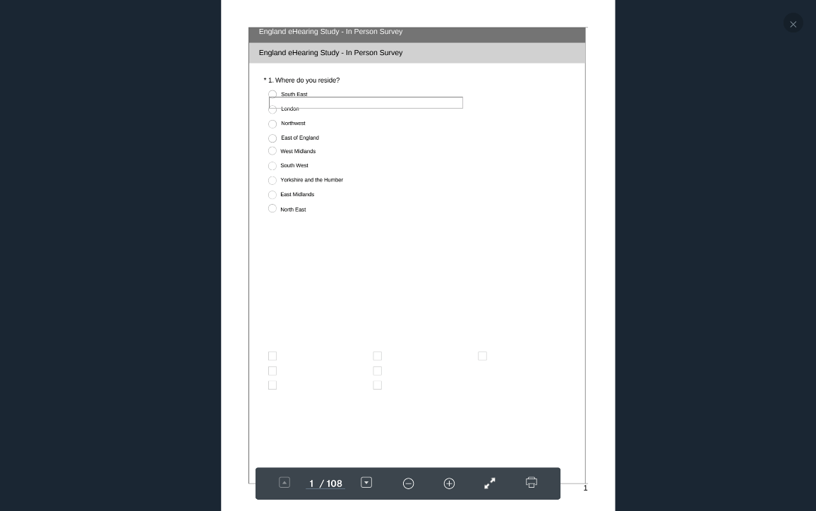

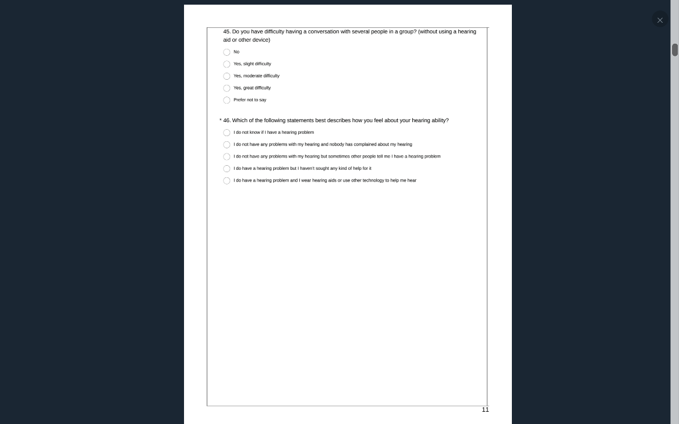

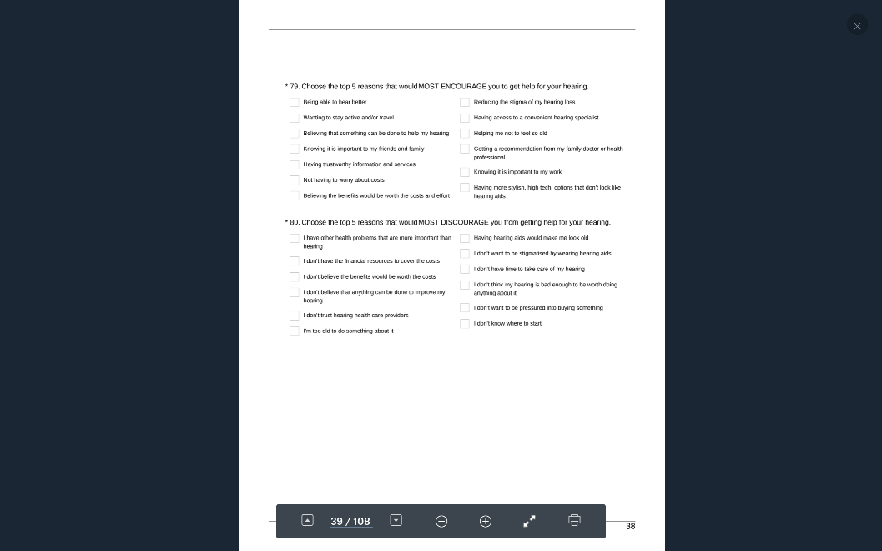

Pathway #2 1-46, 81-134

Q #46: Yes, problem. Have not sought help.

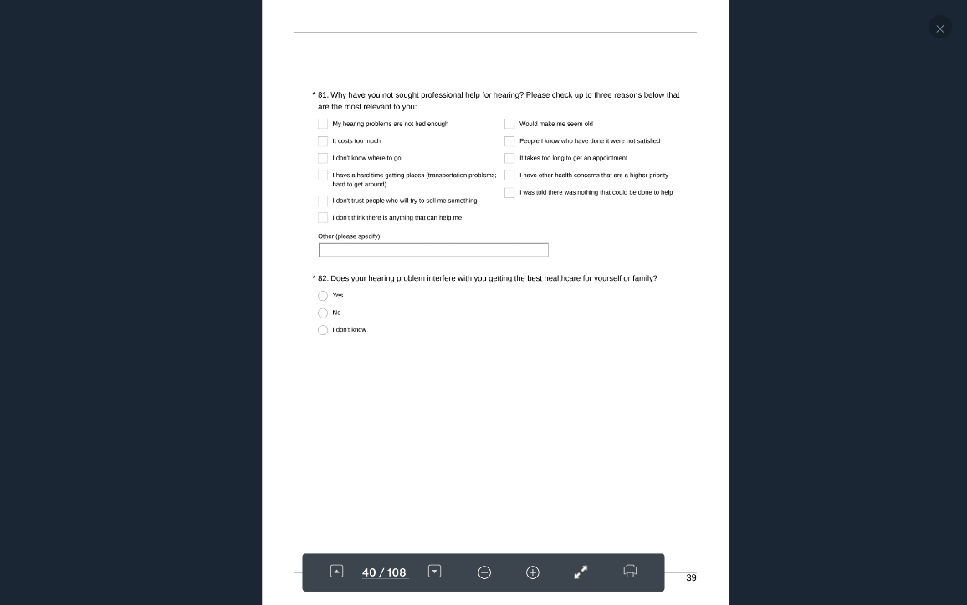

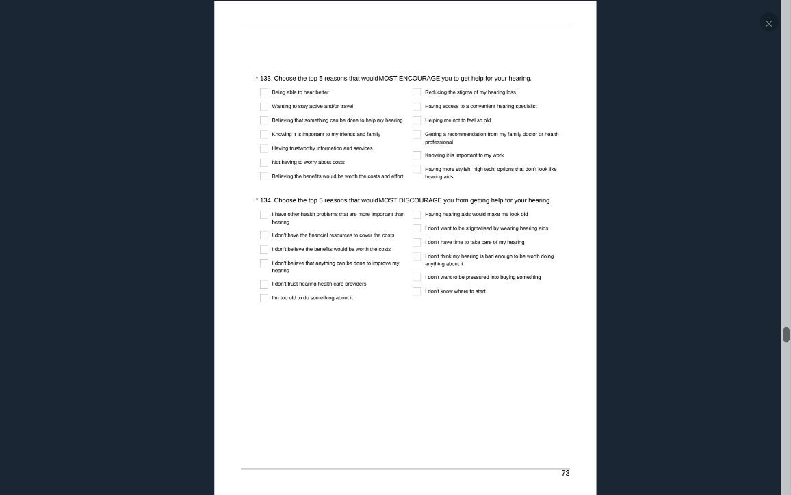

Pathway #3 1-46, 135-187

Q #46: Yes, problem. Yes, sought help.

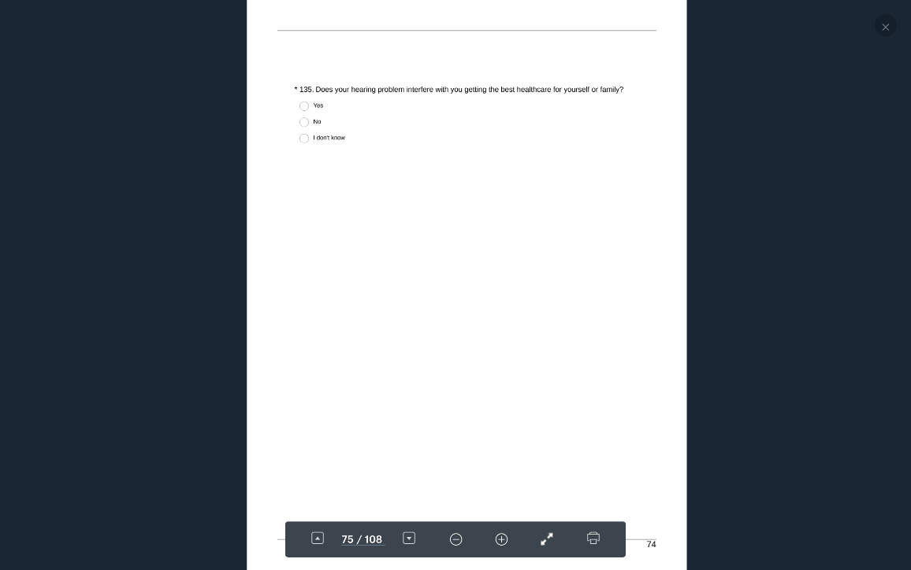

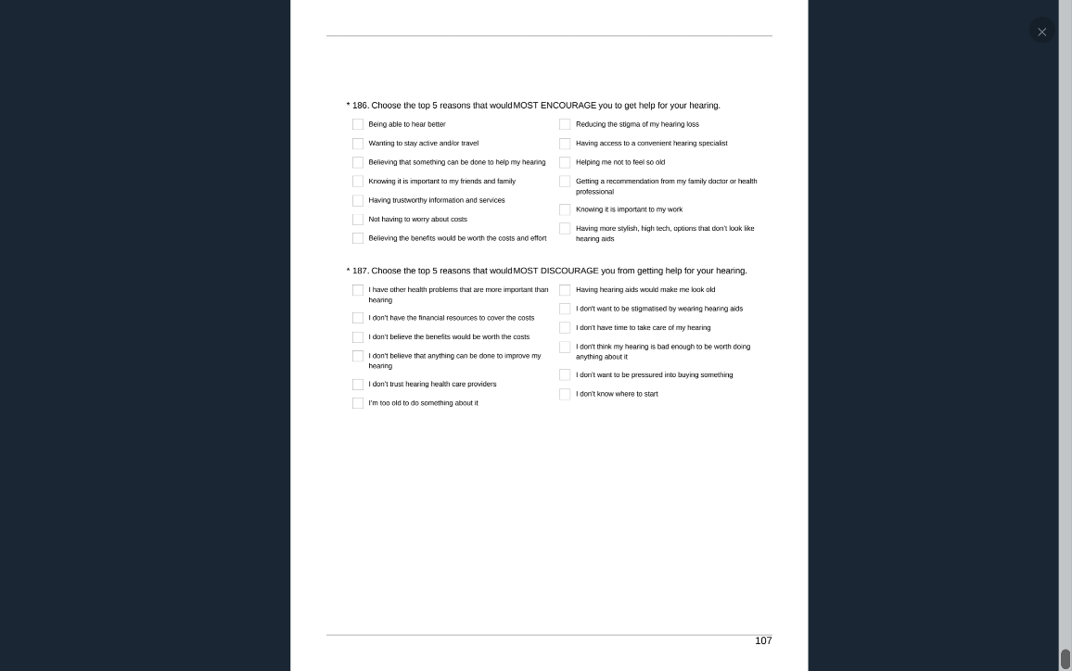

### UK National Online.pdf (not in person despite heading)

Pathway #1 1-80

Q #46: First 3 responses combined. Don’t know or don’t think they have a problem.

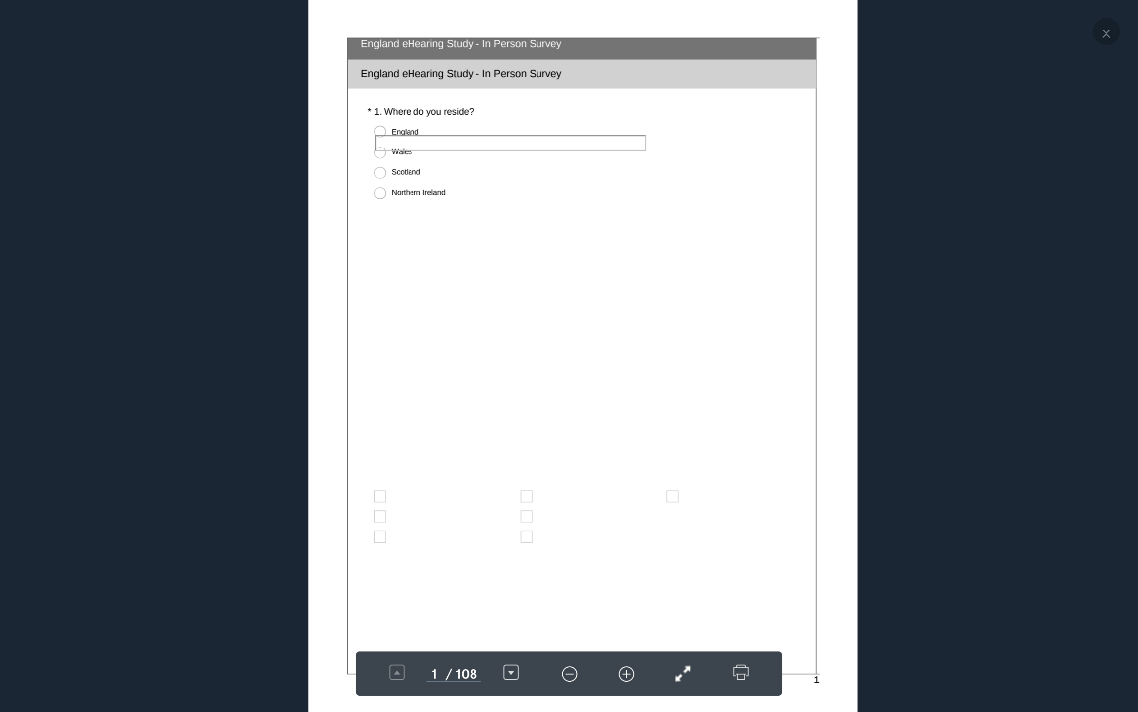

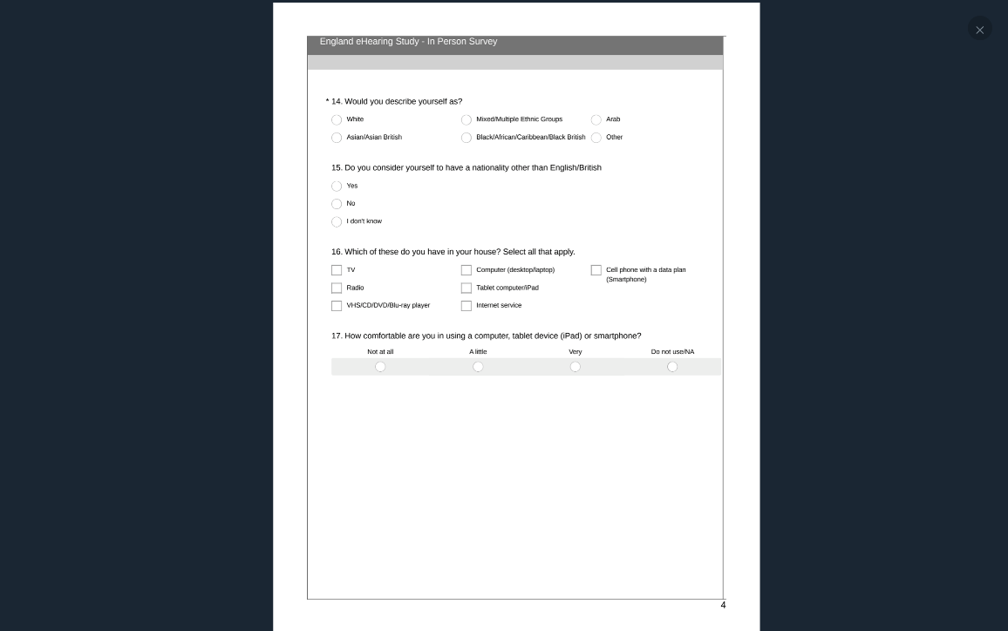

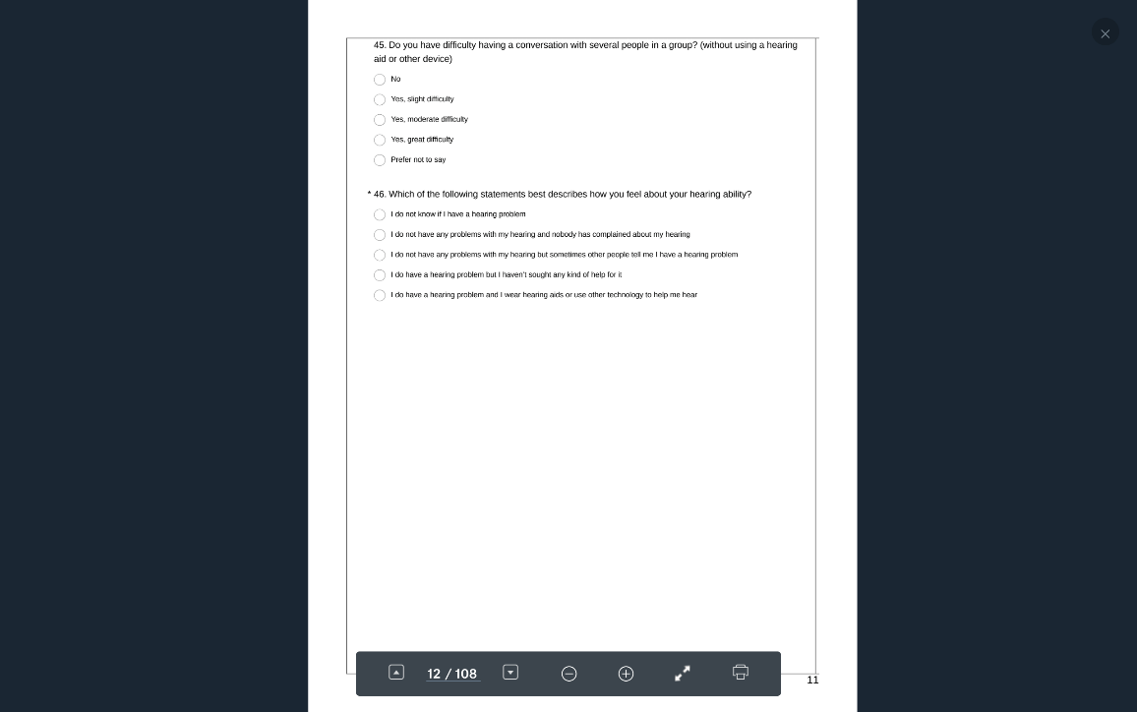

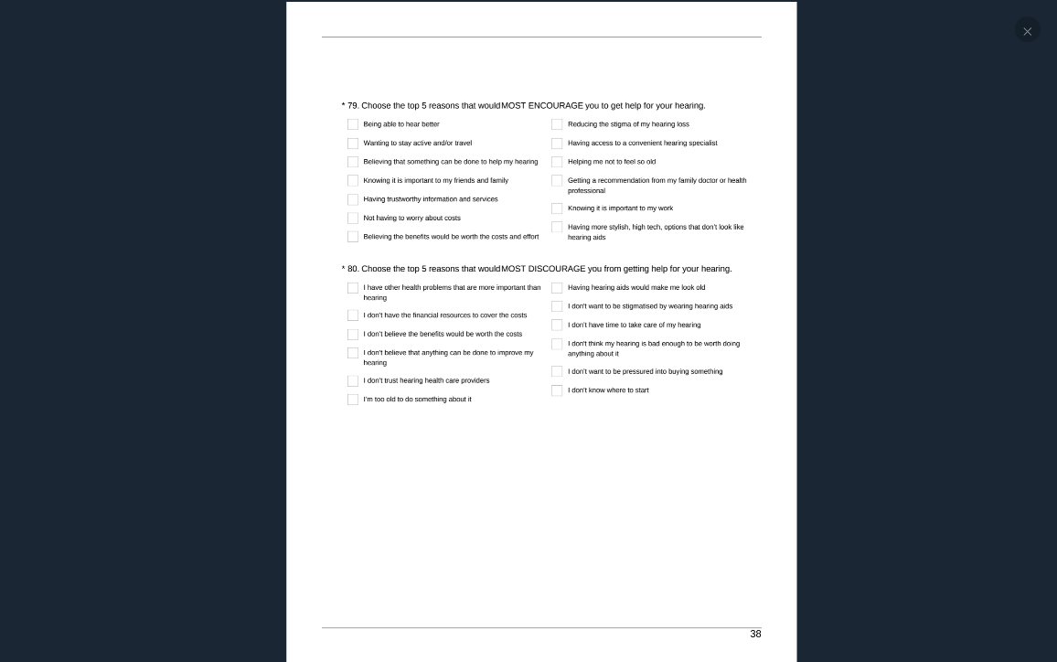

Pathway #2 1-80 81-134

Q #46: First 3 responses combined. Yes, problem. Have not sought help.

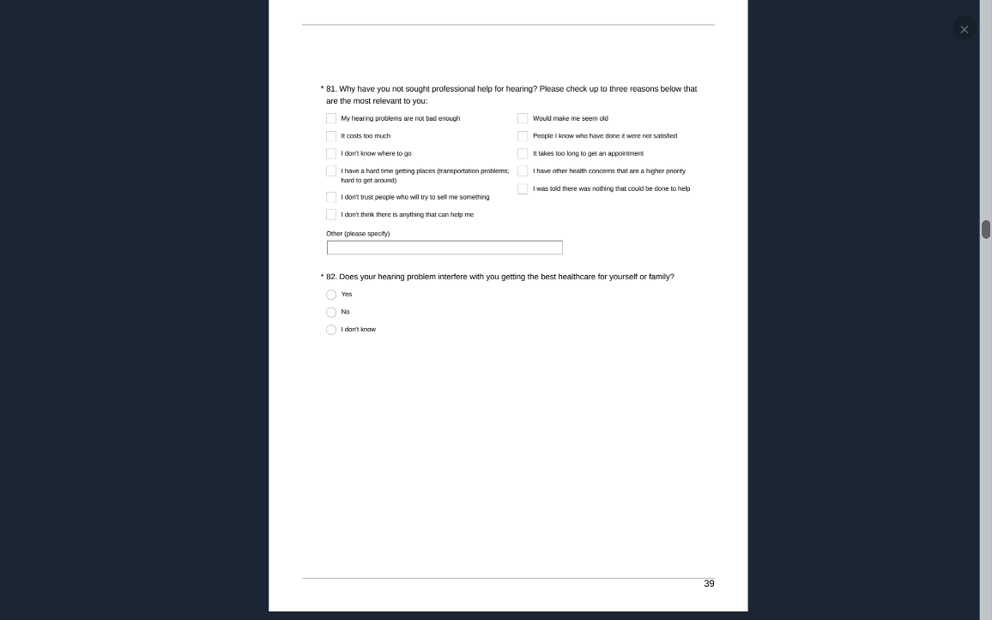

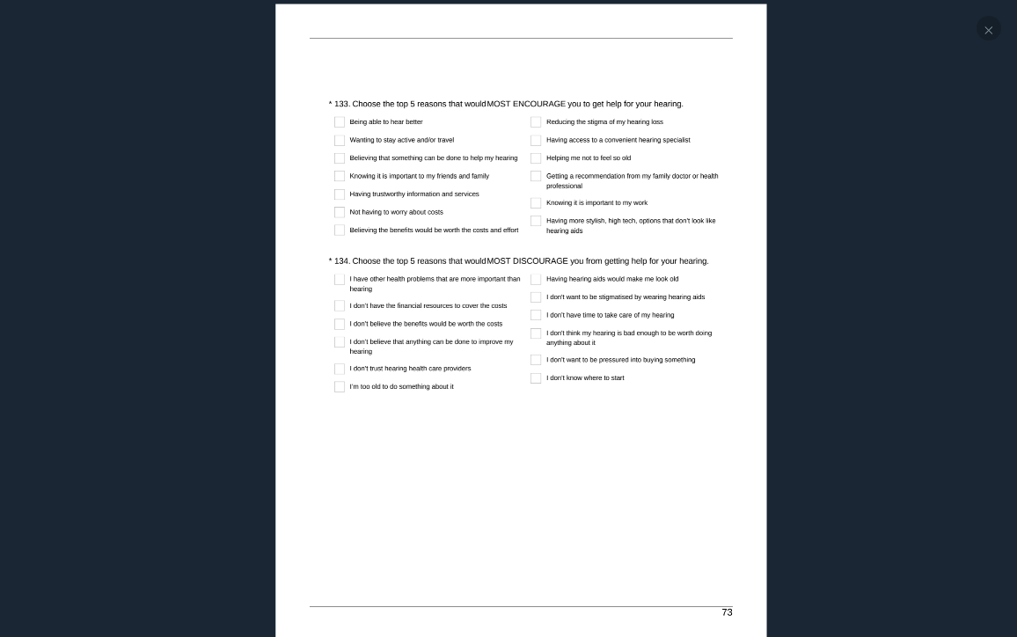

Pathway #3 1-80 135-187

Q #46: First 3 responses combined. Yes, problem. Yes, sought help.

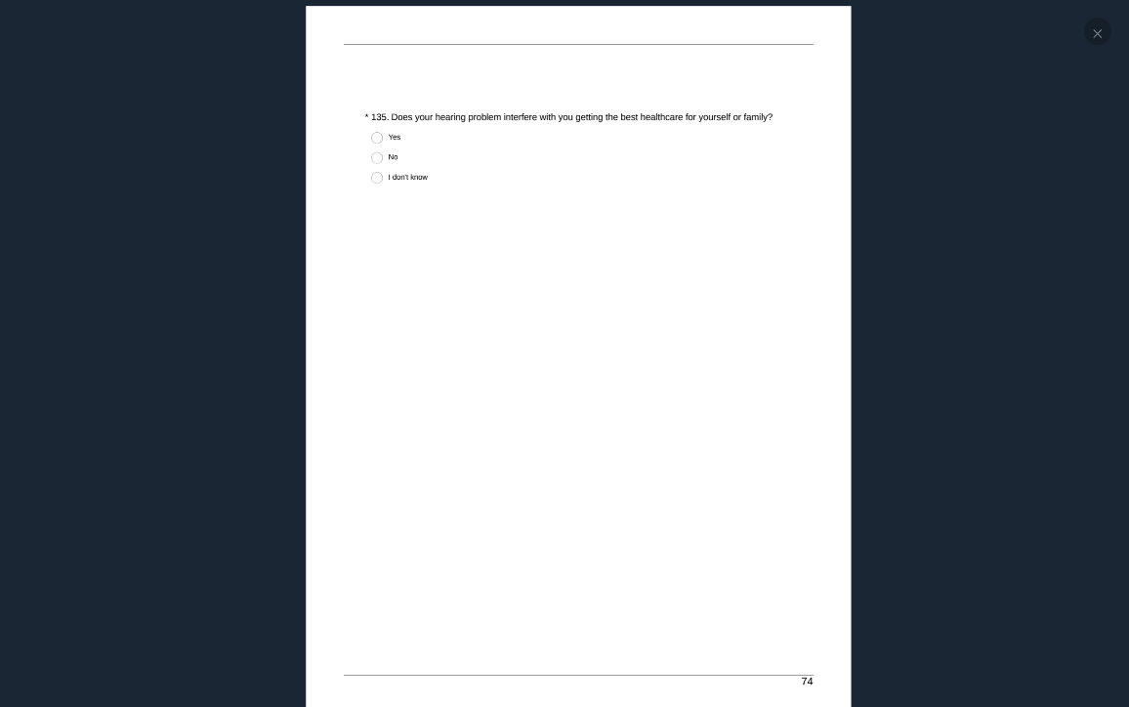

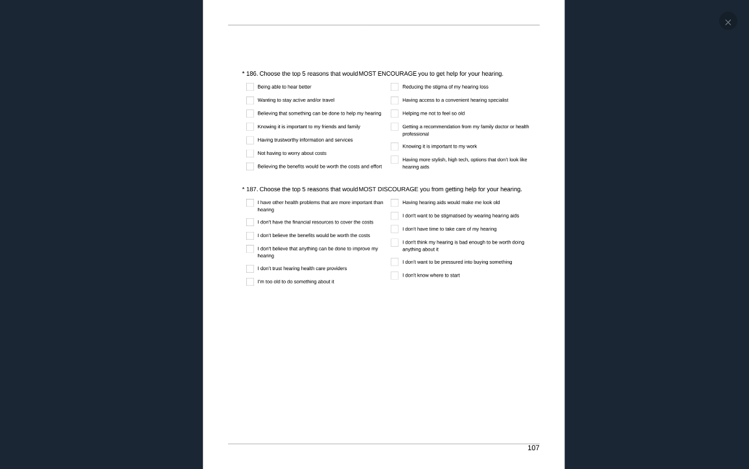

### UK London In Person.pdf

Pathway #1 1-80

Q #46: First 3 responses combined. Don’t know or don’t think they have a problem.

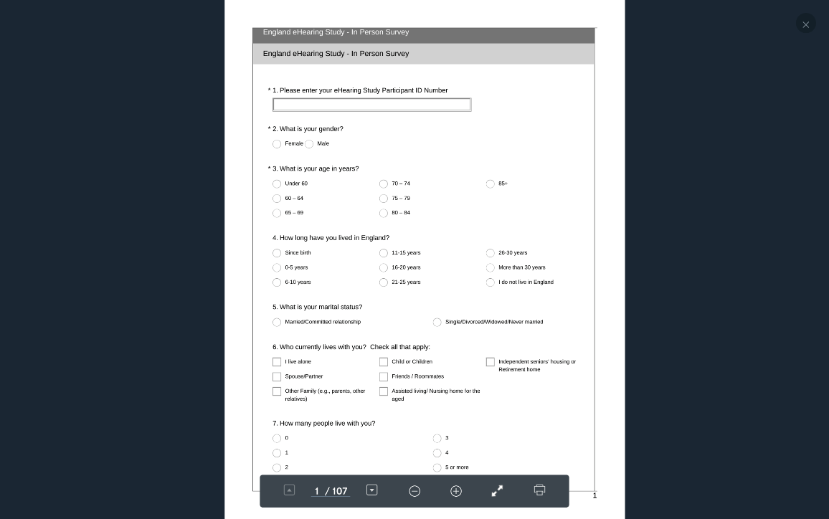

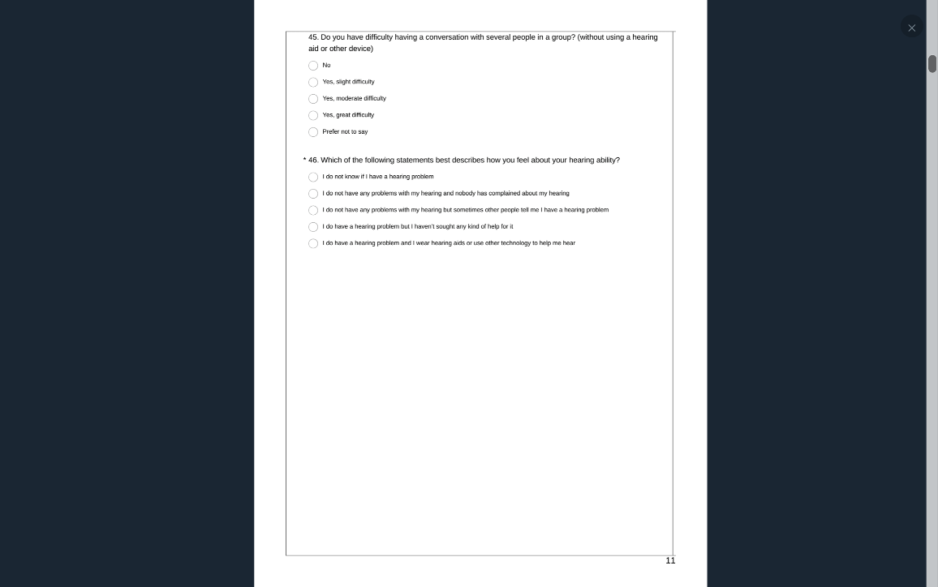

Pathway #2 1-46, 81-134

Q #46: Yes, problem. Have not sought help.

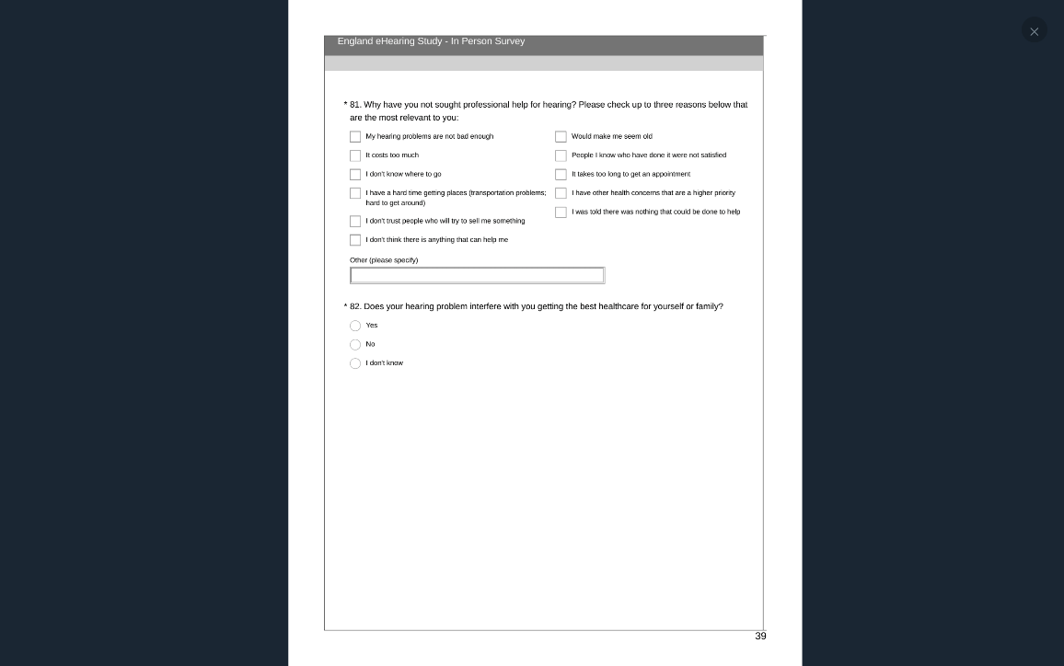

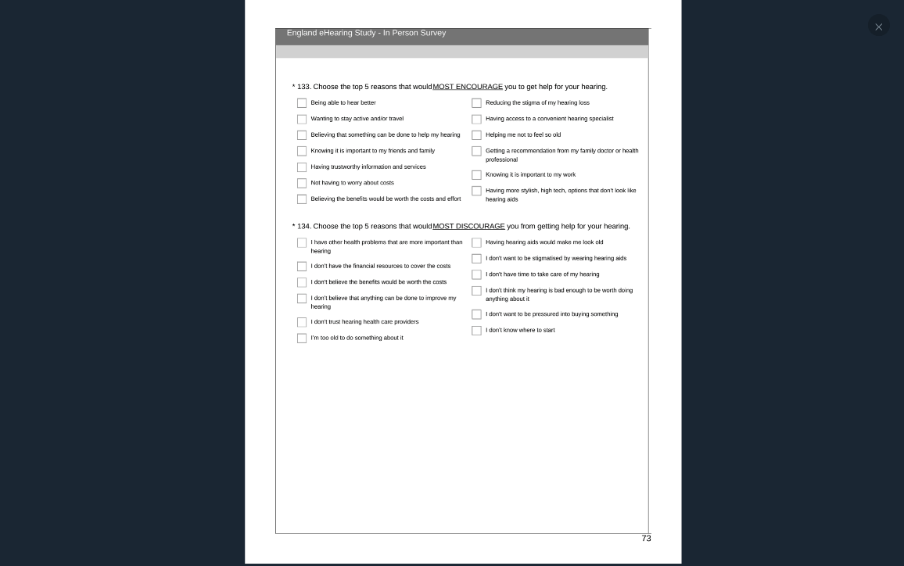

Pathway #3 1-80 135-187

Q #46: First 3 responses combined. Yes, problem. Yes, sought help.

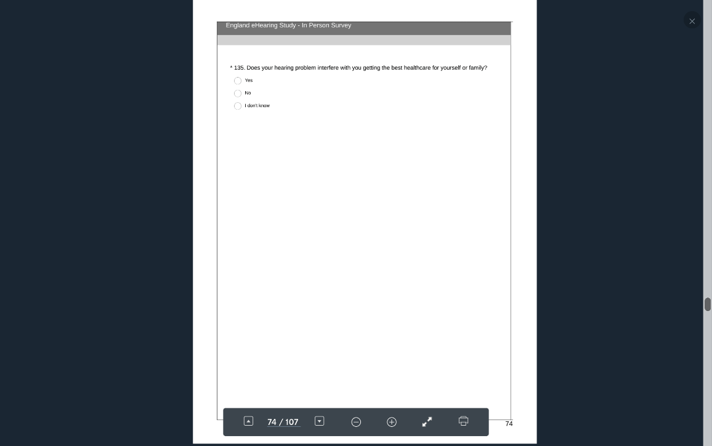

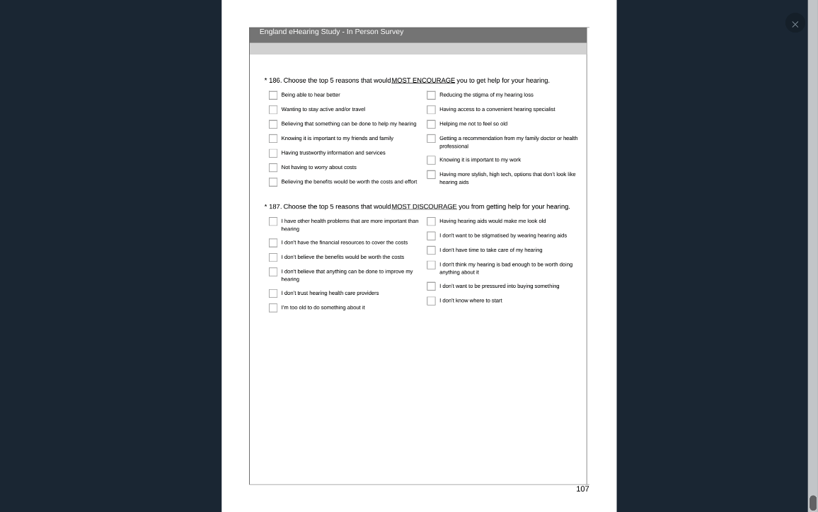

### UK London Online.pdf (not in person despite heading)

Pathway #1 1-80

Q#46 Don’t know or don’t think they have a problem.

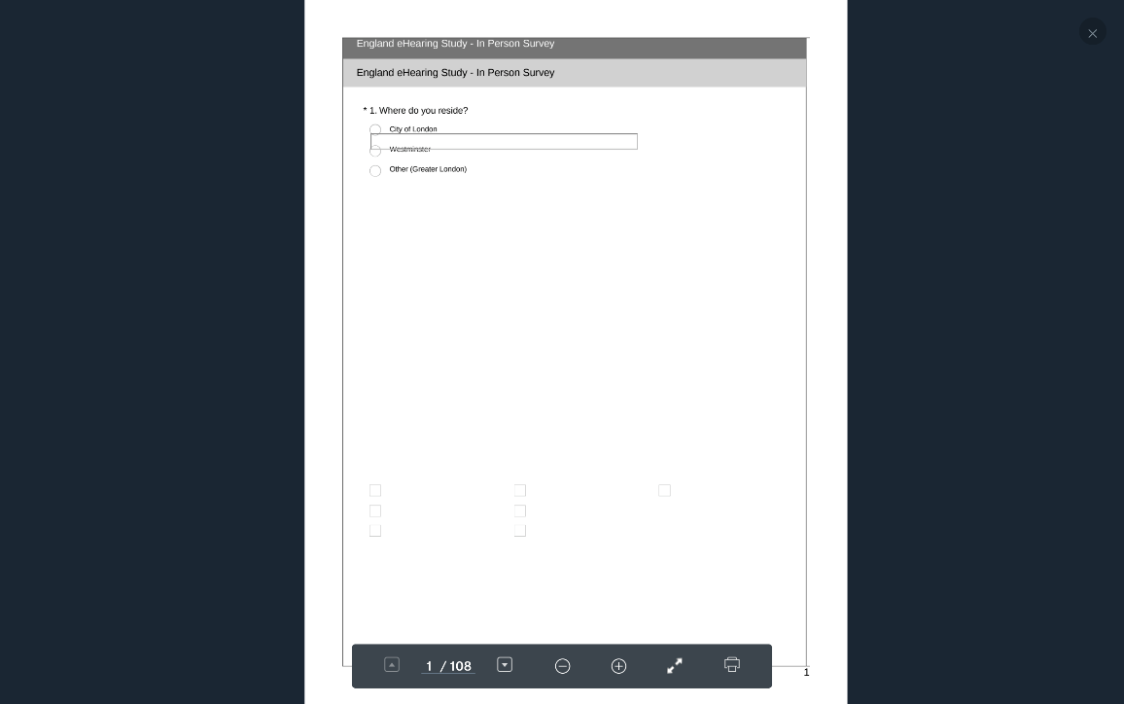



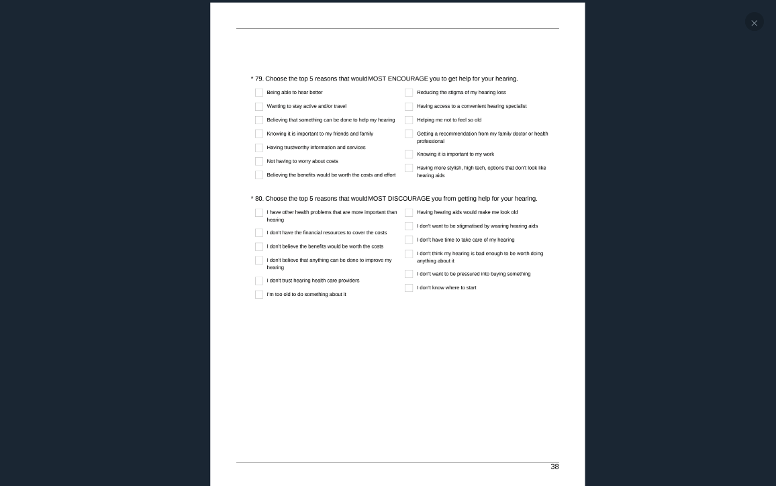

Pathway #2 1-80 81- 134

Q #46: Yes, problem. Have not sought help.

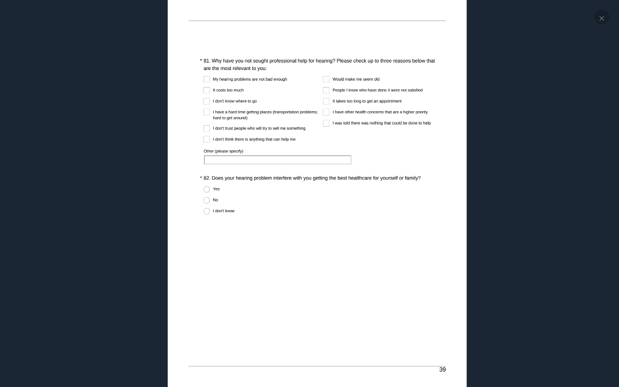

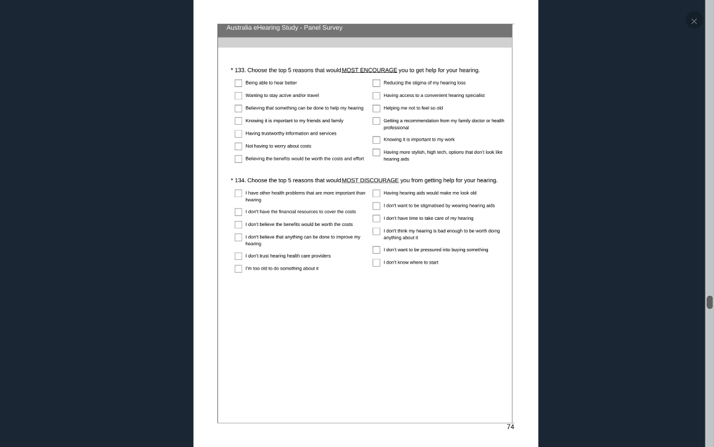

Pathway #3 1-80 135- 187

Q #46: Yes, problem. Yes, sought help.



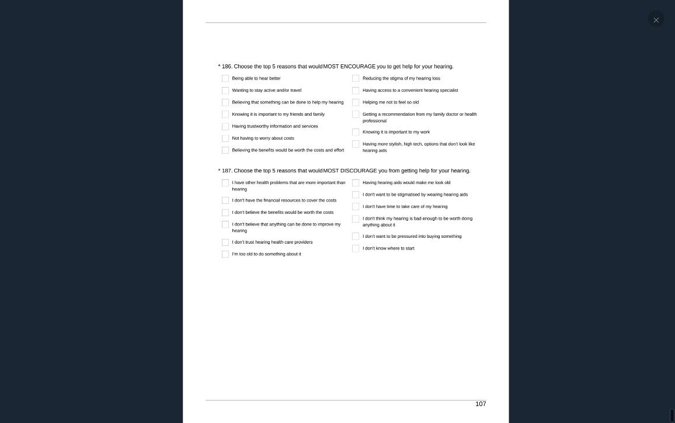

## SURVEY STRUCTURE Australia

### Australia National Including NSW Online

Pathway #1 1-80

Q #46: First 3 responses combined. Don’t know or don’t think they have a problem.

1.Where do you reside? New South Wales, Victoria, Queensland, South Australia, Western Australia, Tasmania, Northern Territory, Australian Capital Territory

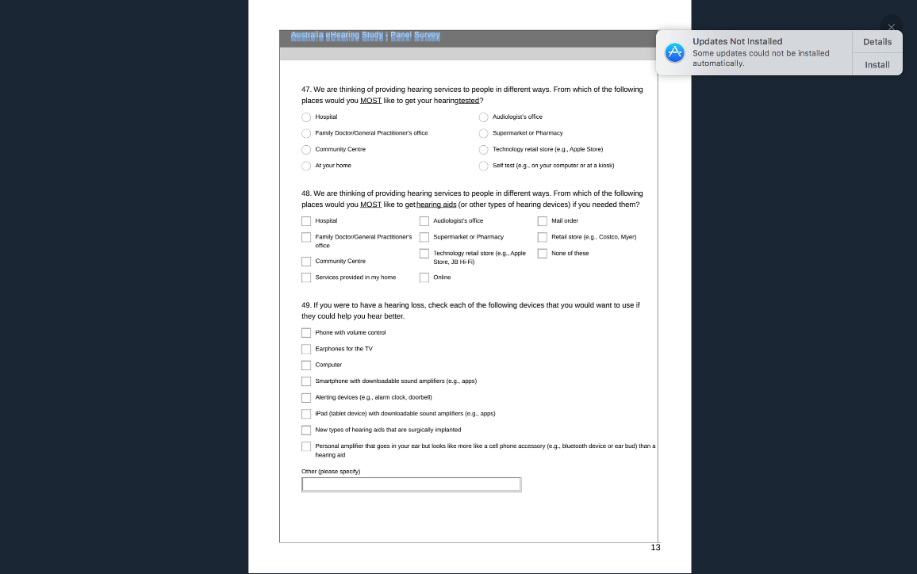

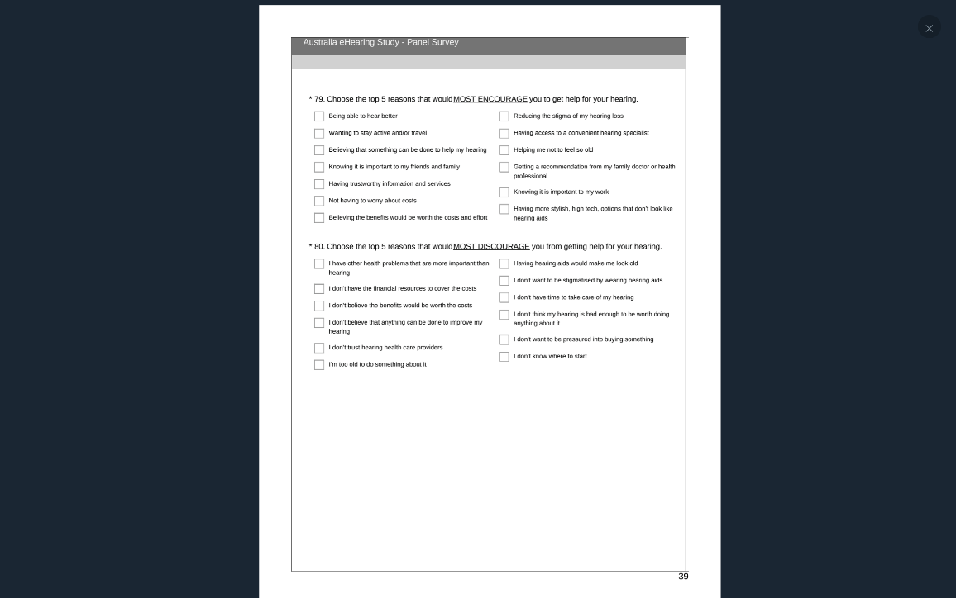

Pathway #2 1-46, 81-134

Q #46: Yes, problem. Have not sought help.

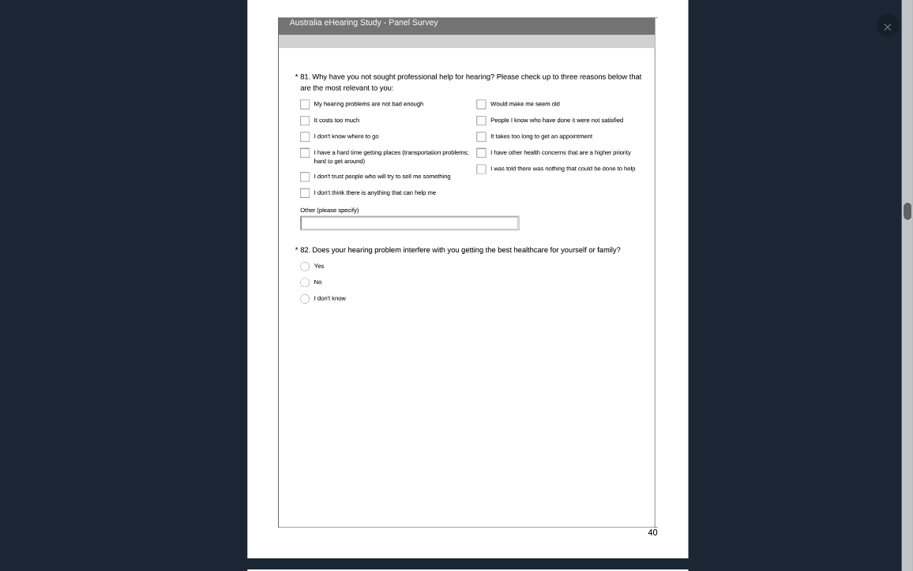



Pathway #3 1-46, 135-187

Q #46: Yes, problem. Yes, sought help.

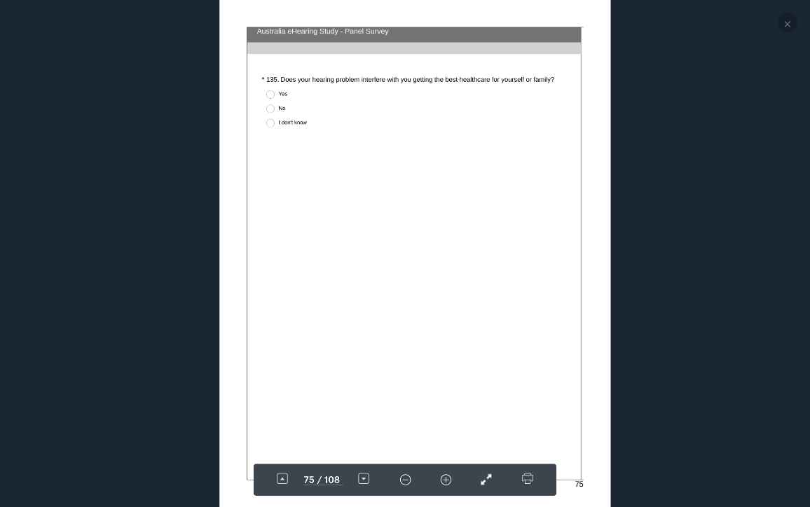

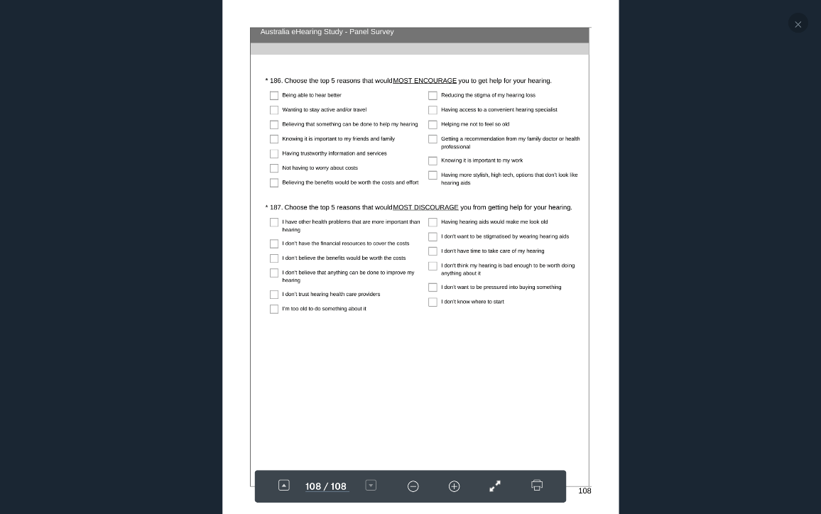

### Australia NSW Online (NSW ONLY- Includes Sydney)

Pathway #1 1-80

Q #46: First 3 responses combined. Don’t know or don’t think they have a problem.

*1. Where do you reside? Sydney or suburbs, New Castle-Maitland, Central Coast, Wollongong, All other.

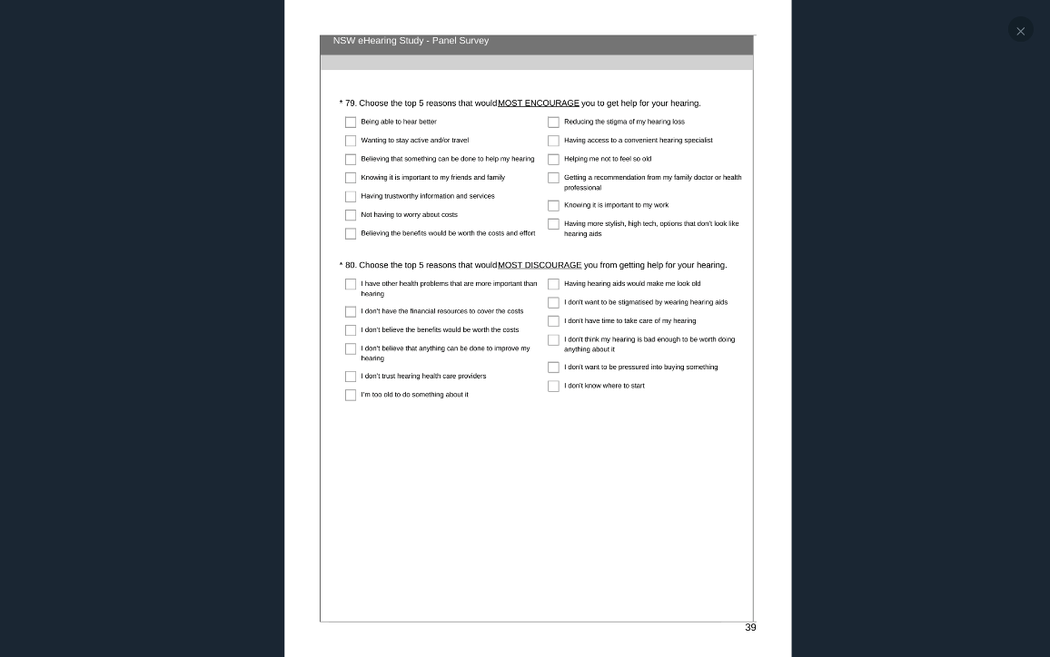

Pathway #2 1-46, 81-134

Q #46: Yes, problem. Have not sought help.

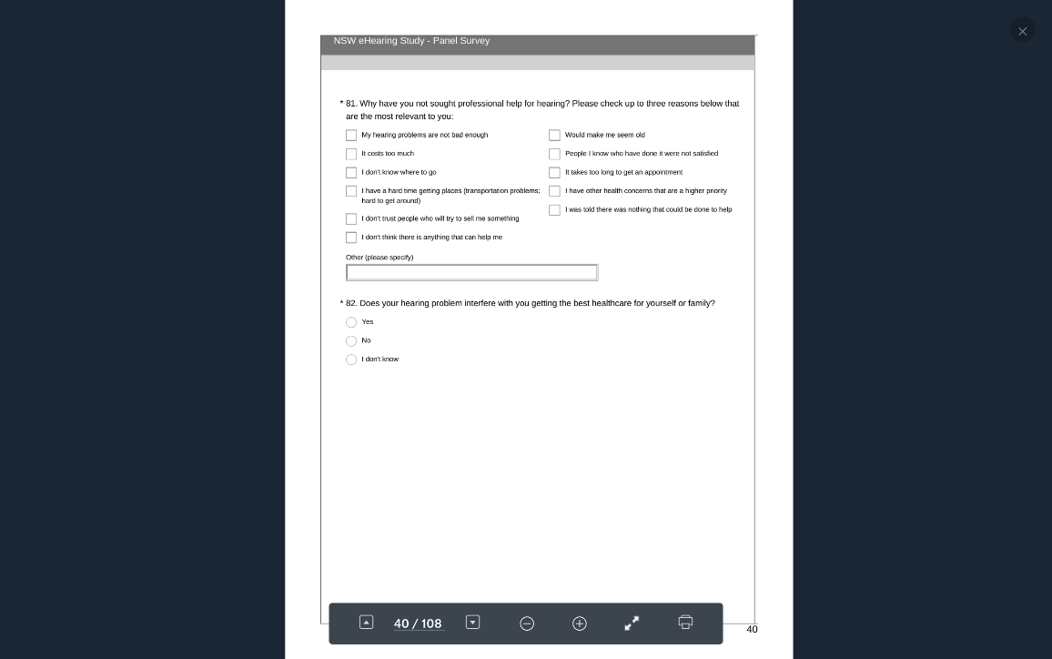

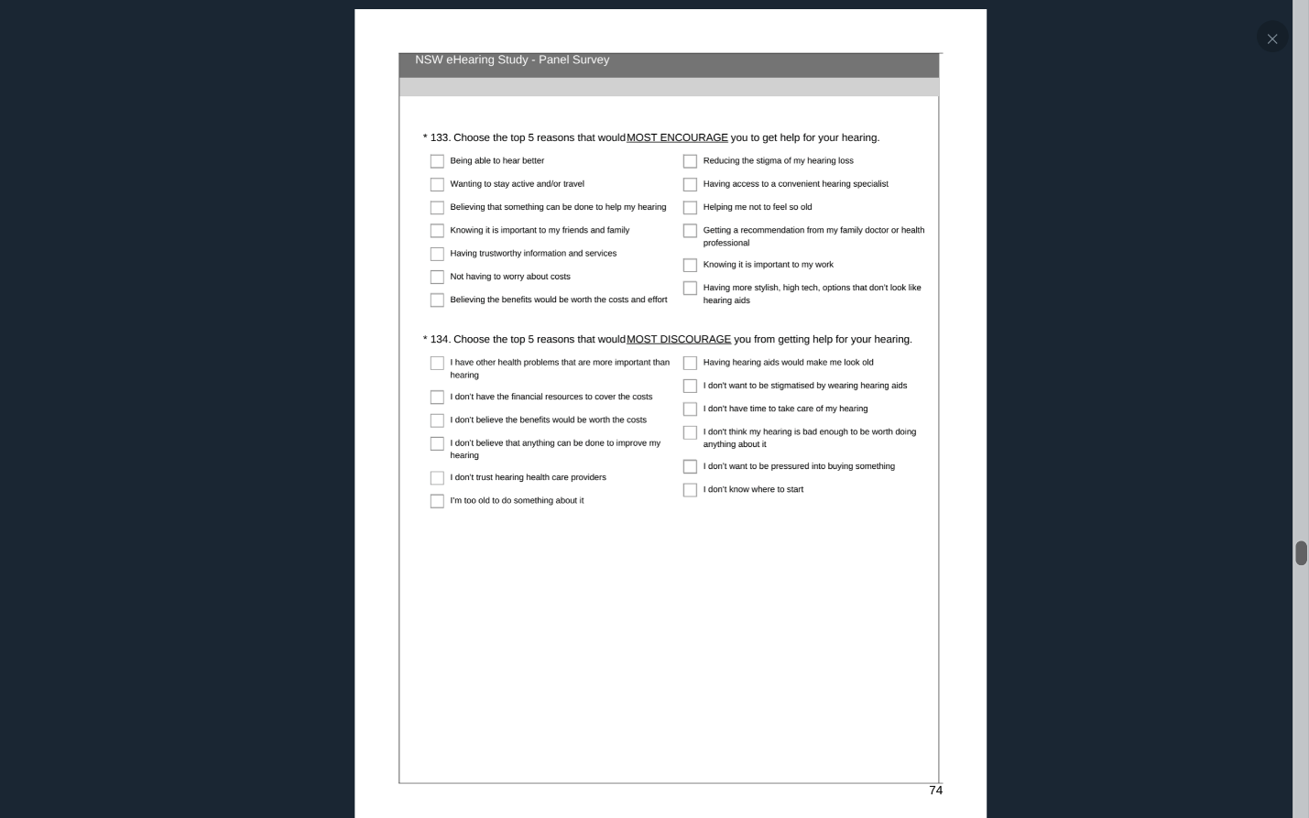

Pathway #3 1-46, 135-187

Q #46: Yes, problem. Yes, sought help.

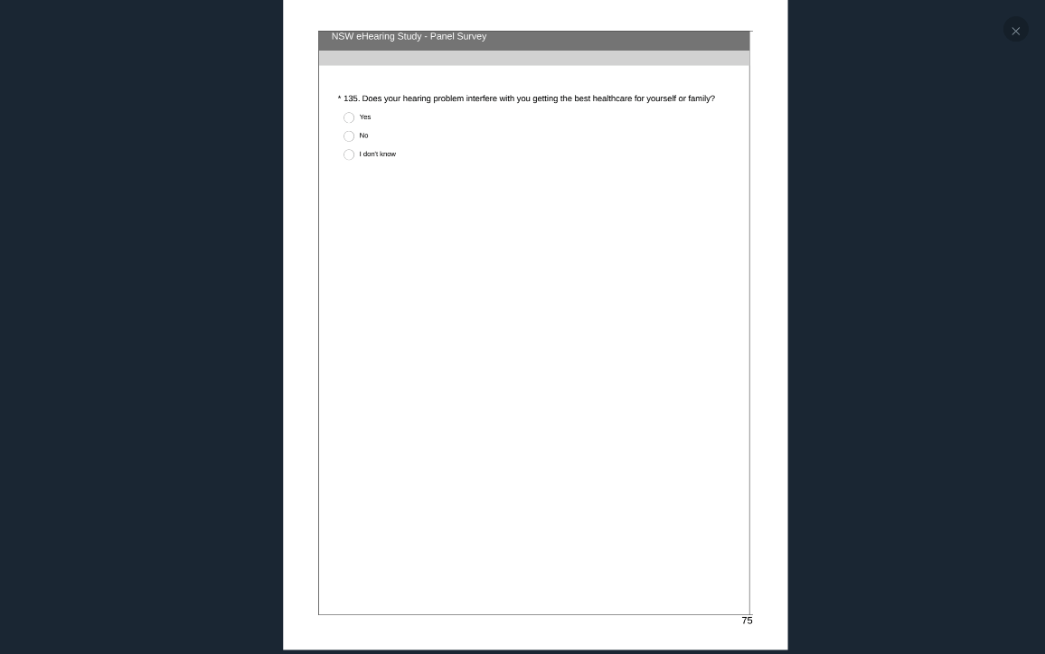

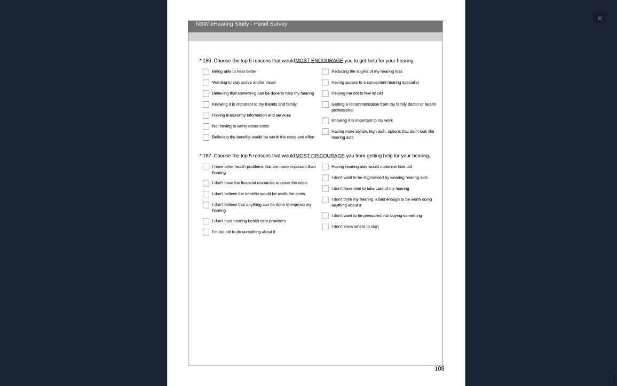

### Australia eHearing Study-InPerson Survey (Sydney only)

Pathway #1 1-80

Q #46: First 3 responses combined. Don’t know or don’t think they have a problem.

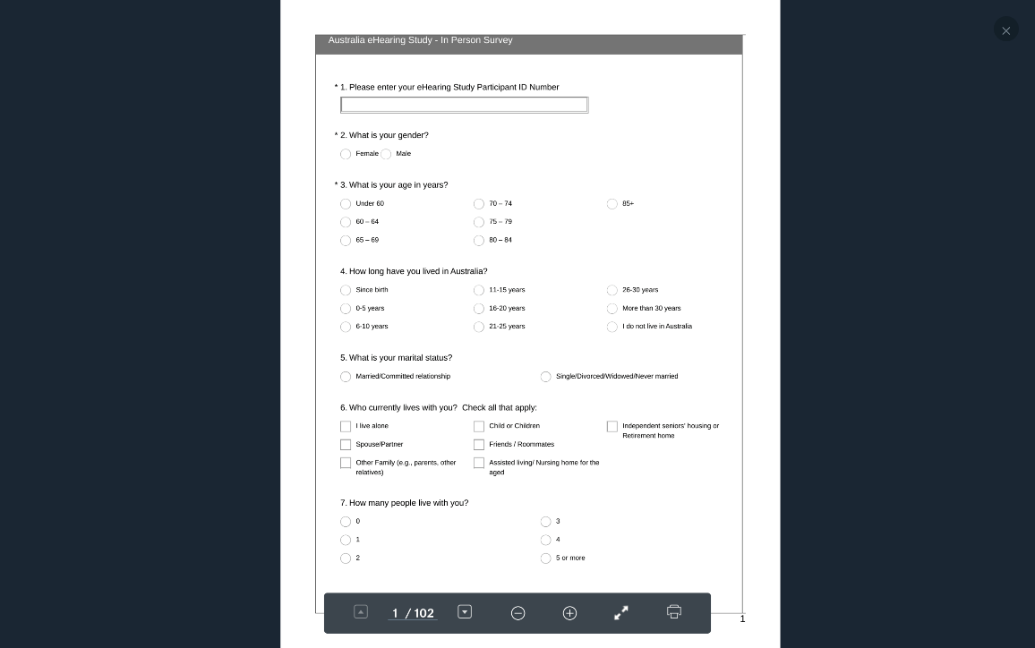

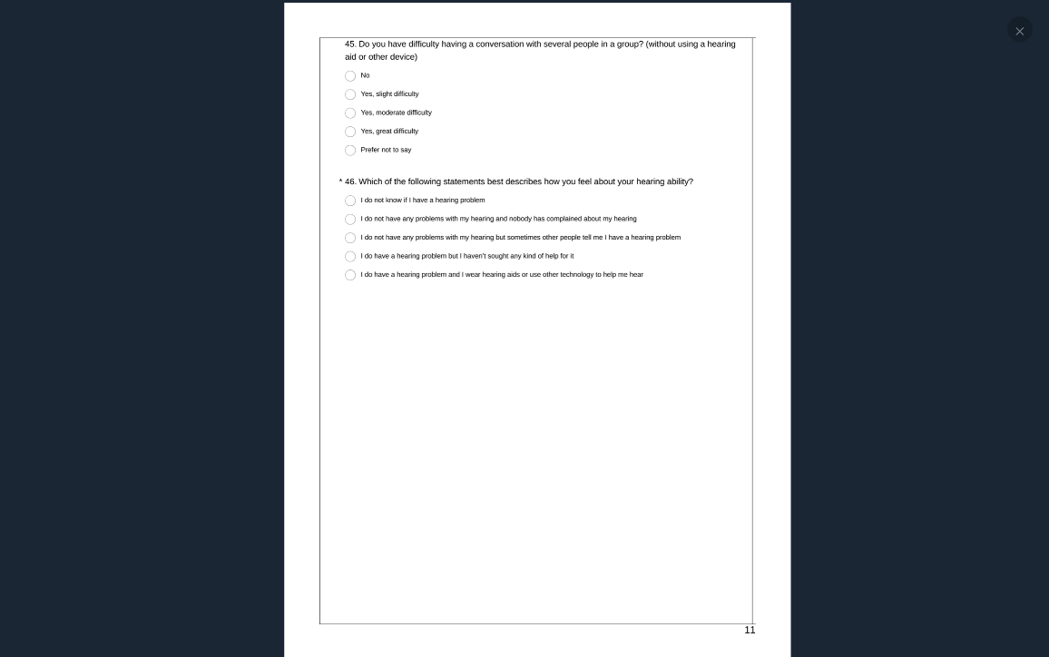

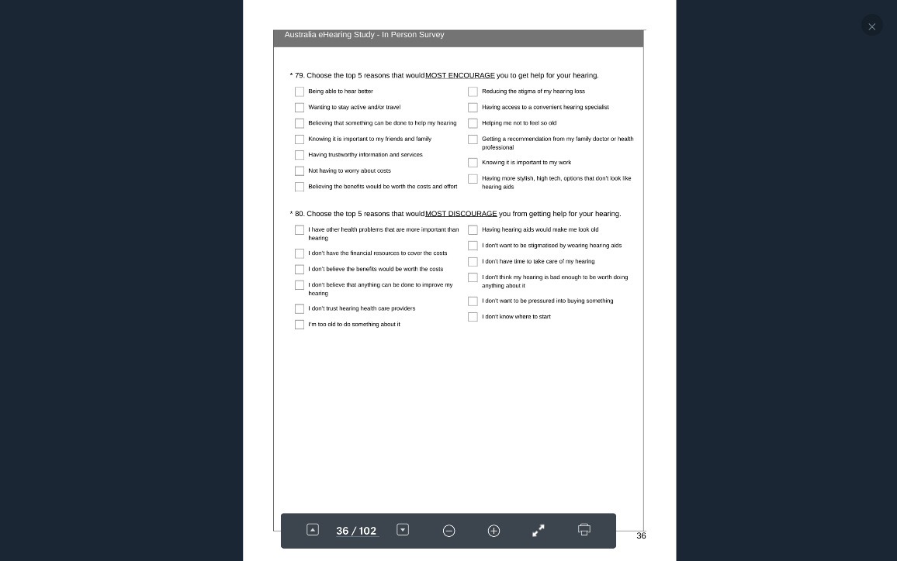

Pathway #2 1-46 81-134

Q #46: Yes, problem. Have not sought help.

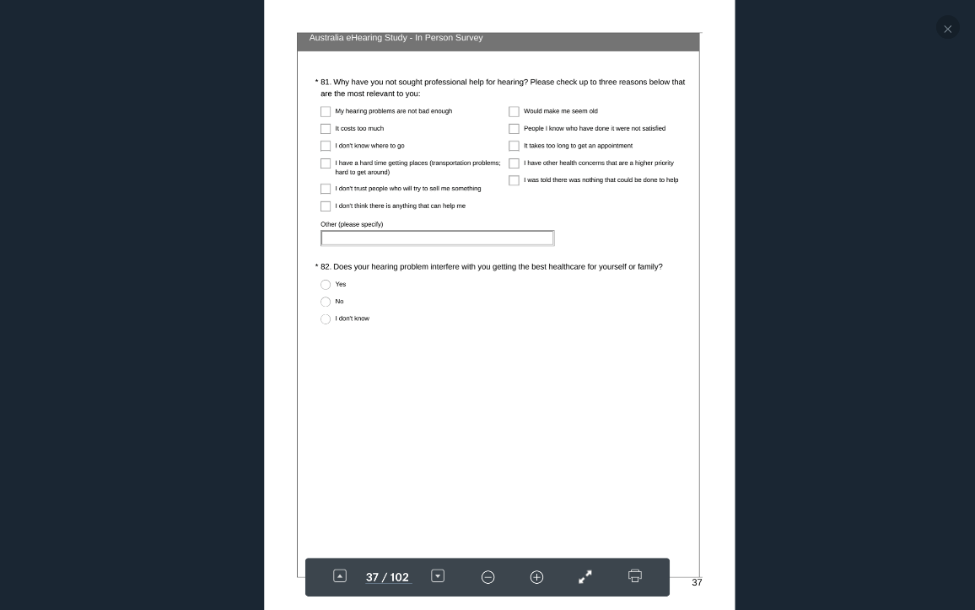

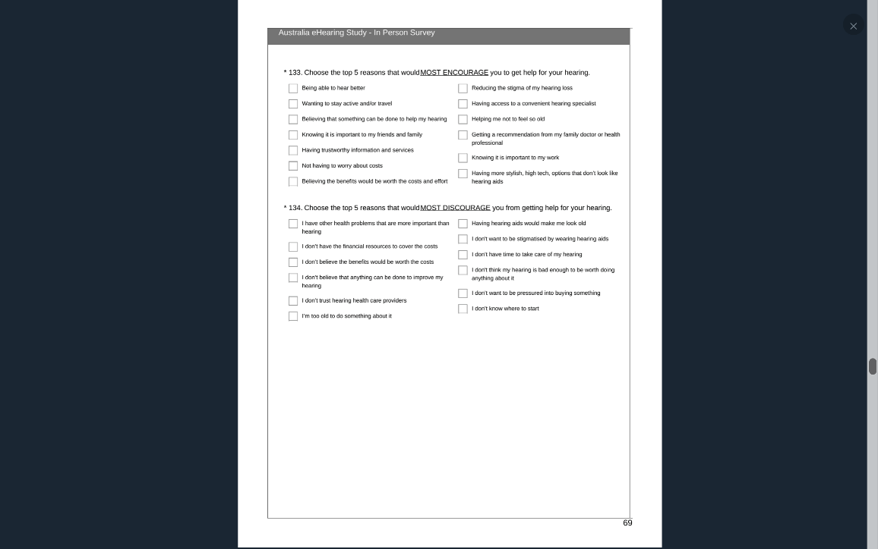

Pathway #3 1-46 135-187

Q #46: Yes, problem. Yes, sought help.

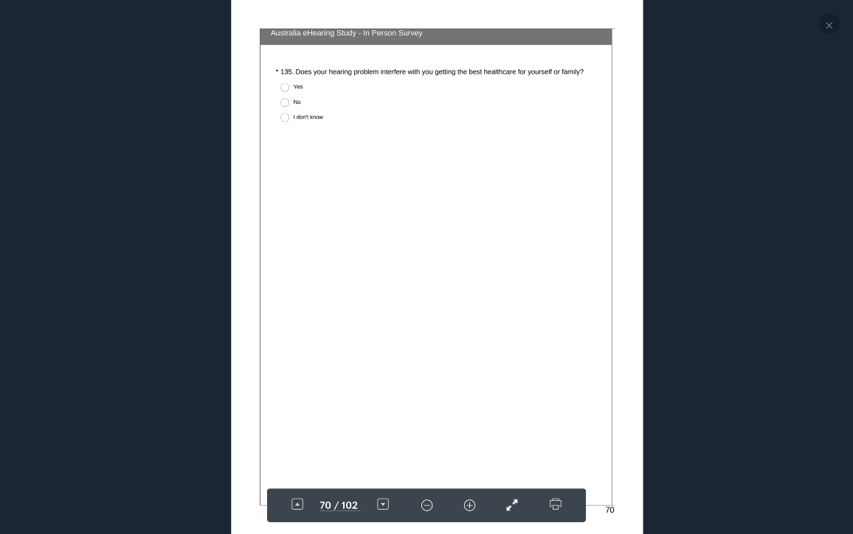

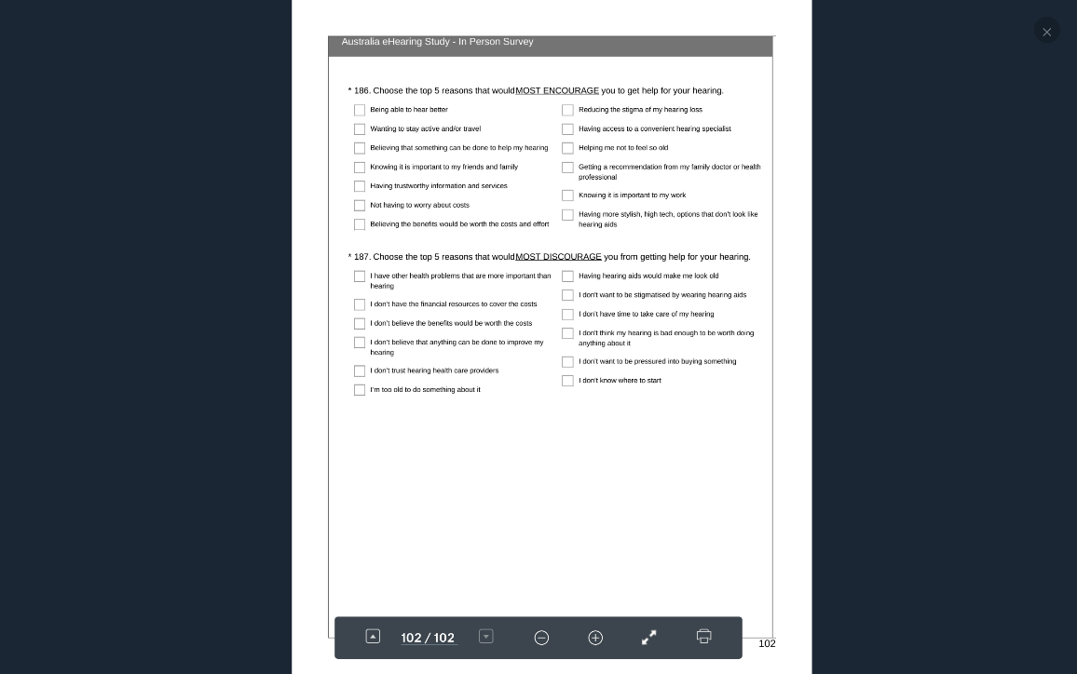

## SURVEY STRUCTURE CANADA

**SURVEY STRUCTURE**

### Canada National Minus Ontario Online (doesn’t include Ontario)

Pathway #1 1-80

Q #46: First 3 responses combined. Don’t know or don’t think they have a problem.

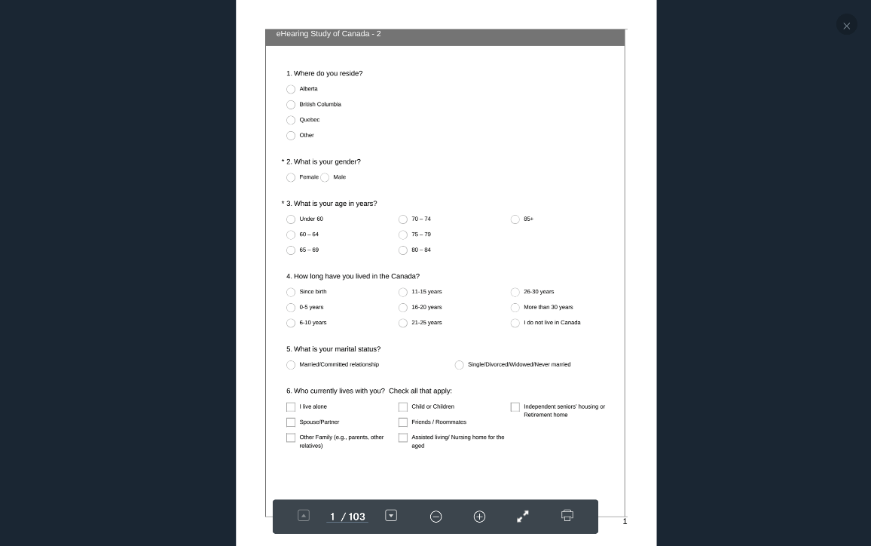

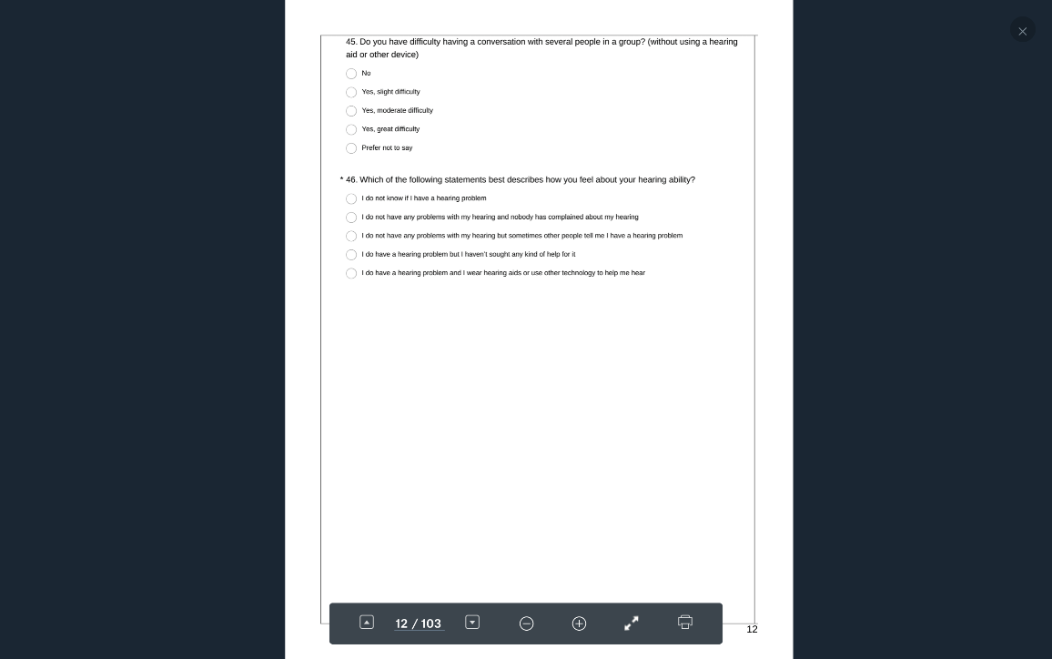

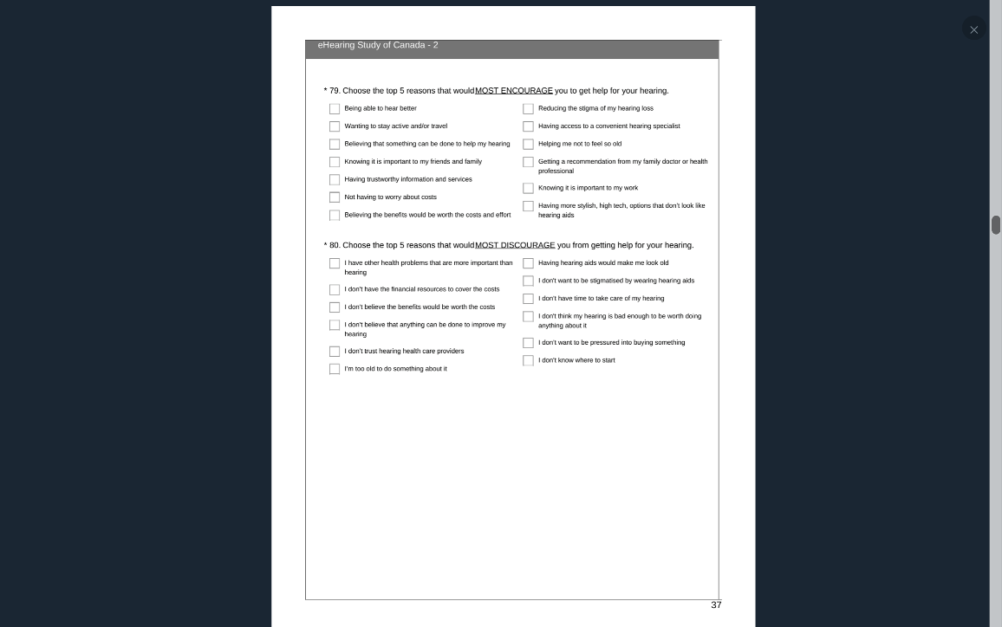

Pathway #2 1-46, 81-134

Q #46: Yes, problem. Have not sought help.

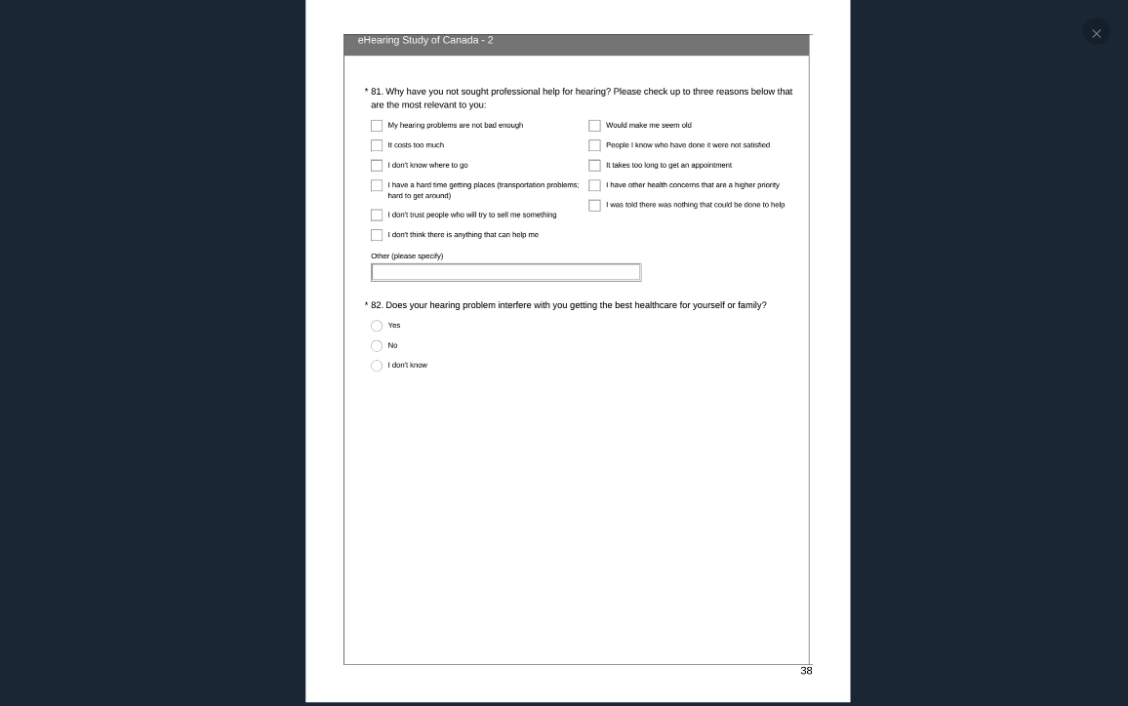

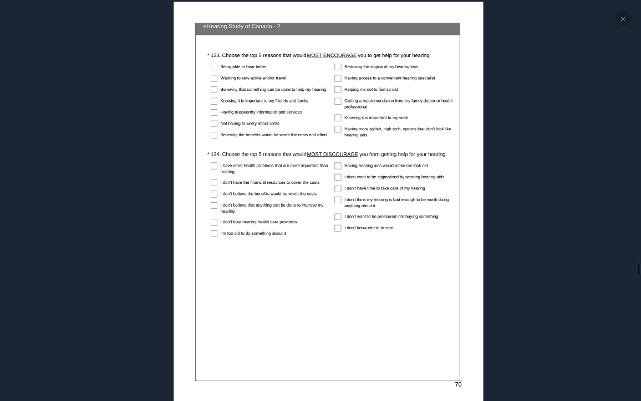

Pathway #3 1-46, 135-187

Q #46: Yes, problem. Yes, sought help.

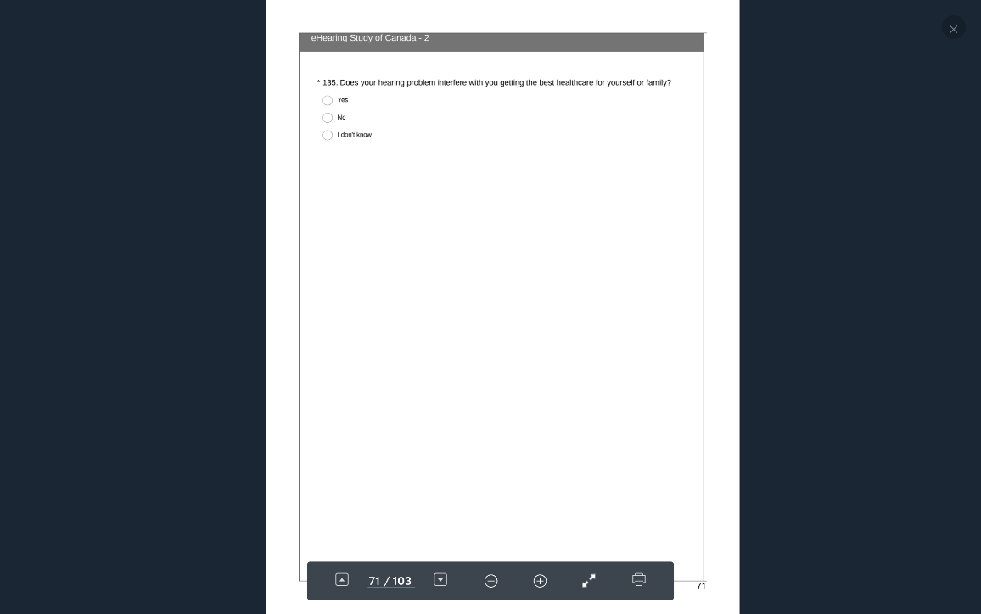

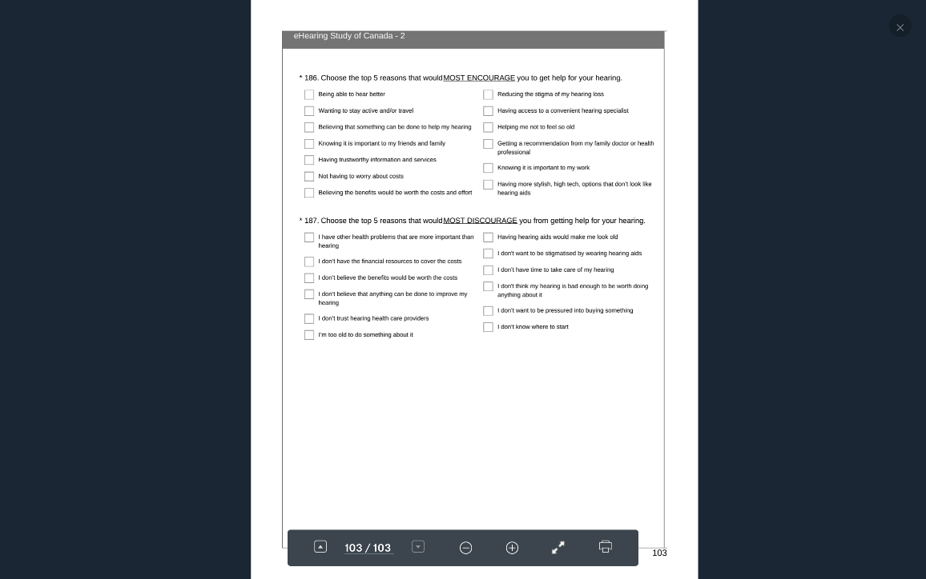

### Canada Ontario Online (Includes Toronto)

Pathway #1 1-79

Q #45: First 3 responses combined. Don’t know or don’t think they have a problem.

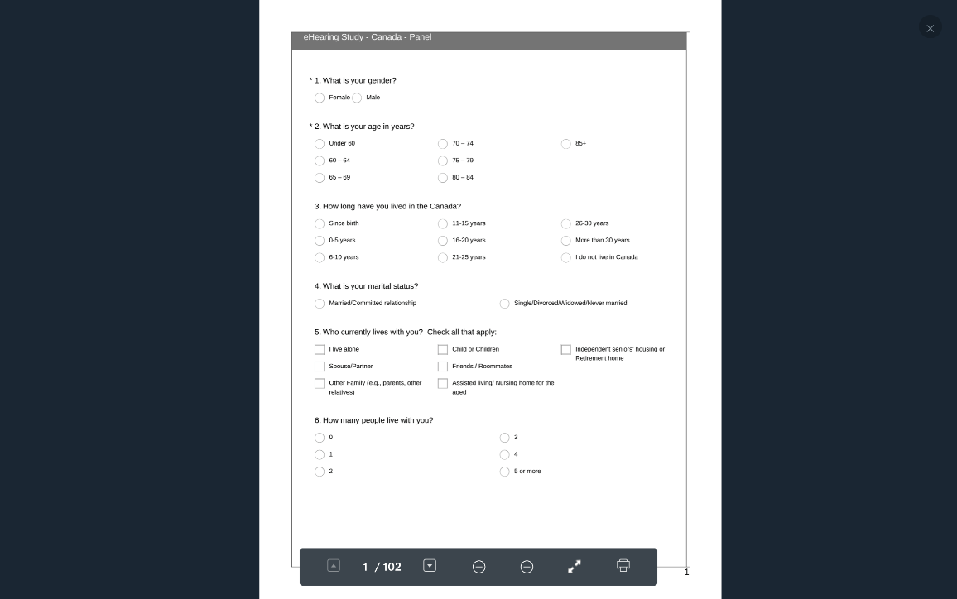

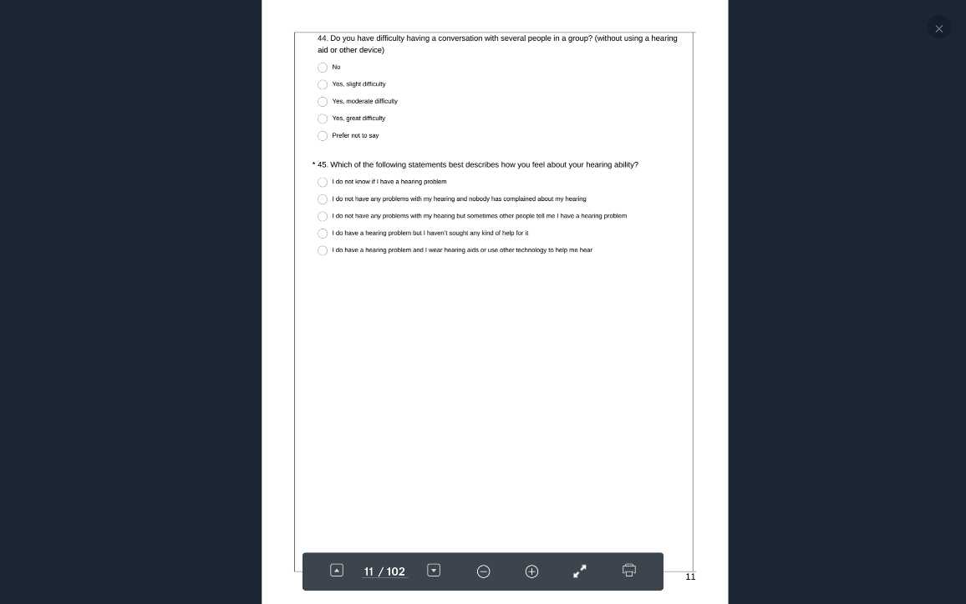

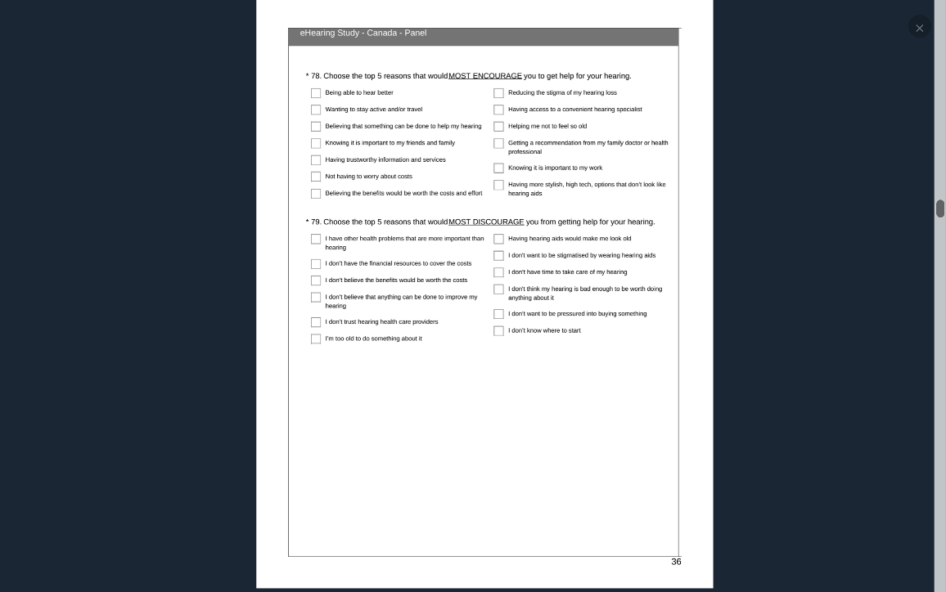

Pathway #2 1-45, 80-133

Q #45: Yes, problem. Have not sought help.

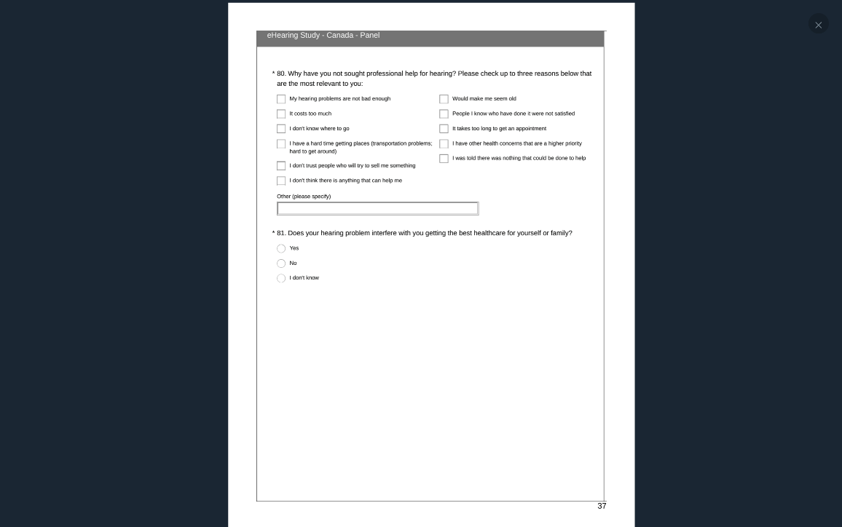

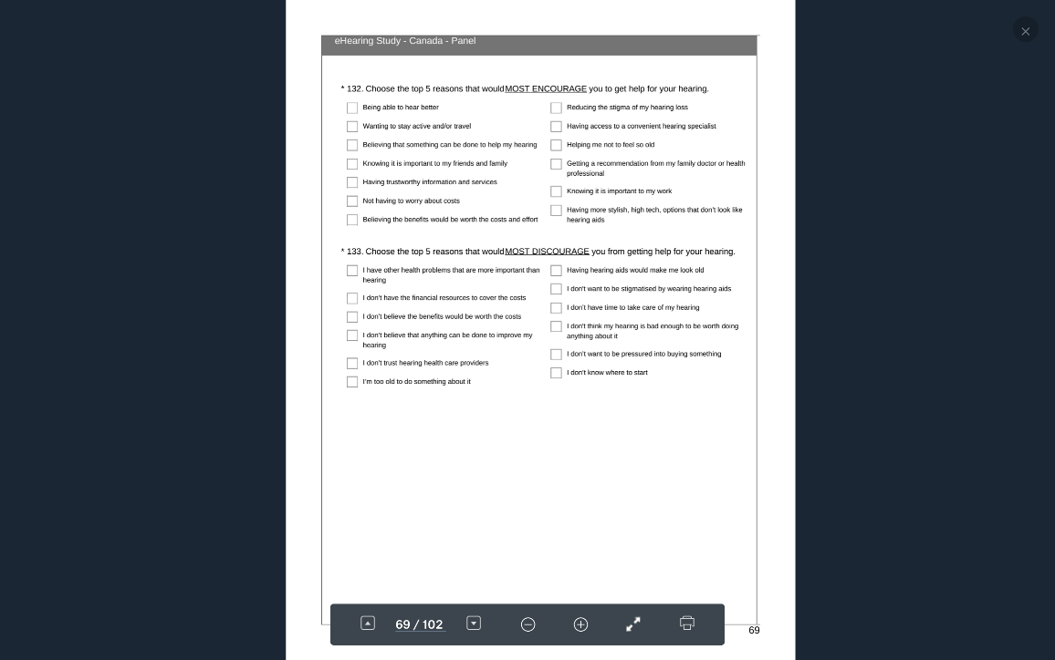

Pathway #3 1-45, 134-187

Q #45: Yes, problem. Yes, sought help.

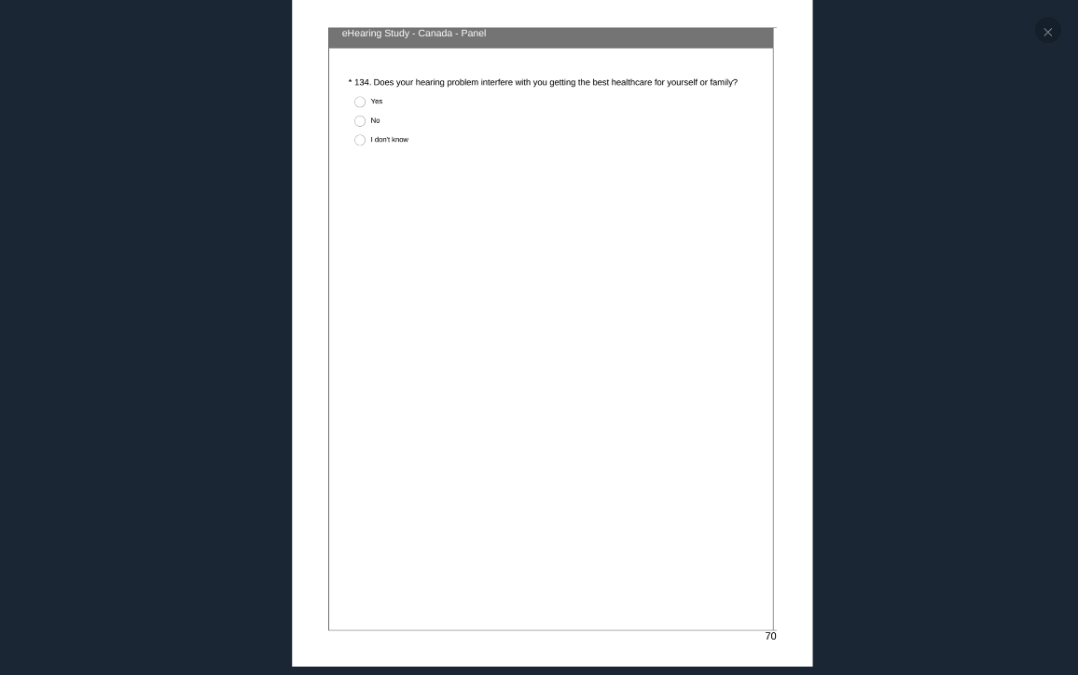

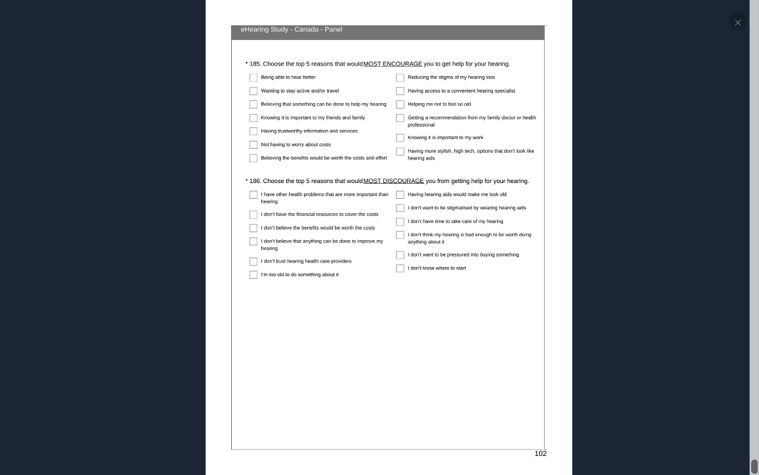

### Canada-InPerson Survey (Toronto/Mississauga only)

Pathway #1 1-80

Q #46: First 3 responses combined. Don’t know or don’t think they have a problem.

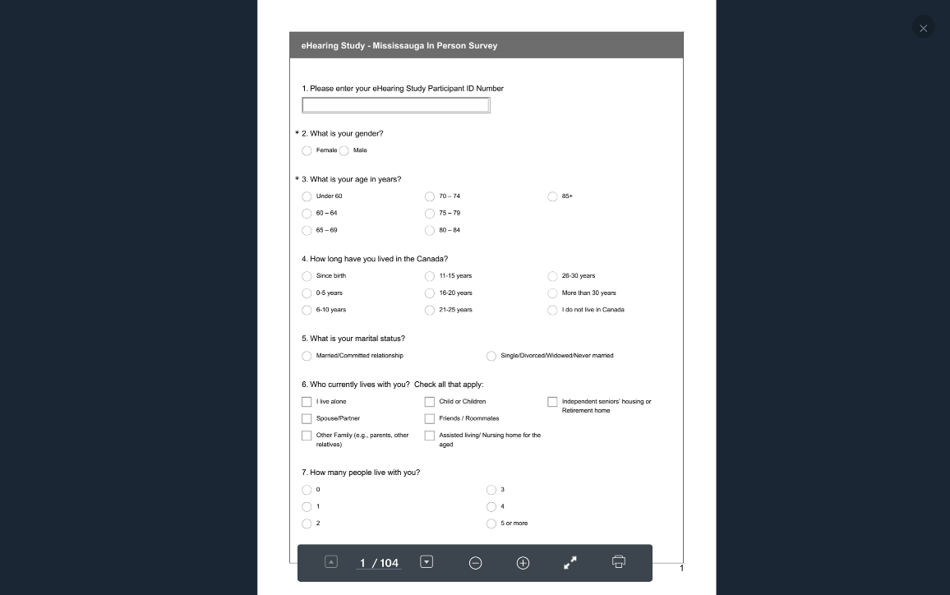

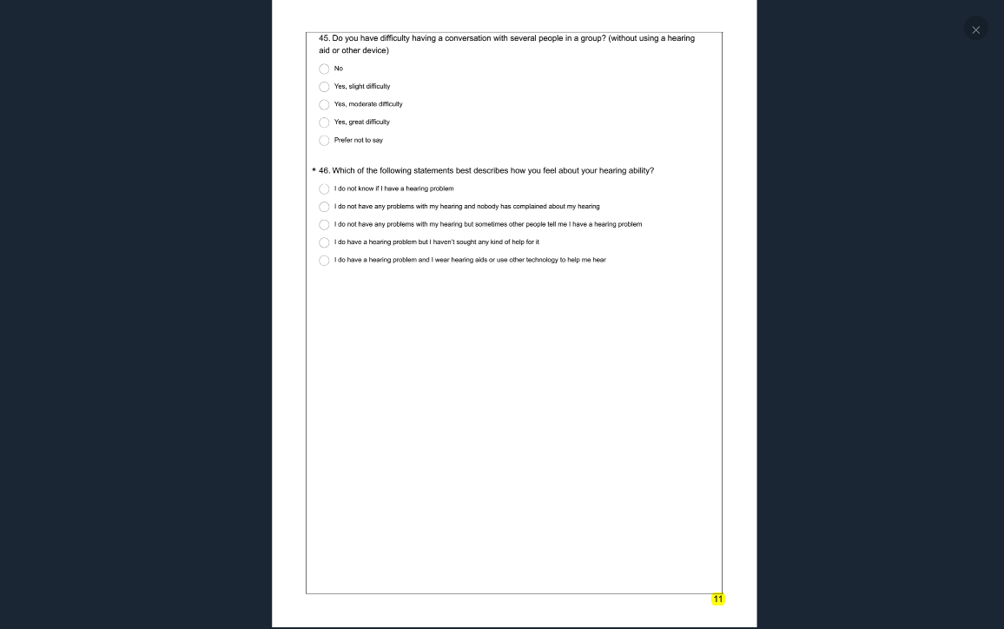

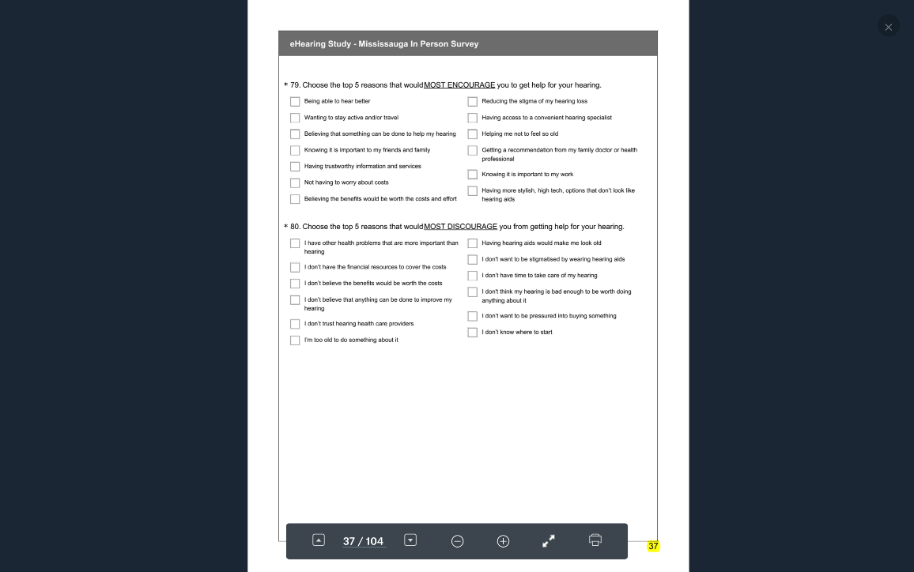

Pathway #2 1-46 81-134

Q #46: Yes, problem. Have not sought help.

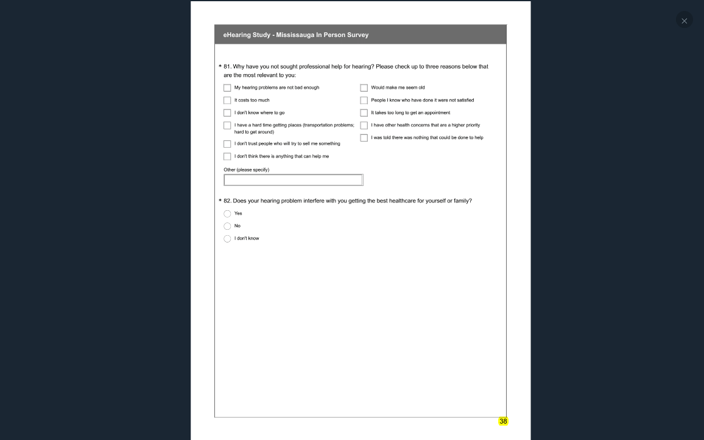

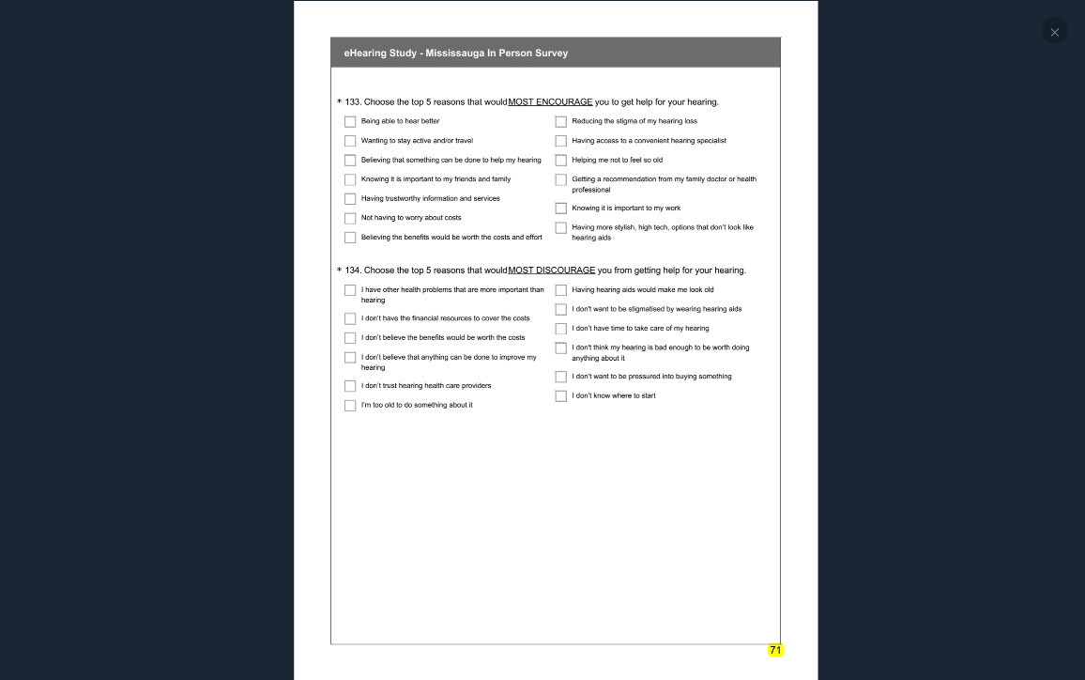

Pathway #3 1-46 135-187

Q #46: Yes, problem. Yes, sought help.

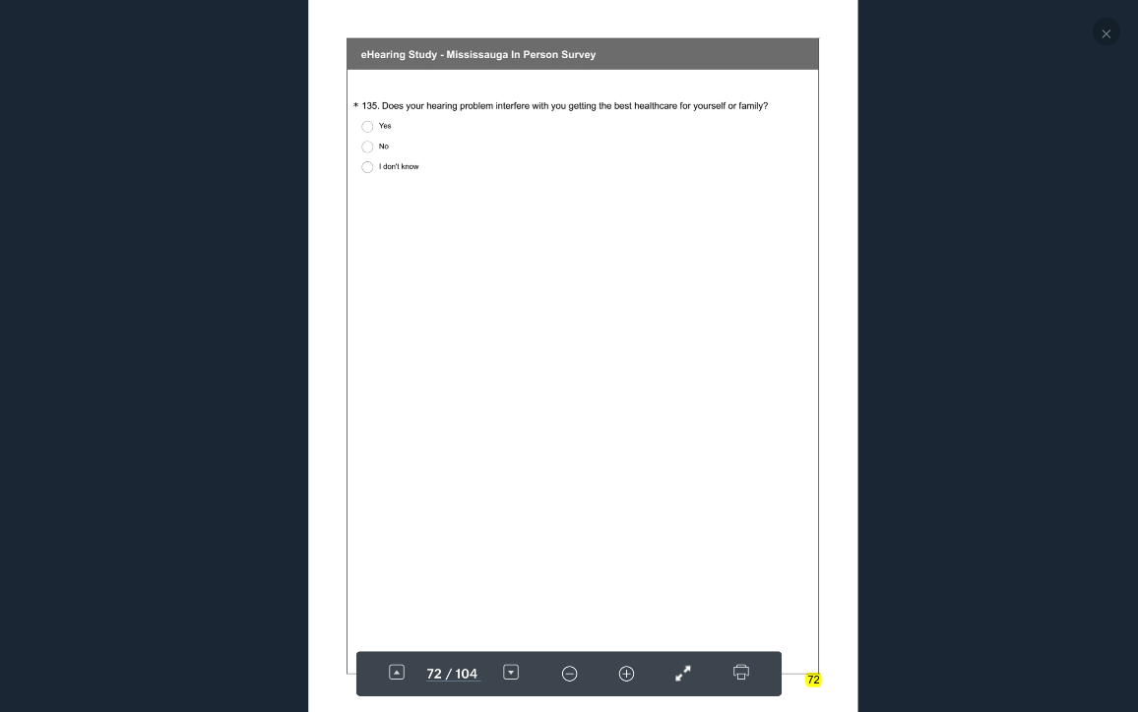

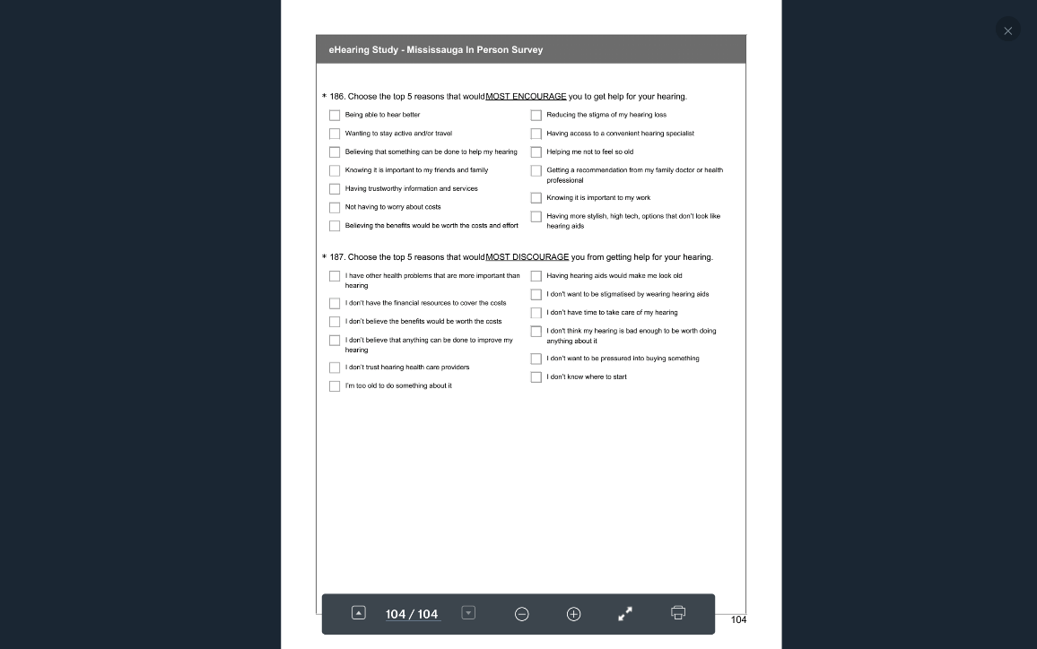

## SURVEY STRUCTURE USA

### US NATIONAL INCLUDING WA STATE ONLINE

Pathway #1 1-80

Q#45 Don’t know or don’t think they have a problem.

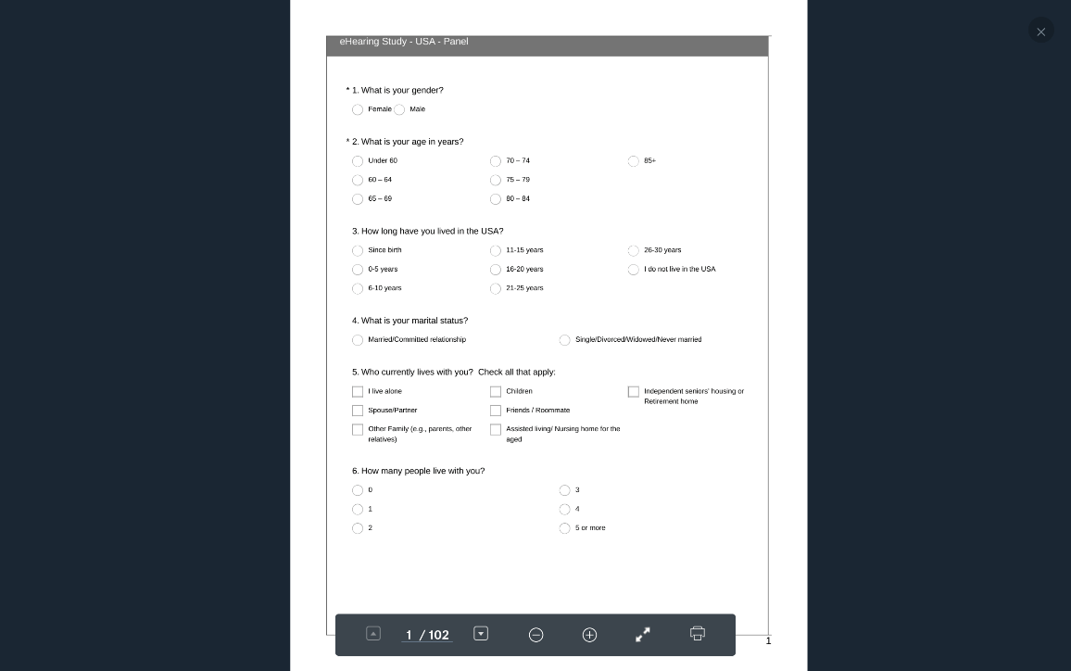

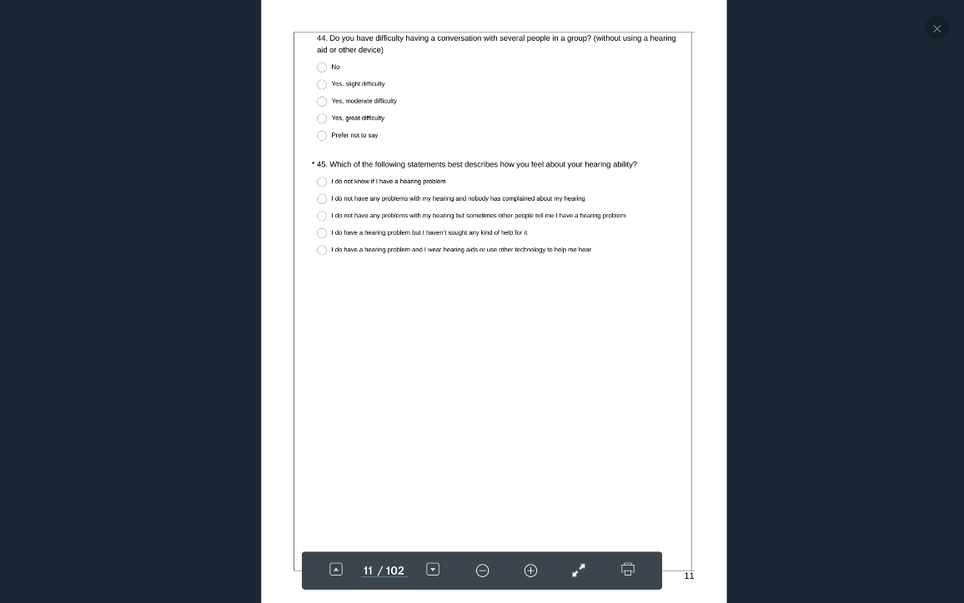

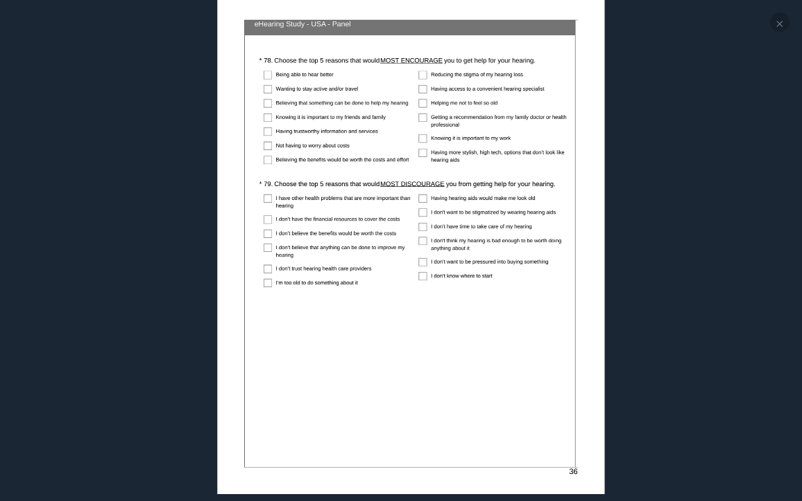

Pathway #2 1-45, 80-133

Q #46: Yes, problem. Have not sought help.

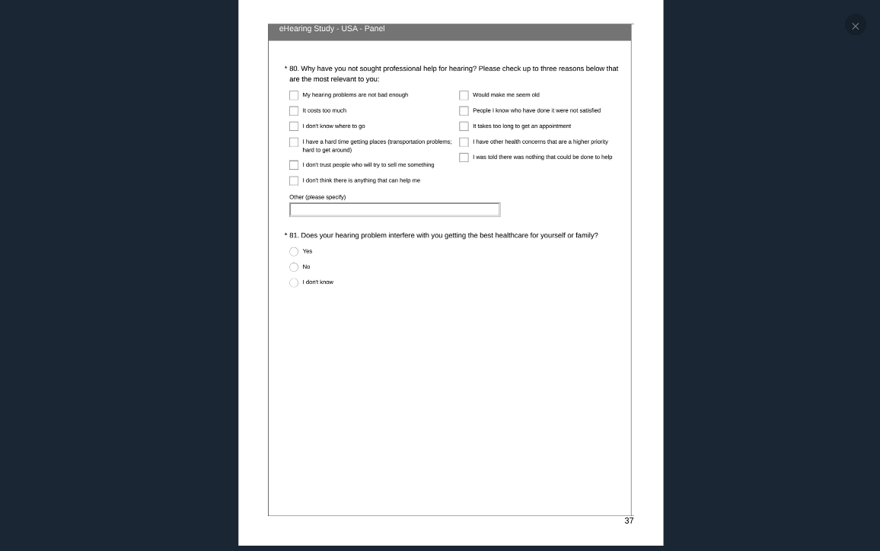

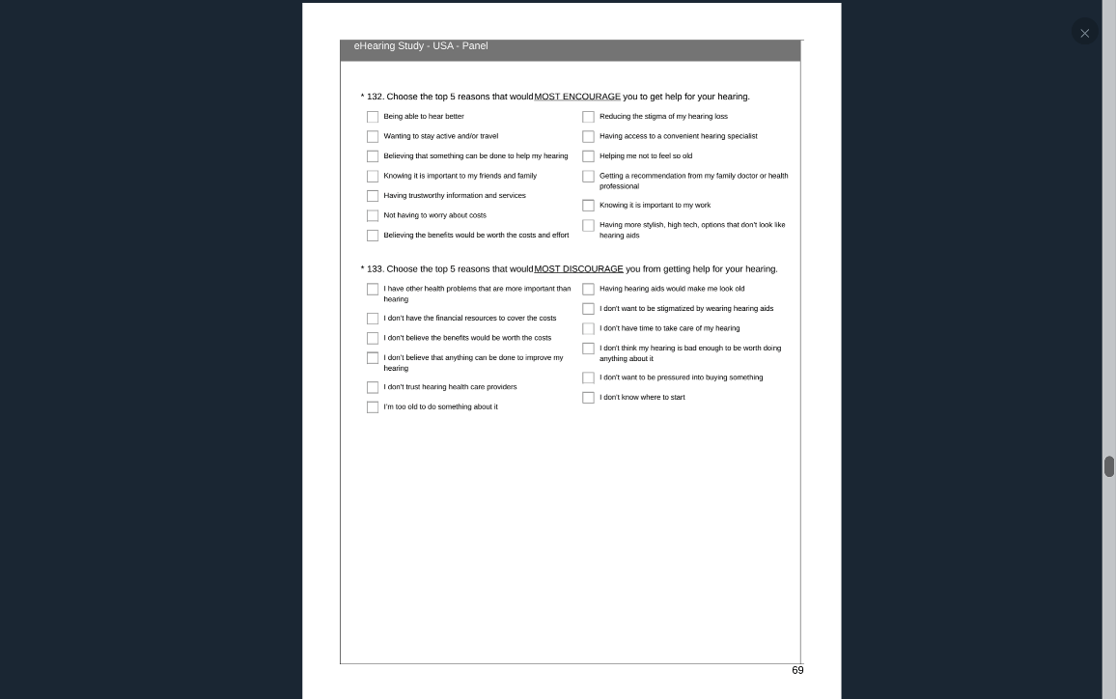

Pathway #3 1-45, 134-186

Q #46: Yes, problem. Yes, sought help.

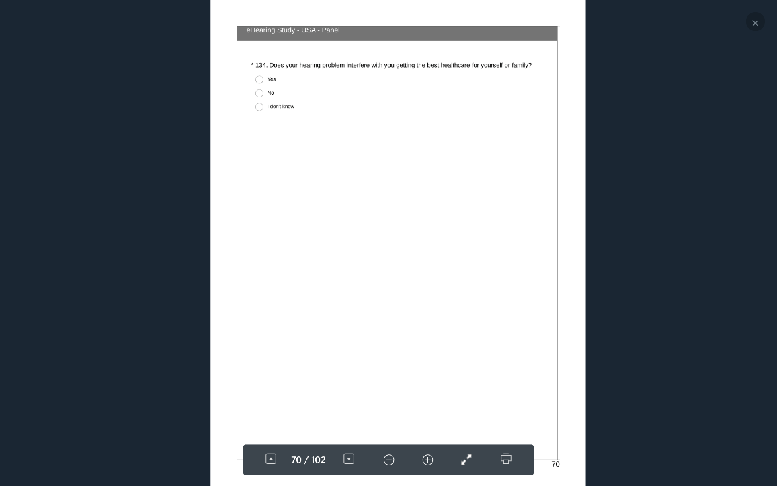

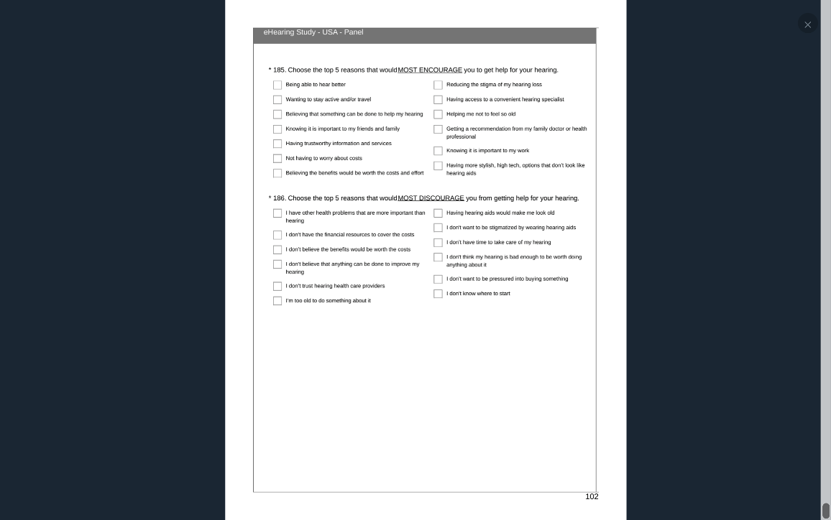

### USA Washington State Online.pdf

Pathway #1 1-80

Q #46: First 3 responses combined. Don’t know or don’t think they have a problem.

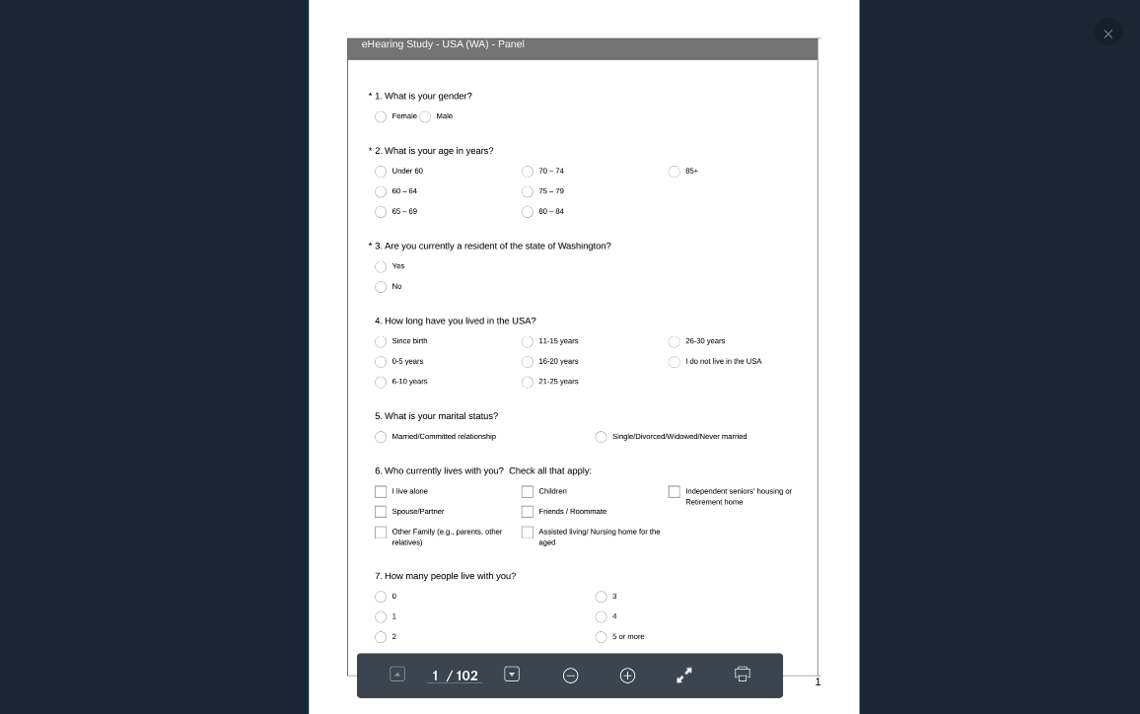

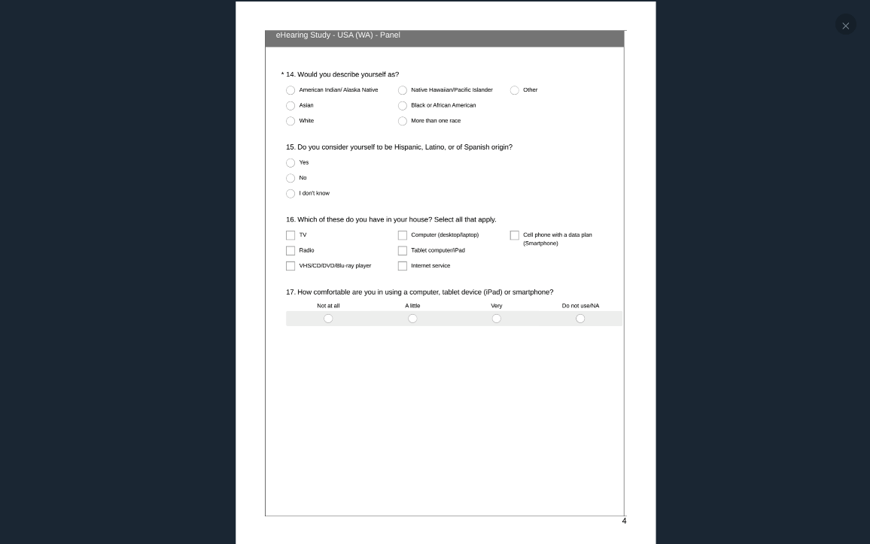

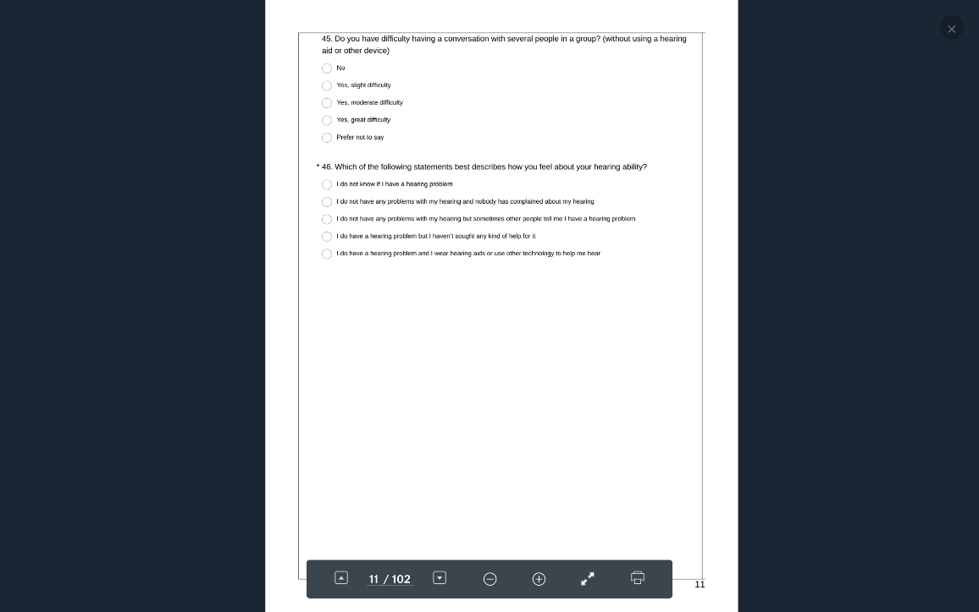

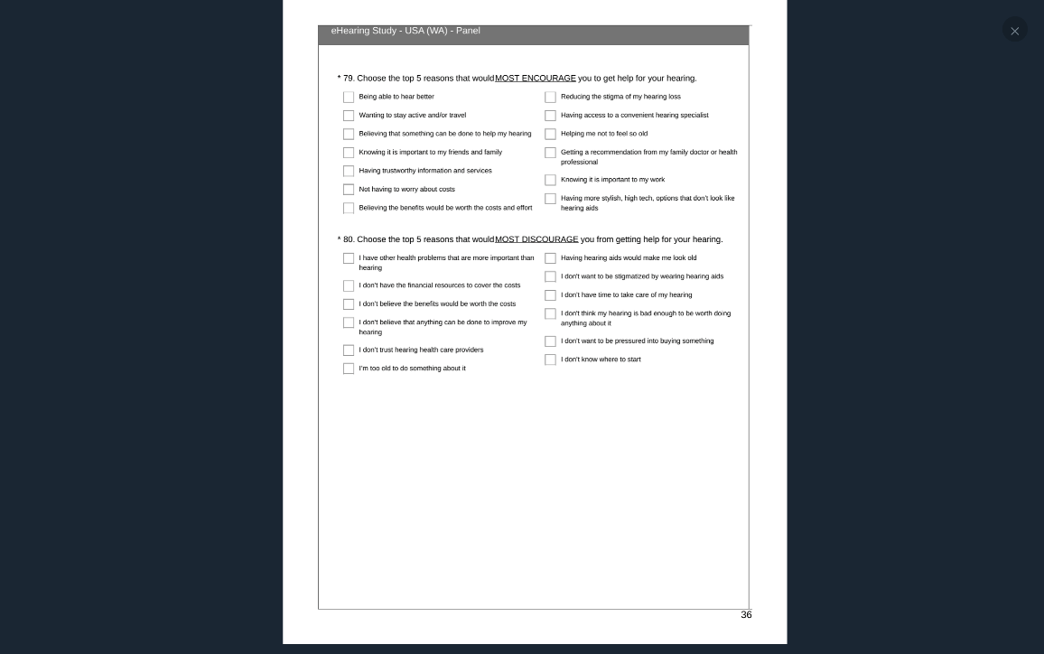

Pathway #2 1-46 81-134

Q #46: First 3 responses combined. Yes, problem. Have not sought help.

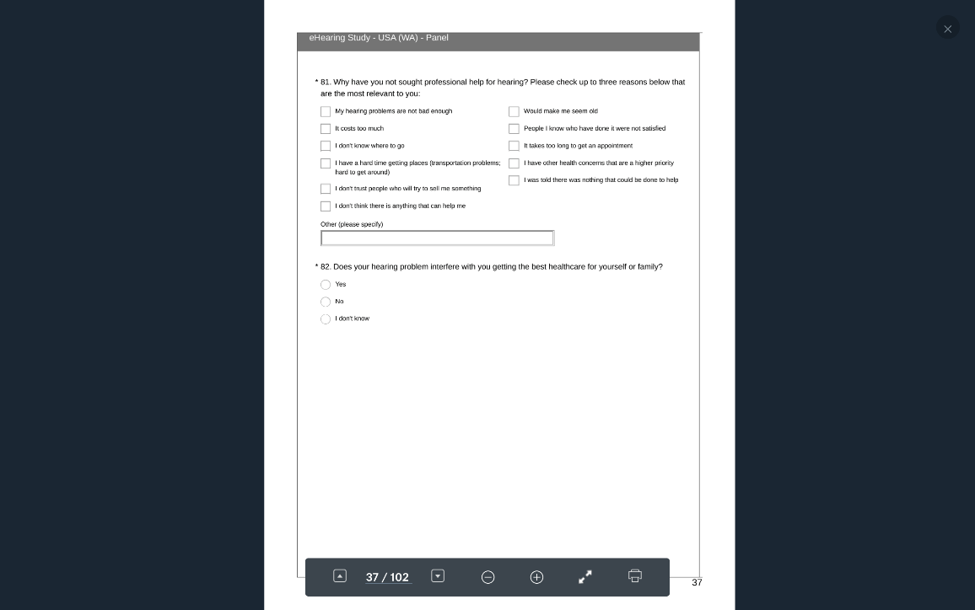

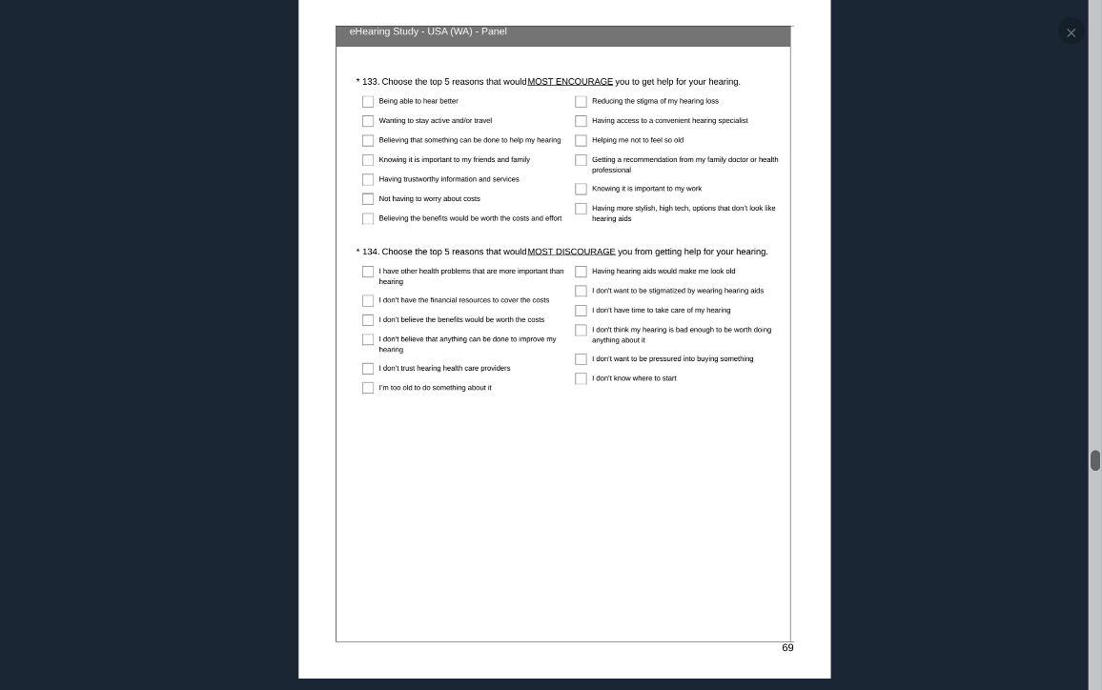

Pathway #3 1-46 135-187

Q #46: First 3 responses combined. Yes, problem. Yes, sought help.

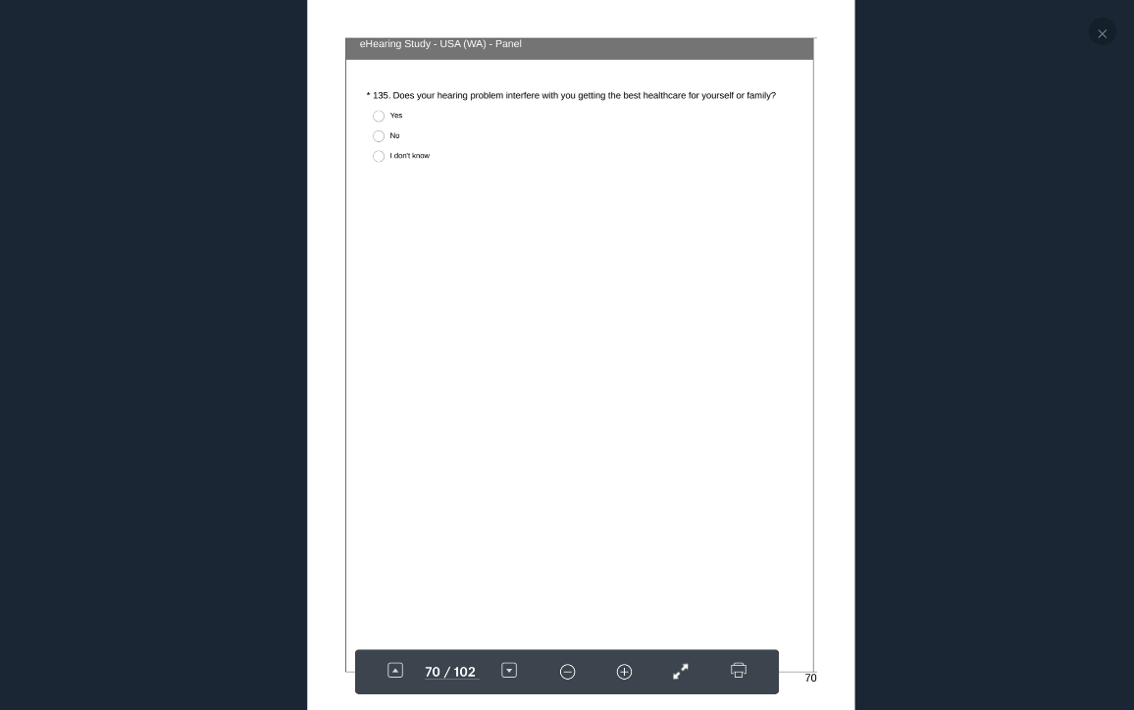

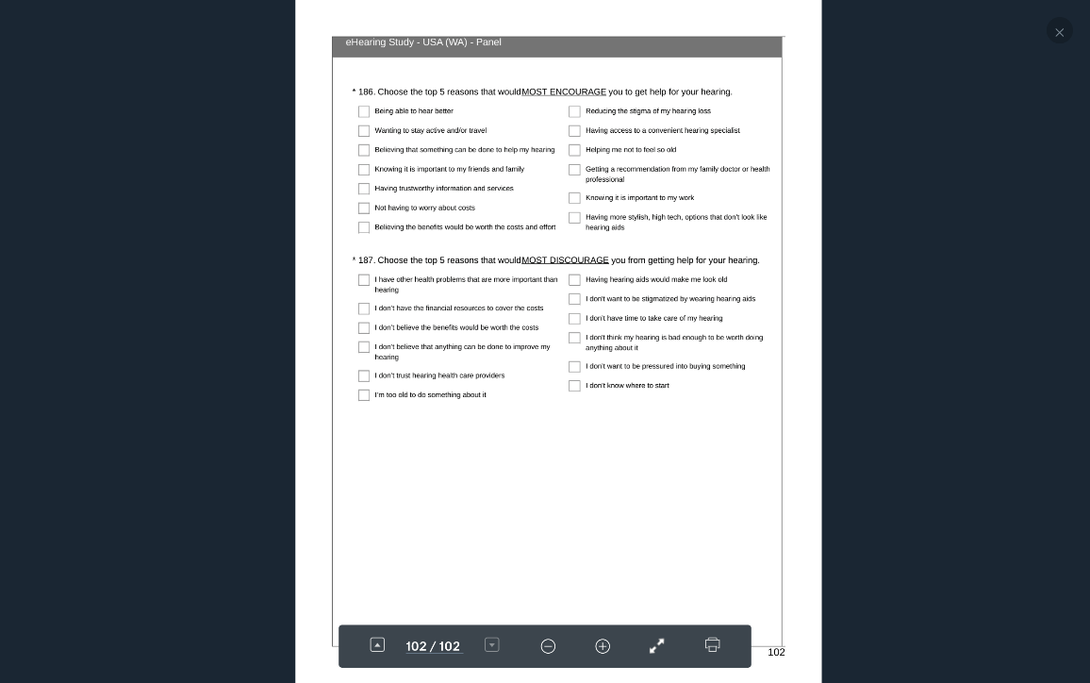

### USA SEATTLE In Person.pdf

Pathway #1 1-80

Q #46: First 3 responses combined. Don’t know or don’t think they have a problem.

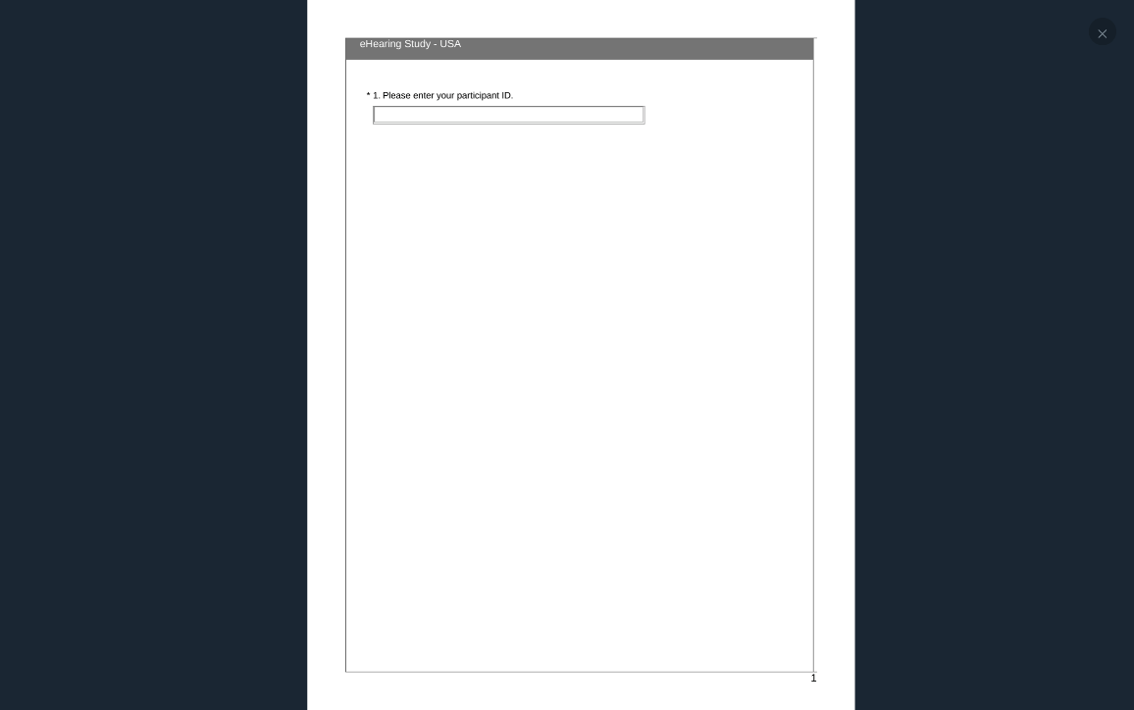

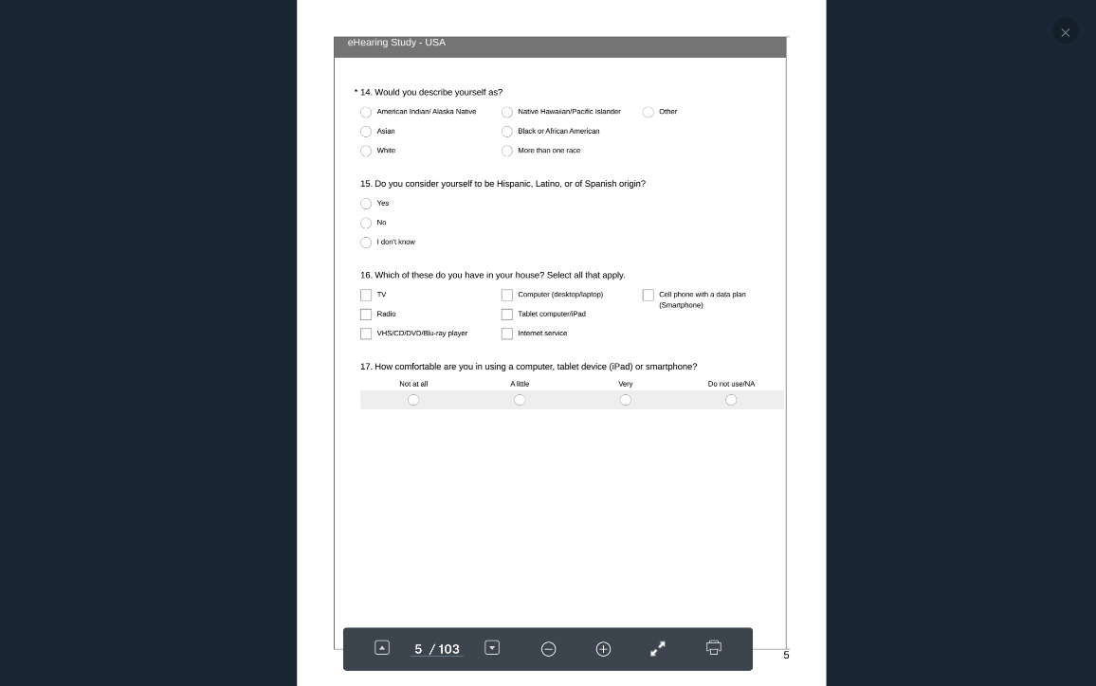

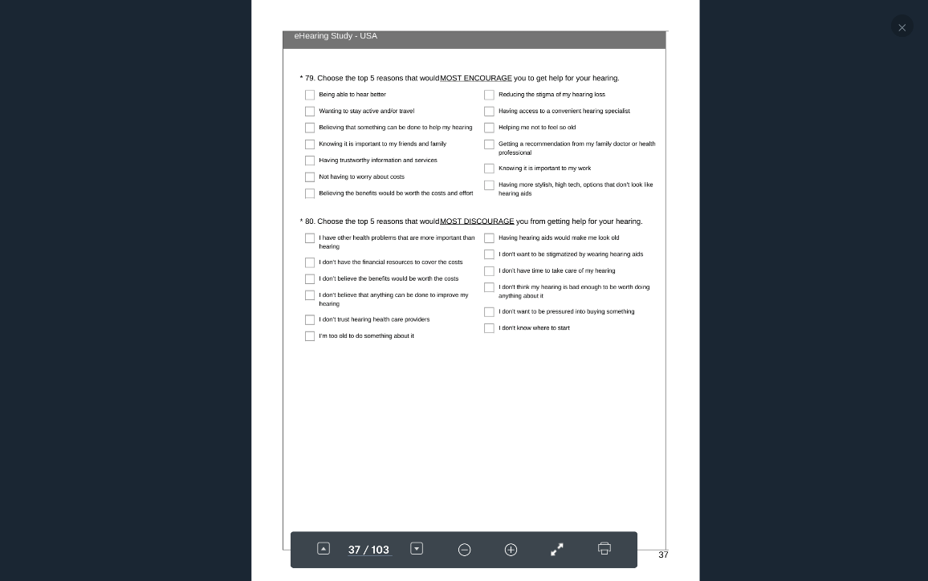

Pathway #2 1-46, 81-134

Q #46: Yes, problem. Have not sought help.

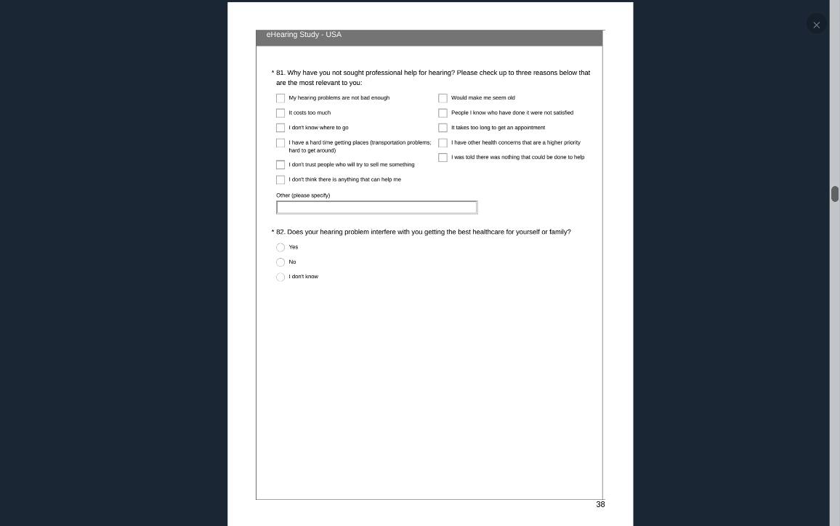

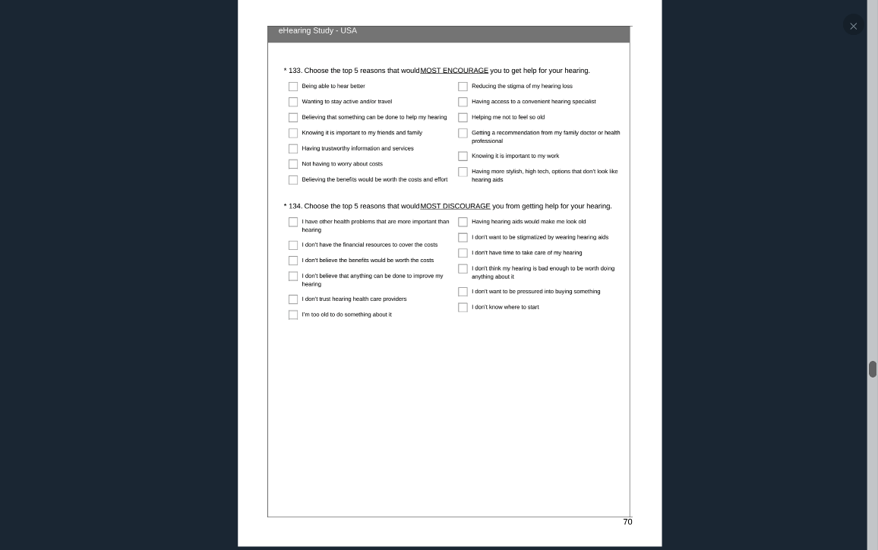

Pathway #3 1-46 135-187

Q #46: First 3 responses combined. Yes, problem. Yes, sought help.

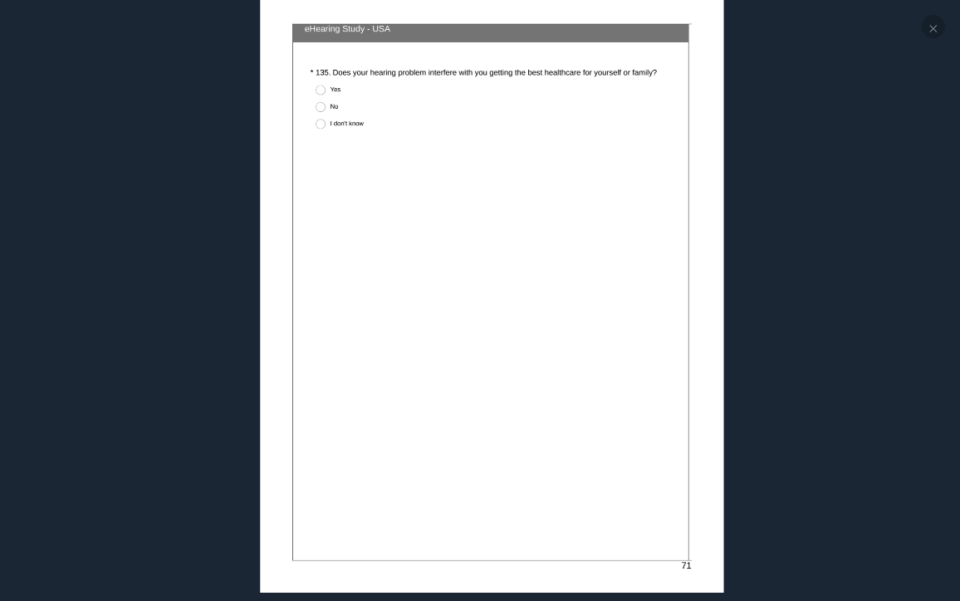

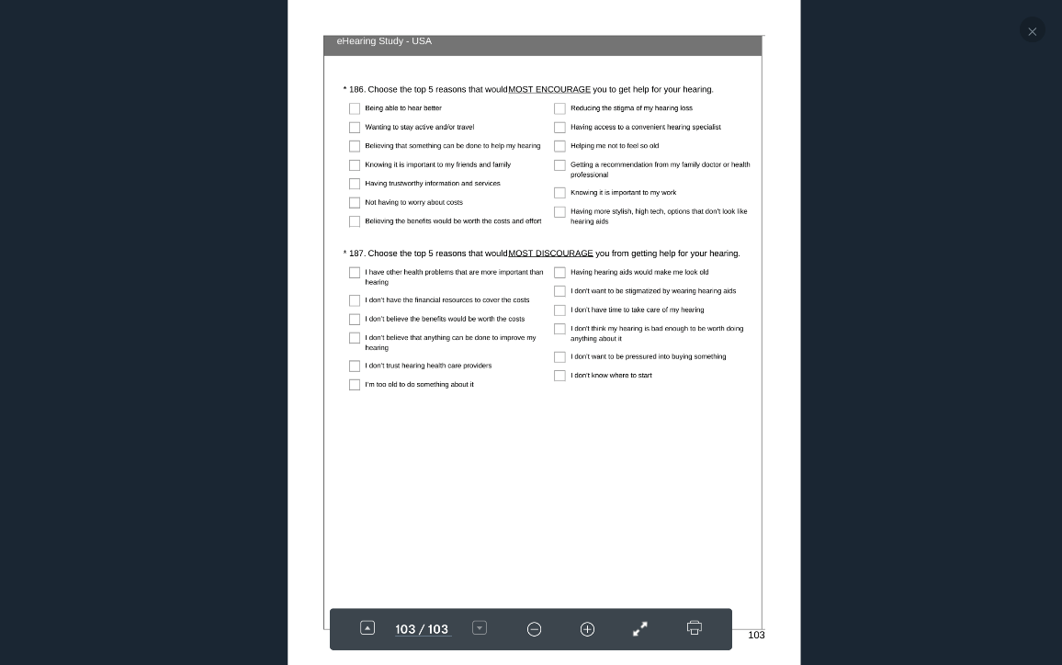

# Subject Tables

10,744 (the number of people who initiated the survey)

10,282 (number of people who completed required demographic and pathway questions - e.g. NIH ethnicity tables were a required question in order to move forward)

Research Now

All Research Now subjects= 8050

Subjects >=60 = 7590

Subjects >=60 who responded to Q2 = 7585

Subjects >=60 who responded to Q41 = 7590-1348= 6242

#Female >=60 responded to Q41 = 3563-550=3013

%female responded to Q41 = 3013/6242=48.3%

#male >=60 responded to Q41 =3229

%male responded to Q41 = 3229/6242=51.7%

In Person

All In person subjects = 1933

Subjects who responded to Q2 and >60= 1927

Subjects >=60 who responded to Q41 = 1933-22=1911

#Female>=60 responded to Q41=998

%female >=60 responded to Q41=52.2%

#male >=60 responded to Q41 = 913

%male responded to Q41 = 3229/6242=47.2%

Combined

Cleaned combined data = 9983 (cleaned for empty, data missingness)

Cleaned combined Data >=60 = 9517

Cleaned combined Data >=60 who answered #41 = 8153